CE 6006 TRAFFIC ENGINEERING AND MANAGEMENT
UNIT I - TRAFFIC PLANNING AND CHARACTERISTICS
Road Characteristics – Road user characteristics – PIEV theory – Vehicle – Performance characteristics – Fundamentals of Traffic Flow – Urban Traffic problems in India – Integrated planning of town ,country ,regional and all urban infrastructure – Towards Sustainable approach. – land use & transport and modal integration.

1. What is traffic engineering? Write its scope and objectives with significance.

TRAFFIC ENGINEERING
Traffic engineering is a branch of civil engineering that uses engineering techniques to achieve the safe and rapid, comfortable, convenient, economical, and environmentally compatible movement of people and goods on roadways.
Traffic engineering is closely associated with other disciplines:
- Transport engineering
- Pavement engineering
- Bicycle transportation engineering
- Highway engineering
- Transportation planning
- Urban planning
- Human factors engineering
Objects of Traffic Engineering:-
- To provide efficient flow of traffic.
- To provide free flow of traffic.
- To provide rapid flow of traffic.
- To provide safety to the traffic

SCOPE OF TRAFFIC ENGINEERING:-
Traffic Engineering includes the study of the following phases:-
- Traffic characteristics
- Traffic operations
- Traffic planning
- Traffic geometrical design
- Traffic administration
SIGNIFICANCE OF TRAFFIC ENGINEERING:-
“Transportation is an essential part of human activity and in many ways forms the basis of all socio-economic interactions. Indeed, no two locations will interact effectively without a viable means of movement. In many developing countries, inadequate transport facilities are often the norm rather than the exception. Thus, a good transport system is essential to support economic growth and development.”
2. Explain the characteristics of vehicles.

CHARACTERISTICS OF VEHICLES AND ROAD USERS
1. Characteristics of Vehicles
It is important to know about the vehicle characteristics because we can design road for any vehicle but not for an indefinite one. The road should be such that it should cater to the needs of existing and anticipated vehicles. Some of the vehicle factors that affect transportation are discussed below.
1.1 Resistance to motion of a Vehicle:
The power developed by the engine (Pp) should be sufficient to overcome all resistance to motion at the desired speed and to accelerate at any desired rate to the desired speed.
The following forces have to be overcome for this purpose.
a) Rolling Resistance (Pf)
b) Air Resistance (Pa)
c) Grade Resistance (Pi)
d) Inertia forces during Acceleration and deceleration (Pj)
e) Transmission Losses
a) Rolling Resistance (Pf)
Rolling resistance, sometimes called rolling friction or rolling drag, is the force resisting the motion when a body (such as a ball, tire, or wheel) rolls on a surface.

When the vehicle wheels roll over the road surface, the irregularities and roughness of the surface cause the deformation in the tyres. The road surface itself may undergo deformations. Shocks and impacts are caused by such a motion and these hinder rolling motion of the vehicle. The rolling resistance varies with the type of surfacing. The values are given in Table 1.
Table 1: Values of Coefficient of Rolling Resistance
S.No | Type of Surfacing | Coefficient of Rolling Resistance
1 | Cement concrete and asphalt surfacing | 0.01 to 0.02
2 | Road with smooth chippings or gravel surface, treated with bituminous binder | 0.02 to 0.025
3 | Chippings or gravel surfacings, not treated with binder, having small pot-holes | 0.03 to 0.04
4 | Cobblestone pavement | 0.04 to 0.05
5 | Earth road, smooth, dry and compact | 0.03 to 0.06
6 | Ploughed field, saturated and swampy ground, loose sand | 0.15 to 0.30 and over

The rolling resistance is given by,
P_{f} = m* f * g
Where, m = Mass of the vehicle in kg
f = Coefficient of Rolling Resistance
g = Acceleration due to gravity in m/sec²
P_{f} = Rolling Resistance in N
Research carried out in India has yielded the following values of rolling resistance which is shown in Table 2.
Table 2: Values of Coefficient of Rolling Resistance from Indian Studies
S.No | Type of Surface | Rolling Resistance coefficient
1 | Asphalt concrete | 0.01
2 | Premixed carpet in good condition | 0.016
3 | Premixed carpet in bad condition | 0.022
4 | Water-bound macadam in good condition | 0.025
5 | Water-bound macadam in bad condition | 0.037
6 | Gravel | 0.046
7 | Earth | 0.055

The rolling resistance depends on the speed of the vehicle also. Though its value is approximately constant up to a speed of about 50 K.P.H., at higher values of speed, the coefficient increases the value.
The following approximate equation accounts for this increase,
f_{v} = f₀ { 1+0.01(V-50)}
Where, fv = coefficient of rolling resistance at speed V
V = Speed in K.P.H
f₀ = coefficient of rolling resistance, (Assumed constant upto a speed of 50 K.P.H., and can be taken from Table 1)
b) Air Resistance (Pa)
Air resistance is a force that is caused by air. The force acts in the opposite direction to an object moving through the air.
When a vehicle is in motion, air resists it in the following ways:
- Since air has density, it exerts a reaction pressure against the front of the vehicle when it moves at speed.
- The friction of air against the sides of the vehicle body causes resistance.
- The eddying of the air stream behind the vehicle, under the body and around the wheels causes power loss.
- The flow of air through the vehicle for ventilating and cooling causes resistance to motion.
The following formula can be used to determine the air resistance, Pa:
P_{a} = C_{a}. A v²
Where, P_{a} = Air resistance in N
A = Projected front area of the vehicle in sq.meters on a plane at right angles to the direction of motion; for Indian vehicles, it can be taken from Table 3.
v = Speed of the vehicle relative to air in m/sec
C_{a} = Coefficient of air resistance, having values in Table 3.
g = Acceleration due to gravity, 9.81 m/sec²

Table 3: Values of Frontal Area and Coefficient of Air Resistance
S.No | Type of Vehicle | Frontal Area (m²) | Mass (kg) | Coefficient of resistance C_{a} (kg/m²)
1 | Premier Padmini Car | 1.63 | 1065 | 0.42
2 | Ambassador Car | 2.15 | 1365 | 0.39
3 | Jeep | 2.38 | 1200 | 0.37
4 | Tata Truck | 5.37 | 6120 | 0.48
5 | Ashok Leyland Truck | 5.37 | 8125 | 0.48
6 | Maruti Car | 1.54 | 880 | 0.40

c) Grade Resistance (Pi)
The force, due to gravity, that resists the movement of a vehicle up a slope is called as Grade Resistance.
A vehicle which was moving on a level stretch at a particular speed has to move up an incline, additional work has to be done in keeping the vehicle at the same speed as in the level stretch.
The additional work is equal to the work that will be needed to lift the vehicle through a height represented by the inclination. If the horizontal distance is unity (i.e 1 meter), and the slope “i” percent, the rise will be (i/100) m.
If the mass of the vehicle is “m” kg, the additional force to move the vehicle up the incline, Pi is given by,
±Pi = (m.i.g)/100
It may be noted that if the slope becomes downward, i becomes -ve and P_{i} also becomes -ve, representing a reduction in the force to move the vehicle.
d) Inertia forces during Acceleration and deceleration (P_{j})
Inertia is the resistance of any physical object to any change in its state of motion, including changes to its speed and direction. It is the tendency of objects to keep moving in a straight line at constant velocity.
When the speed of a moving vehicle needs to be increased some additional power is needed to accelerate. Similarly if the vehicle has to gather a desired speed from a stopped position, additional force is needed to accelerate. The additional force P_{j} is given by,
Force = Mass * Acceleration
Hence, (±P_{j}) = ma = m. (dv/dt)
Where, Pj = Force to accelerate, N
m = Mass of the vehicle, kg
a = Average acceleration of the vehicle, m/sec²
= dv/dt
The value of P_{j} will be positive if the vehicle is to accelerate and negative if the vehicle is to decelerate.
e) Transmission Losses
Losses in power occur to the mode of power transmission (Clutch or automatic fluid coupling) from the engine to the gear system and in the gear system itself. The vehicle has a system of gears such that the speed of the vehicle can be altered relative to the engine speed.
At the start of the vehicle, high power is needed but at low speed. Similarly, a high engine power is needed while climbing uphill, which is accomplished at a lower road speed than when driving at a movement along a good road where the resistance to motion will be small, a high gear will tend to be used.
The total effect of all the activities will consume about 10-15 percentage of the engine power, which may be as high as 25percentage in case of trucks in their lowest gear.

f) Power requirements of the Vehicle:
The mechanical power developed by the engine is transmitted to the driving wheels by the transmission system. The torque development at the flywheel is converted to a torque at the rear axle and the following equation holds good:
Rear Axle torque, T_{a} = k.T_{c}.G_{t}.G_{a}
Where, Ta = Rear-axle torque
k = Efficiency of the transmission system, which takes into account the loss of power due to overcoming the resistance of all mechanism between the engine and the driving wheels, and can be taken to be about 0.85 to 0.90
T_{c} = Engine torque at the fly-wheel
G_{t} = Transmission gear ratio
G_{a} = Rear-axle gear ratio
The rear axle torque imparts tractive force Pp at the contact of the wheel and the road. This tractive force also known as “tyrerim pull” is given by the following equation.
Pp = Rear axle torque / Radius of the rolling drive tyre
= (k. T_{e}. G_{t}.G_{a}) / r_{ω}
r_{ω} is related to the radius of the tyre r0, by the following formula,
r_{ω} = λ r0
Where, λ= tyre deformation factor, will have a value of 0.945 – 0.950 for high pressure air tyres and 0.930 -0.935 for low pressure tyres, on hard surfaces.
The horse power corresponding to the tractive effort Pp when the vehicle moves at a speed of “v” m/sec is,
Power output = P_{p}. v
But, $v=V*\frac{1000}{3600}=\frac{V}{3.6}$
∴ $Power Output=Pp*\frac{V}{3.6}$

Also, $v=\frac{2*π*rω*n}{60*Gt*Ga}$
Where “n ” is the engine speed in R.P.M
∴$v=\frac{0.377*rω*n}{Gt*Ga}$
Hence, $Power Output=\frac{Pv*0.377*rω*n}{Gt*Ga}$
Engine Power (in Watts) = $\frac{Pv*0.377*rω*n}{Gt*Ga*k}$
where, k – transmission efficiency
Engine horse -Power (in metric) = (Engine power in watts) / 735
It may be noted that the tractive efforts developed at the wheels should be equal to the resistance to be overcome.
P_{p} = (Rolling resistance + Air resistance + Grade resistance + Inertia forces due to acceleration and deceleration)
= P_{f} ± P_{a} ± P_{i} ± P_{j}
1.2 Other Vehicle Characteristics:
- Dimensions and Weight
- Turning capability
- Braking System
- Acceleration and Deceleration
- Vehicle lighting system
- Features of the vehicle body
- Tyres etc

3. Briefly explain the road user characteristics.

2. Human factors affecting transportation / Road User Characteristics:
Road users can be defined as drivers, passengers, pedestrians etc., who use the streets and highways. It is said to be the most complex factor as the human performances varies from individual to individual.
Thus, the transportation engineer should deal with a variety of road user characteristics. So, the design considerations should safely and efficiently accommodate the elderly persons, the children, the handicapped, the slow and speedy, and the good and bad drivers.
2.1 Variability
The most complex problem while dealing human characteristics is its variability. The human characteristics like ability to react to a situation, vision and hearing, and other physical and psychological factors vary from person to person and depend on age, fatigue, nature of stimuli, presence of drugs/alcohol etc.
The influence of all these factors and the corresponding variability cannot be accounted when a facility is designed. So a standardized value is often used as the design value. The 85th percentile value of different characteristics is taken as a standard. It represents a characteristic that 85 percent of the population can meet or exceed.
For example: if we say that the 85th percentile value of walking speed is about 2 m/s, it means that 85 percent of people has walking speed faster than 2 m/s. The variability is thus fixed by, selecting proper 85th percentile values of the characteristics.
2.2 Critical characteristics
The road user characteristics can be of two main types, some of them are quantifiable like reaction time, visual acuity etc. while some others are less quantifiable like the psychological factors, physical strength, fatigue, and efficiency.

2.3 Reaction time
The road user is subjected to a series of stimuli both expected and unexpected. The time taken to perform an action according to the stimulus involves a series of stages like:
• Perception : Perception is the process of perceiving the sensations received through the sense organs, nerves and brains. It is actually the recognitions that a stimulus on which a reaction is to happen exists.
• Intellection : Intellection involves the identification and understanding of stimuli.
• Emotion : This stage involves the judgment of the appropriate response to be made on the stimuli like to stop, pass, move laterally etc.
• Volition : Volition is the execution of the decision which is the result of physical actions of the driver.
For example, if a driver approaches an intersection where the signal is red, the driver first sees the signal (perception), he recognizes that is is a red/STOP signal, he decides to stop and finally applies the brake (volition).
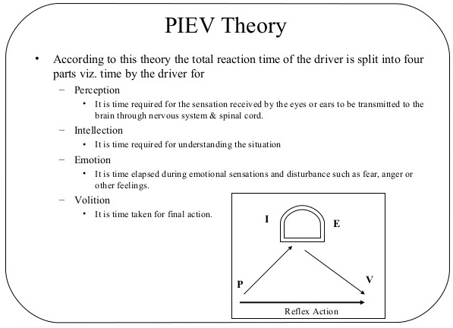
This sequence is called the PIEV time or perception-reaction time. But apart from the above time, the vehicle itself travelling at initial speed would require some more time to stop. That is, the vehicle travelling with initial speed u will travel for a distance, d = vt where, t is the above said PIEV time. Again, the vehicle would travel some distance after the brake is applied.
2.4 Visual acuity and driving
The perception-reaction time depends greatly on the effectiveness of drivers vision in perceiving the objects and traffic control measures.
The PIEV time will be decreased if the vision is clear and accurate.
Visual acuity relates to the field of clearest vision. The most acute vision is within a cone of 3 to 5 degrees, fairly clear vision within 10 to 12 degrees and the peripheral vision will be within 120 to 180 degrees.

This is important when traffic signs and signals are placed, but other factors like dynamic visual acuity, depth perception etc., should also be considered for accurate design.
Glare vision and colour vision are also equally important. Glare vision is greatly affected by age.
Glare recovery time is the time required to recover from the effect of glare after the light source is passed, and will be higher for elderly persons.
Colour vision is important as it can come into picture in case of sign and signal recognition.
2.5 Walking
Pedestrian traffic along footpaths, sidewalks, crosswalks, safety zones, islands, and over and under passes should be considered for Transportation planning and design. On an average, the pedestrian walking speed can be taken between 1.5 m/sec to 2 m/sec.
But the influence of physical, mental, and emotional factors need to be considered. Parking spaces and facilities like signals, bus stops, and over and under passes are to be located and designed according to the maximum distance to which a user will be willing to walk.
It was seen that in small towns 90 per cent park within 185 m of their destinations while only 66 per cent park so close in large city.

2.6 Other Characteristics
Hearing is required for detecting sounds, but lack of hearing acuity can be compensated by usage of hearing aids. The variability of attitude of drivers with respect to age, sex, knowledge and skill in driving etc., are also important.
Two of the important constituents of transportation system are drivers and users/passengers. Understanding of certain human characteristics like perception - reaction time and visual acuity and their variability are to be considered by Traffic Engineer. Because of the variability in characteristics, the 85th percentile values of the human characteristics are fixed as standards for design of traffic facilities.
4. Explain in detail about basic principles of traffic flow.

BASIC PRINCIPLES OF TRAFFIC FLOW:
In mathematics and civil engineering, traffic flow is the study of interactions between vehicles, drivers, and infrastructure (including highways, signage, and traffic control devices), with the aim of understanding and developing an optimal road network with efficient movement of traffic and minimal traffic congestion problems.
Traffic stream parameters
Speed
Spot Speed
Running speed
Journey speed
Time mean speed and space mean speed
Flow
Volume
Density - Density is defined as the number of vehicles occupying a given length of highway or lane and is generally expressed as vehicles per km. One can photograph a length of road x, count the number of vehicles, n_{x}, in one lane of the road at that point of time and derive the density k as,
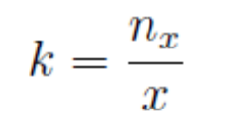
From the figure, the density is the number of vehicles between the point A and B divided by the distance between A and B. Density is also equally important as flow but from a different angle as it is the measure most directly related to traffic demand. Again it measures the proximity of vehicles in the stream which in turn affects the freedom to maneuver and comfortable driving.
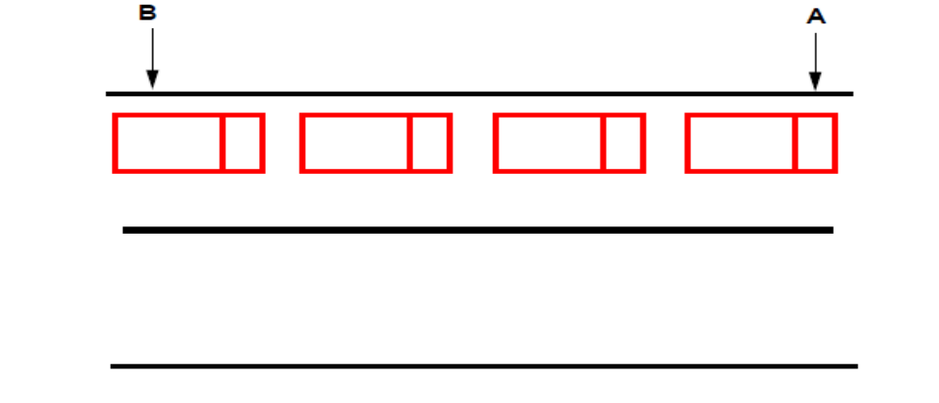
Derived characteristics- From the fundamental traffic flow characteristics like flow, density, and speed, a few other parameters of traffic flow can be derived. Significant among them are the time headway, distance headway and travel time. They are discussed one by one below.
Time headway
The microscopic character related to volume is the time headway or simply headway. Time headway is defined as the time difference between any two successive vehicles when they cross a given point. Practically, it involves the measurement of time between the passage of one rear bumper and the next past a given point. If all headways h in time period, t, over which flow has been measured are added then,
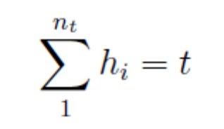
But the flow is defined as the number of vehicles n_{t} measured in time interval t, that is,
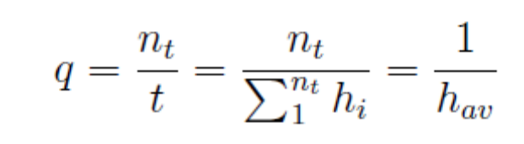
Where, hav is the average headway. Thus average headway is the inverse of flow. Time headway is often referred to as simply the headway.
Distance headway
Another related parameter is the distance headway. It is defined as the distance between corresponding points of two successive vehicles at any given time. It involves the measurement from a photograph, the distance from rear bumper of lead vehicle to rear bumper of following vehicle at a point of time. If all the space headways in distance x over which the density has been measured are added,
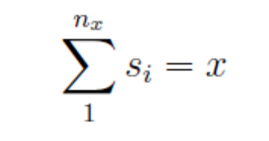
But the density (k) is the number of vehicles n_{x} at a distance of x, that is
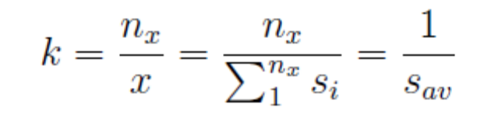
Where, s_{av} is average distance headway. The average distance headway is the inverse of density and is sometimes called as spacing.
Travel time
Travel time is defined as the time taken to complete a journey. As the speed increases, travel time required to reach the destination also decreases and vice-versa. Thus travel time is inversely proportional to the speed. However, in practice, the speed of a vehicle fluctuates over time and the travel time represents an average measure.
Fundamental relations of traffic flow
The relationship between the fundamental variables of traffic flow, namely speed, volume, and density is called the fundamental relations of traffic flow. This can be derived by a simple concept. Let there be a road with m length v km, and assume all the vehicles are moving with v km/hr. Let the number of vehicles counted by an observer at A for one hour is n1. By definition, the number of vehicles counted in one hour is flow (q). Therefore,
n1 = q
Similarly, by definition, density is the number of vehicles in unit distance. Therefore number of vehicles n 2 in a road stretch of distance v 1 will be density × distance. Therefore,
n 2 = k × v
Since all the vehicles have speed v, the number of vehicles counted in 1 hour and the number of vehicles in the stretch of distance v will also be same.(ie n 1 = n 2 ). Therefore,
q = k × v
This is the fundamental equation of traffic flow. Please note that, v in the above equation refers to the space mean speed.
Fundamental diagrams of traffic flow
The relation between flow and density, density and speed, speed and flow, can be represented with the help of some curves. They are referred to as the fundamental diagrams of traffic flow. They will be explained in detail one by one below.
Flow-density curve
The flow and density varies with time and location. The relation between the density and the corresponding flow on a given stretch of road is referred to as one of the fundamental diagram of traffic flow. Some characteristics of an ideal flow-density relationship are listed below:
1. When the density is zero, flow will also be zero, since there is no vehicle on the road.
2. When the number of vehicles gradually increases the density as well as flow increases.
3. When more and more vehicles are added, it reaches a situation where vehicles can’t move. This is referred to as the jam density or the maximum density. At jam density, flow will be zero because the vehicles are not moving.
4. There will be some density between zero density and jam density, when the flow is maximum. The relationship is normally represented by a parabolic curve.
Speed Flow Diagram
The relationship between the speed and flow can be postulated as follows. The flow is zero either because there is no vehicle or there are too many vehicles so that they cannot move. At maximum flow, the speed will be in between zero and free flow speed. This relationship is shown in figure. The maximum flow q_{max} occurs at speed u. It is possible to have two different speeds for a given flow.
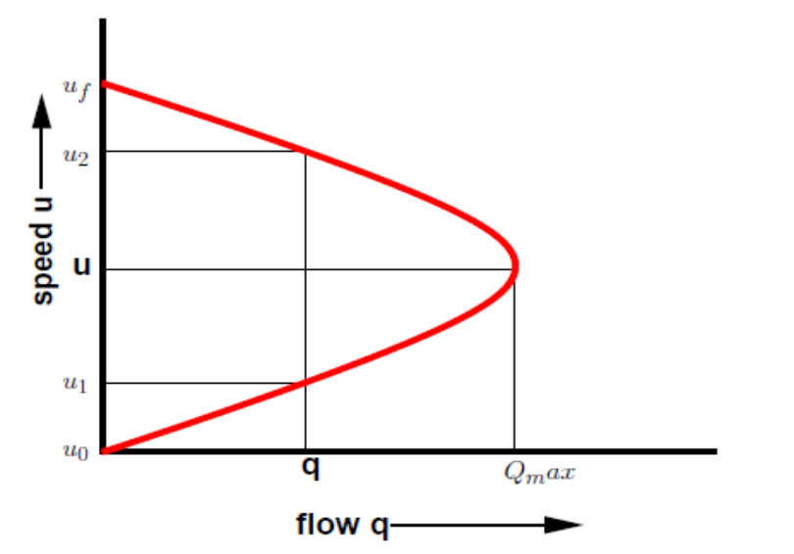

Speed-density diagram
Similar to the flow-density relationship, speed will be maximum, referred to as the free flow speed, and when the density is maximum, the speed will be zero. The simplest assumption is that this variation of speed with density is linear as shown by the solid line in figure 31:4. Corresponding to the zero density, vehicles will be flowing with their desire speed, or free flow speed. When the density is jam density, the speed of the vehicles becomes zero. It is also possible to have non-linear relationships as shown by the dotted lines.
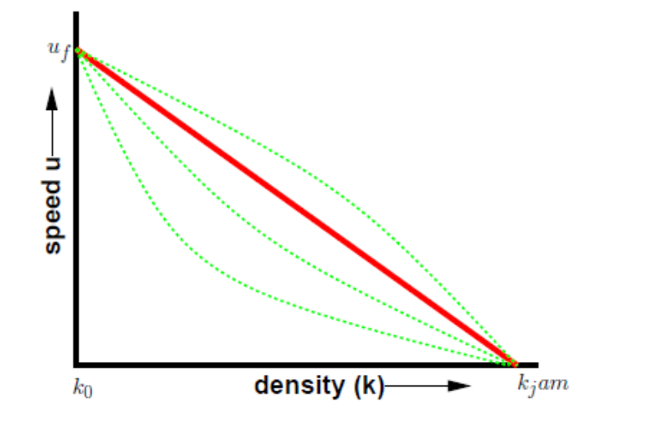
Combined diagrams
The diagrams shown in the relationship between speed-flow, speed-density, and flow-density are called the fundamental diagrams of traffic flow. These are as shown in figure.
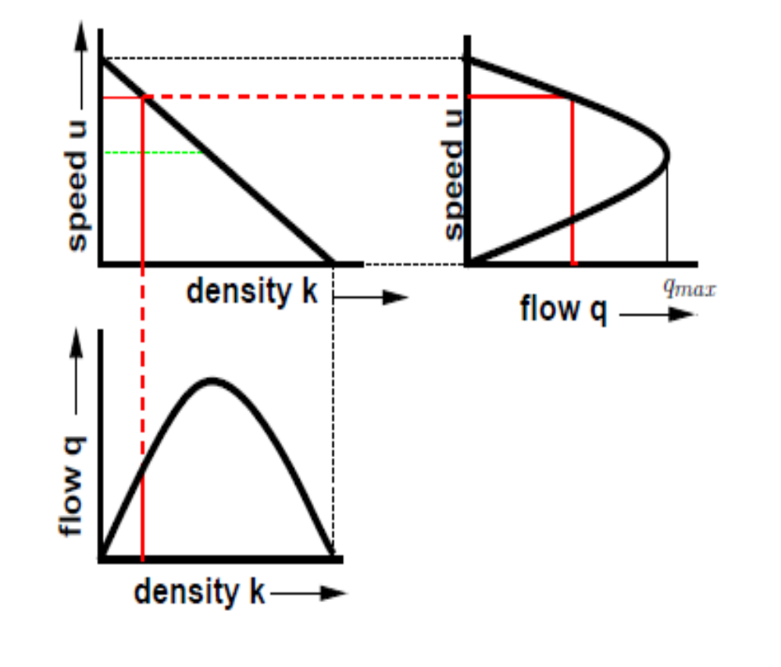

5. make a note on urban traffic problems in india.

URBAN TRANSPORT PROBLEMS IN INDIA
a) Road congestion
As populations increase, the average travel distances as well as intensity are expected to increase as there is a direct correlation between the two indicators. Average trips lengths for metro cities including Bengaluru are over 8 km, while it is 6 km or less for all other metro cities. This trend in trip length and frequency is only expected to increase with increasing income levels, migration, participation of women and a service -oriented economy.
As more people travel over longer distances on regular basis for employment and education purposes, will inevitably lead to road congestion.
b) Parking problems
The acute shortage of parking spaces both on and off the streets in Indian cities increases the time spent searching for a parking spot and induces traffic congestion. Available data shows that a high proportion of Indian streets are faced with on -street parking issue.
This problem is especially acute in smaller, compact Indian cities. Delhi has 14 per cent of road lengths used for on-street parking while Surat has almost 60 per cent of its road lengths blocked by on-street parking.
On -street parking is perversely incentivized because it is either free or priced lower than off-street parking. Even if cities invest in multi-level car parks in prime areas, the parking rates are not expected to recover the costs. In Delhi, the public parking charges are fixed as low as Rs10 for 8 hours during the daytime when it should be at least Rs40 per hour.
Kolkata has the highest parking charges in India and these charges are time and place variable, i.e. higher parking charges in specific commercial zones and the rates increase by the hour. In Kolkata, a car pays Rs 80 for eight hours of parking during daytime, while in Delhi MCD region; car parking charges are as low as Rs10 for up to 10 hours of parking. Following Figure shows the eight-hour average parking rates in different cities but does not include special parking rates in parking spaces like malls, airports, etc.
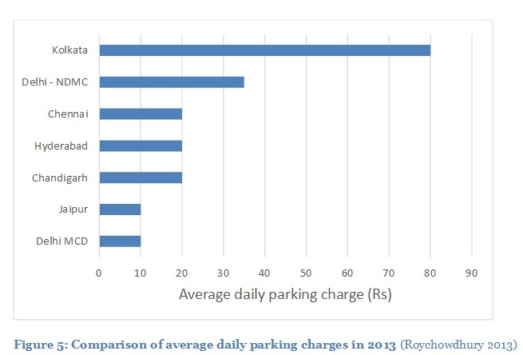
c) Air pollution
The severity of air pollution in Indian cities is judged based on CPCB’s (Central Pollution
Control Board) air quality classification. According to available air quality data, of 180 Indian cities, there is a wide variation in the pollution concentration and severity across cities. Cities are considered critically polluted if the levels of criteria pollutants (namely PM10 and NO2) are more than 1.5 times the standard. Results show that half of the residential areas in cities monitored by CPCB are at critical levels of air pollution. According to US -based Health Effects Institute, people residing within 500 metres from roads are exposed to vehicular fumes. The danger is especially pronounced when diesel vehicles are operating, as diesel emissions are known to trigger adverse respiratory health effects. A study of select Indian cities indicates that the share of transport sector’s contribution increases when tinier fractions of particulates are considered. In Indore, transport contributes to 30 per cent of PM10 but 46 per cent of PM2.5, while in Chennai, it is 20 per cent of PM10 and 35 per cent of PM 2.5.
Air pollution in Indian cities is the fifth leading cause of death in India. Annually, about 620,000 premature deaths occur due to air pollution in Indian cities. Premature deaths due to air pollution occur as a consequence of cardio-vascular ailments. Over a decade, air quality management attempts have met with mixed responses. Metro cities that have initiated pollution control action have witnessed either stabilization or dip in the pollution levels, however, in other cities, the situation has been observed to be getting worse. Toxic air and its effects on health are seriously compromising the ‘livability’ of Indian cities.
d) Deteriorating road safety
The high dependence of migrants on non-motorized transport modes such as walking and cycling causes traffic mix in common roads where fast-moving motorized traffic shares the roads with slow-moving modes leading to an increasing number of fatalities and road accidents (WHO, 2013). In most Indian cities, non-motorized modes like cycling and walking presently share the same right of way as cars and two-wheelers leading to unsafe conditions for all (National Urban Transport Policy (NUTP), 2008). The number of fatalities is also increasing in relation to the increasing motorization and higher slow-moving vehicles in the traffic stream. While progress has been made towards protecting people in cars, the needs of vulnerable groups of road users, primarily cyclists and pedestrians, are not being met. Pedestrian fatalities constitute a significant share of total fatalities and the magnitude is in fact much higher in cities that lack adequate pedestrian facilities.
In New Delhi, Bengaluru and Kolkata, the pedestrian fatality share is greater than 40 per cent. In the case of Bengaluru, three pedestrians are killed on roads every two days and more than 10,000 are hospitalized annually. Elderly people and school children carry a large share of the burden with 23 per cent fatalities and 25 per cent injuries (Bhatt et al., 2013). The percentage of streets with pedestrian pathways is hardly 30 per cent in most Indian cities. The main reason behind this is inequitable distribution of road space and the fact that streets in India are not designed with the intention of accommodating all the functions of a street. Furthermore, only a part of the right of way is developed leading to unorganized and unregulated traffic, which is unsafe for pedestrians and cyclists.

6. write brief note on sustainable transportation.

TOWARDS SUSTAINABLE APPROACH:
A Modal share (also called mode split, mode-share, or modal split) is the percentage of travellers using a particular type of transportation or number of trips using said type. In freight transportation, this may be measured in mass.
Factors influencing the choice of mode:
The factors may be listed under three groups
1. Characteristics of the trip maker:
The following features are found to be important:
(a) Car availability and/or ownership;
(b) Possession of a driving license;
(c) Household structure (young couple, couples with children, retired people etc.);
(d) Income;
(e) Decisions made elsewhere, for example the need to use a car at work, take children to school, etc;
(f) Residential density.
2. Characteristics of the journey:
Mode choice is strongly influenced by:
(a) The trip purpose; for example, the journey to work is normally easier to undertake by public transport than other journeys because of its regularity and the adjustment possible in the long run;
(b) Time of the day when the journey is undertaken.
(c) Late trips are more difficult to accommodate by public transport.
3. Characteristics of the transport facility:
There are two types of factors. One is quantitative and the other is qualitative.
Quantitative factors are:
(a) Relative travel time: in-vehicle, waiting and walking times by each mode;
(b) Relative monetary costs (fares, fuel and direct costs);
(c) Availability and cost of parking
Qualitative factors which are less easy to measure are:
(a) Comfort and convenience
(b) Reliability and regularity
(c) Protection, security
A good mode choice should include the most important of these factors.
Towards sustainability:
In more general terms, sustainability is the ability to withstand the systems and processes in all situations.
The organizing principle for sustainability is sustainable development, which includes the four interconnected domains: ecology, economics, politics and culture.
Sustainable transport refers to the broad subject of transport that is sustainable in the senses of social, environmental and climate impacts and the ability to, in the global scope, supply the source energy indefinitely.
Components for evaluating sustainability include the particular vehicles used for road, water or air transport; the source of energy; and the infrastructure used to accommodate the transport (roads, railways, airways, waterways, canals and terminals).
Sustainable transport systems make a positive contribution to the environmental, social and economic sustainability of the communities they serve.
Modal share is an important component in developing sustainable transport within a city or region. In recent years, many cities have set modal share targets for balanced and sustainable transport modes, particularly 30% of non-motorized (cycling and walking) and 30% of public transport.
These goals reflect a desire for a modal shift, or a change between modes, and usually encompass an increase in the proportion of trips made using sustainable modes.
Environmentally sustainable transport
Transport systems are major emitters of greenhouse gases, responsible for 23% of world energy-related GHG emissions in 2004, with about three quarters coming from road vehicles. Currently 95% of transport energy comes from petroleum.
Energy is consumed in the manufacture as well as the use of vehicles, and is embodied in transport infrastructure including roads, bridges and railways.
The environmental impacts of transport can be reduced by improving the walking and cycling environment in cities, and by enhancing the role of public transport, especially electric rail.
7. WRITE IN DETAIL ABOUT COMPONENTS OF TRAFFIC ENGINEERING.

LAND USE & TRANSPORT AND MODAL INTEGRATION
Components of Traffic Engineering
- Road,
- Traffic and
- Land Use Characteristics
1. ROAD - A road is a route, or way on land between two places that has been paved or otherwise improved to allow travel by some conveyance, including a horse, cart, bicycle, or motor vehicle etc.,
Roads consist of one or two carriageways, each with one or more lanes and any associated sidewalks.
Roads that are available for use by the public may be referred to as public roads or as highways.
A highway is any public road or other public way on land. It is used for major roads, but also includes other public roads and public tracks.
Road transport is one of the most common modes of transport. Roads in the form of track ways, human path ways etc., were used even from the pre-historic times.
Since then many experiments were going on to make the riding safe and comfort. Thus road construction became an inseparable part of many civilizations and empires.
2. TRAFFIC - Traffic on roads may consist of pedestrians, ridden or herded animals, vehicles, streetcars, buses and other conveyances, either singly or together, while using the public way for purposes of travel.
Traffic laws are the laws which govern traffic and regulate vehicles, while rules of the road are both the laws and the informal rules that may have developed over time to facilitate the orderly and timely flow of traffic.
Organized traffic generally has well-established priorities, lanes, right-of-way, and traffic control at intersections.
3. LAND USE CHARACTERISTICS - Land use is the human use of land. Land use involves the management and modification of natural environment into built environment such as settlements and semi-natural habitats etc.,
Land-use planning is the general term used for a branch of urban planning encompassing various disciplines which seek to order and regulate land use in an efficient and ethical way, thus preventing land-use conflicts.
Land Use – Transport Interaction:
The connection between transportation and land use is a fundamental concept in transportation. Transportation and land use are inexorably connected.

Everything that happens to land use has transportation implications and every transportation action affects land use.
State departments of transportation help shape land use by providing infrastructure to improve accessibility and mobility.
Accessibility can be measured by the number of travel opportunities or destinations within a particular travel radius, measured in terms of either travel time or distance.
On the other hand, mobility is a measure of the ability to move efficiently between origins and these destinations. Thus, mobility is directly influenced by the layout of the transportation network and the level of service it offers. Land development generates travel, and travel generates the need for new facilities, which in turn increases accessibility and attracts further development. The question of whether transportation influences development or whether land use dictates transportation has been a matter of ongoing concern among transportation professionals.
Transportation is a non-separable part of any society. It exhibits a very close relation to the style of life, the range and location of activities and the goods and services which will be available for consumption. Transportation is responsible for the development of civilizations from very old times by meeting travel requirement of people and transport requirement of goods. Such movement has changed the way people live and travel. Urban transportation system is a complex system with multiple variables and feedback loops between subsystems and influencing factors.
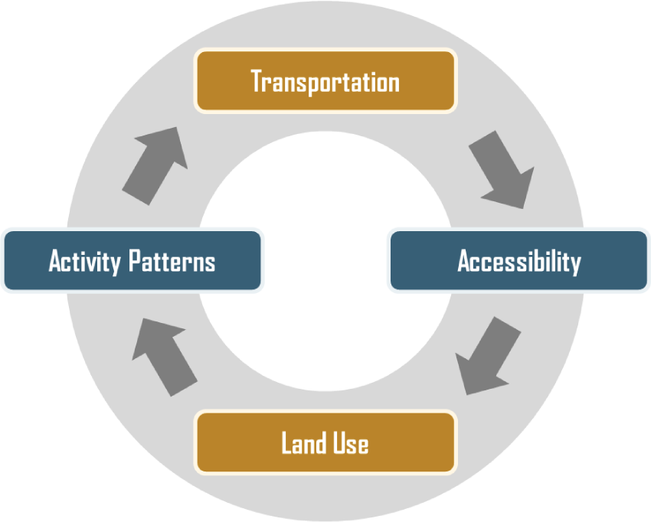

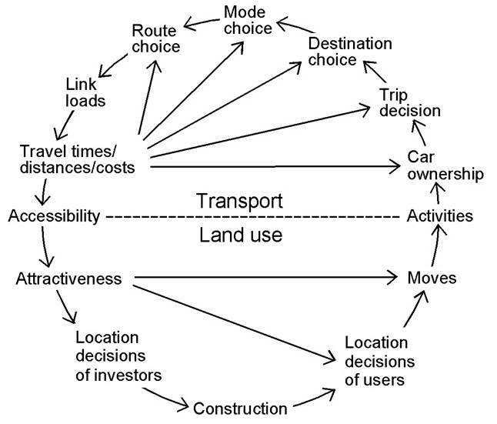

CE 6006 TRAFFIC ENGINEERING AND MANAGEMENT
UNIT I TRAFFIC PLANNING AND CHARACTERISTICS
PART A (2 MARKS QUESTIONS WITH ANSWERS)
1. Define Traffic Engineering.
Traffic engineering is a branch of civil engineering that uses engineering techniques to achieve the safe and rapid, comfortable, convenient, economical, and environmentally compatible movement of people and goods on roadways.
2. What are all the disciplines closely associated with Traffic Engineering?
- Transport engineering
- Pavement engineering
- Bicycle transportation engineering
- Highway engineering
- Transportation planning
- Urban planning
- Human factors engineering
3. Write the objects of Traffic Engineering.
- To provide efficient flow of traffic
- To provide free flow of traffic
- To provide rapid flow of traffic
- To provide safety to the traffic
4. List the Scope of Traffic Engineering.
- Traffic characteristics
- Traffic operations
- Traffic planning
- Traffic geometrical design
- Traffic administration
5. Write the Significance of Traffic Engineering.
Transportation is an essential part of human activity and in many ways forms the basis of all socio-economic interactions. Indeed, no two locations will interact effectively without a viable means of movement. In many developing countries, inadequate transport facilities are often the norm rather than the exception. Thus, a good transport system is essential to support economic growth and development.
6. List the important Vehicle characteristics.
- Resistance to motion of a Vehicle
a) Rolling Resistance (Pf)
b) Air Resistance (Pa)
c) Grade Resistance (Pi)
d) Inertia forces during Acceleration and deceleration (Pj)
e) Transmission Losses
- Dimensions and Weight
- Turning capability
- Braking System
- Acceleration and Deceleration
7. What do you understand the term Resistance?
Resistance - the ability not to be affected by something, especially adversely.
8. What is Rolling Resistance?
Rolling resistance, sometimes called rolling friction or rolling drag, is the force resisting the motion when a body (such as a ball, tire, or wheel) rolls on a surface.
9. What is Air Resistance?
Air resistance is a force that is caused by air. The force acts in the opposite direction to an object moving through the air.
10. What is Grade Resistance?
The force, due to gravity, that resists the movement of a vehicle up a slope is called Grade Resistance.
11. Define Inertia.
Inertia is the resistance of any physical object to any change in its state of motion, including changes to its speed and direction. It is the tendency of objects to keep moving in a straight line at constant velocity.
12. What is meant by Road User?
Road users can be defined as drivers, passengers, pedestrians etc., who use the streets and highways.
13. What is Perception?
Perception is the process of perceiving the sensations received through the sense organs, nerves and brains. It is actually the recognitions that a stimulus on which a reaction is to happen exists.
14. What is Intellection?
Intellection involves the identification and understanding of stimuli.
15. Differentiate between Emotion and Volition.
Emotion | Volition
This stage involves the judgment of the appropriate response to be made on the stimuli like to stop, pass, move laterally etc. | Volition is the execution of the decision which is the result of physical actions of the driver.

16. Write PIEV Theory.

17. What is Visual Acuity?
Visual acuity relates to the field of clearest vision. The most acute vision is within a cone of 3 to 5 degrees, fairly clear vision within 10 to 12 degrees and the peripheral vision will be within 120 to 180 degrees.
18. Define the term - Glare recovery time.
Glare recovery time is the time required to recover from the effect of glare after the light source is passed, and will be higher for elderly persons.
- Define Traffic Flow.
In mathematics and civil engineering, traffic flow is the study of interactions between vehicles, drivers, and infrastructure (including highways, signage, and traffic control devices), with the aim of understanding and developing an optimal road network with efficient movement of traffic and minimal traffic congestion problems.

- List the major Traffic stream parameters.
- Speed
- Spot Speed
- Running speed
- Journey speed
- Time mean speed and space mean speed
- Flow
- Volume
- Density
- Define Density.
Density is defined as the number of vehicles occupying a given length of highway or lane and is generally expressed as vehicles per km. One can photograph a length of road x, count the number of vehicles, n_{x}, in one lane of the road at that point of time and derive the density k as,
- Define Time headway
The microscopic character related to volume is the time headway or simply headway. Time headway is defined as the time difference between any two successive vehicles when they cross a given point.
- What is Distance headway?
It is defined as the distance between corresponding points of two successive vehicles at any given time.
Where, the density (k) is the number of vehicles n_{x} at a distance of x, that is
Where, s_{av} is average distance headway. The average distance headway is the inverse of density and is sometimes called as spacing.
- What is Travel time?
Travel time is defined as the time taken to complete a journey. As the speed increases, travel time required to reach the destination also decreases and vice-versa.
- Draw the Speed Flow Diagram.
- Draw the Speed-density diagram.

- List the urban traffic problems in India.
a) Road congestion
b) Parking problems
c) Air pollution
d) Deteriorating road safety
- Define Modal share.
A Modal share (also called mode split, mode-share, or modal split) is the percentage of travellers using a particular type of transportation or number of trips using said type. In freight transportation, this may be measured in mass.
- What is Sustainability?
Sustainability is the ability to withstand the systems and processes in all situations.
30. List the components of Traffic Engineering.
- Road,
- Traffic and
- Land Use Characteristics
31. Define Road.
A road is a route, or way on land between two places that has been paved or otherwise improved to allow travel by some conveyance, including a horse, cart, bicycle, or motor vehicle etc.,
32. What is Highway?
A highway is any public road or other public way on land. It is used for major roads, but also includes other public roads and public tracks.
33. What do you understand the term traffic?
Traffic on roads may consist of pedestrians, ridden or herded animals, vehicles, streetcars, buses and other conveyances, either singly or together, while using the public way for purposes of travel.
34. Write note on Land Use.
Land use is the human use of land. Land use involves the management and modification of natural environment into built environment such as settlements and semi-natural habitats etc.,
35. Define Land Use Planning.
Land-use planning is the general term used for a branch of urban planning encompassing various disciplines which seek to order and regulate land use in an efficient and ethical way, thus preventing land-use conflicts.
36. Draw the Land Use Transport Interaction diagram.

