CE 6006 TRAFFIC ENGINEERING AND MANAGEMENT
UNIT II
TRAFFIC SURVEYS
Traffic Surveys – Speed, journey time and delay surveys – Vehicles Volume Survey including non-motorized transports – Methods and interpretation – Origin Destination Survey – Methods and presentation – Parking Survey – Accident analyses -Methods, interpretation and presentation – Statistical applications in traffic studies and traffic forecasting – Level of service – Concept, applications and significance.
1. What is traffic survey? List the types of traffic surveys.

TRAFFIC SURVEYS:
Traffic Surveys and Analysis is concerned with the collection and analysis of traffic data for the purpose of traffic management and traffic control within a network.
It provides guidance on the different types of traffic surveys and surveys that can be undertaken, their use and application, and methods for traffic data collection and analysis.
Types of Traffic Survey
The following traffic surveys can be conducted for appreciating the existing traffic and travel demand characteristics and to prepare the transport infrastructure improvement plans.
1. Road inventory survey
2. Classified traffic volume count survey
3. Origin and destination survey
4. Household interview survey
5. Speed and delay
6. Parking survey
7. Pedestrian survey
8. Intermediate public transport operator survey
9. Intermediate public transport user survey
2. Explain in detail about volume count survey.

VOLUME COUNT SURVEY:
One of the fundamental measures of traffic on a road system is the volume of traffic using the road in a given interval of time. This is also called the flow and is expressed in vehicle per hour or vehicles per day.
The flow is then expressed as PCUs per hour or PCU’s per day. This means that the vehicle count needs to be called by considering their class & type.
Volume Count Survey is conducted to understand the traffic characteristics in term of average daily traffic, traffic composition, peak hour traffic and directional split at individual survey locations. This survey is carried out result for many types of Highways projects to understand the variety of vehicles that passes over 24 hours a day.
Types of Traffic Counts:
It is essential to know the magnitude of traffic data required or to be collected, which will then determine its quality and type of vehicle classification to be adopted. Traffic counting falls in two main categories, namely; manual counts and automatic counts. There is no distinct difference between the two methods however; the economic use or selection of an appropriate method of traffic counting is a function of the level of traffic flow and the required data quality.
- Manual Counts
The most common method of collecting traffic flow data is the manual method, which consists of assigning a person to record traffic as it passes. This method of data collection can be expensive in terms of manpower, but it is nonetheless necessary in most cases where vehicles are to be classified with a number of movements recorded separately, such as at intersections.
At intersection sites, the traffic on each arm should be counted and recorded separately for each movement. It is of paramount importance that traffic on roads with more than one lane are counted and classified by direction of traffic flow.
Permanent traffic-counting teams are normally set up to carry out the counting at the various locations throughout the road network at set interval. The duration of the count is determined prior to commencement of traffic counting and it is dictated by the end use of data. The teams are managed and supervised by the technical staff to ensure efficient and proper collection of data.
Manual Count Recording Methods
Manual counts are recorded using one of three methods: tally sheets, mechanical counting boards, or electronic counting boards.
- Tally Sheets
Recording data onto tally sheets is the simplest means of conducting manual counts. The data can be recorded with a tick mark on a pre-prepared field form. A watch or stopwatch is necessary to measure the desired count interval.
- Mechanical Counting Boards
Mechanical count boards consist of counters mounted on a board that record each direction of travel. Common counts include pedestrian, bicycle, vehicle classification, and traffic volume counts.
Typical counters are push button devices with three to five registers. Each button represents a different stratification of type of vehicle or pedestrian being counted. The limited number of buttons on the counter can restrict the number of classifications that can be counted on a given board. A watch or a stopwatch is also necessary with this method to measure the desired count interval.
- Electronic Counting Boards
Electronic counting boards are battery-operated, hand-held devices used in collecting traffic count data. They are similar to mechanical counting boards, but with some important differences. Electronic counting boards are lighter, more compact, and easier to handle. They have an internal clock that automatically separates the data by time interval. Special functions include automatic data reduction and summary. The data can also be downloaded to a computer, which saves time.
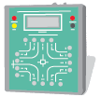

- Automatic Counts
The detection of vehicular presence and road occupancies has historically been performed primarily on or near the surface of the road. The exploitation of new electromagnetic spectra and wireless communication media in recent year, has allowed traffic detection to occur in a non-intrusive fashion, at locations above or to the side of the roadway. Pavement-based traffic detection currently relatively inexpensive will be met with fierce competition in the coming years from detectors that are liberated from the road surface.
Automatic Count Recording Methods
The most commonly used detector types are:
i) Pneumatic tubes (Portable Counters)
ii) Inductive loops
iii) Weigh-in-Motion Sensor types
iv) Micro-millimetre wave Radar detectors
v) Video Camera
i) Portable Counters
Portable counting is a form of manual observation. Portable counters serve the same purpose as manual counts but with automatic counting equipment. The period of data collection using this method is usually longer than when using manual counts. The portable counter method is mainly used for 24-hour counts. Pneumatic road tubes are used to conduct this method of automatic counts. Specific information pertaining to pneumatic road tubes can be found in the users’ manual.
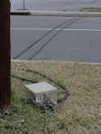

ii) Inductive loops
An induction or inductive loop is an electromagnetic communication or detection system which uses a moving magnet to induce an electrical current in a nearby wire. Induction loops are used for transmission and reception of communication signals, or for detection of metal objects in metal detectors or vehicle presence indicators.
iii) Permanent Counters
Permanent counters are used when long-term counts are to be conducted. The counts could be performed every day for a year or more. The data collected may be used to monitor and evaluate traffic volumes and trends over a long period of time. Permanent counters are not a cost-effective option in most situations. Few jurisdictions have access to this equipment.
iv) Videotape
Observers can record count data by videotaping traffic. Traffic volumes can be counted by viewing videotapes recorded with a camera at a collection site. A digital clock in the video image can prove useful in noting time intervals. Videotaping is not a cost-effective option in most situations. Few small jurisdictions have access to this equipment.
Variations of Volume
The variation of volume with time, i.e. month to month, day to day, and hour to hour and within a hour is also as important as volume calculation. Volume variations can be observed from season to season. Volume will be above average in a pleasant motoring month of summer, but will be more pronounced in rural than in urban area. But this is the most consistent of all the variations and affects the traffic stream characteristics the least. Weekdays, Saturdays and Sundays will also face difference in pattern. But comparing day with day, patterns for routes of a similar nature often show a marked similarity, which is useful in enabling predictions to be made. The most significant variation is from hour to hour. The peak hour observed during mornings and evenings of weekdays, which is usually 8 to 10 per cent of total daily flow or 2 to 3 times the average hourly volume. These trips are mainly the work trips, which are relatively stable with time and more or less constant from day to day.

Types of Volume Measurements:
Since there is considerable variation in the volume of traffic, several types of measurements of volume are commonly adopted which will average these variations into a single volume count to be used in many design purposes.
1. Average Annual Daily Traffic (AADT): The average 24-hour traffic volume at a given location over a full 365-day year, i.e. the total number of vehicles passing the site in a year divided by 365.
2. Average Annual Weekday Traffic (AAWT): The average 24-hour traffic volume occurring on week- days over a full year. It is computed by dividing the total weekday traffic volume for the year by 260.
3. Average Daily Traffic (ADT): An average 24-hour traffic volume at a given location for some period of time less than a year. It may be measured for six months, a season, a month, a week, or as little as two days. An ADT is a valid number only for the period over which it was measured.
4. Average Weekday Traffic (AWT): An average 24-hour traffic volume occurring on weekdays for some period of time less than one year, such as for a month or a season.
The relationship between AAWT and AWT is analogous to that between AADT and ADT. Volume in general is measured using different ways like manual counting, detector/sensor counting, moving-car observer method, etc. Mainly the volume study establishes the importance of a particular route with respect to the other routes, the distribution of traffic on road, and the fluctuations in flow. All which eventually determines the design of a highway and the related facilities. Thus, volume is treated as the most important of all the parameters of traffic stream.
4. DESCRIBE BRIEFLY ABOUT SPEED.

SPEED AND DELAYS
Speed is an important measure of the quality of travel and safety of road network. Speed by definition rate of movement of vehicle in distance per unit time. A typical unit of speed is kilometer per hour (KMPH) or miles per hour (mph)
Mathematically speed or velocity v is given by,
v = d / t
Where, v is the speed of the vehicle in m/s, d is distance travelled in m in time t seconds.
Speed of different vehicles will vary with respect to time and space. To represent this variation, several types of speed can be defined. Important among them are spot speed, running speed, journey speed, time mean speed and space mean speed.
Spot Speed
Spot speed is the instantaneous speed of a vehicle at a specified location. Spot speed can be used to design the geometry of road like horizontal and vertical curves, super elevation etc. Location and size of signs, design of signals, safe speed, and speed zone determination, require the spot speed data. Accident analysis, road maintenance, and congestion are the modern fields of traffic engineer, which uses spot speed data as the basic input. Spot speed can be measured using an enoscope, pressure contact tubes or direct timing procedure or radar speedometer or by time-lapse photographic methods. It can be determined by speeds extracted from video images by recording the distance travelling by all vehicles between a particular pair of frames.
Running speed
Running speed is the average speed maintained over a particular course while the vehicle is moving and is found by dividing the length of the course by the time duration the vehicle was in motion.
Running Speed = Length of course/ Running Time
= Length of course / (Journey time - delay)
Journey speed
Journey speed is the effective speed of the vehicle on a journey between two points and is the distance between the two points divided by the total time taken for the vehicle to complete the journey including any stopped time. If the journey speed is less than running speed, it indicates that the journey follows a stop-go condition with enforced acceleration and deceleration. The spot speed here may vary from zero to some maximum in excess of the running speed. Uniformity between journey and running speeds denotes comfortable travel conditions.

Journey Speed = Distance / Total Journey Time (Including Delays)

Time Mean Speed and Space Mean Speed:
Time mean speed is defined as the average speed of all the vehicles passing a point on a highway over some specified time period. Space mean speed is defined as the average speed of all the vehicles occupying a given section of a highway over some specified time period. Both mean speeds will always be different from each other except in the unlikely event that all vehicles are travelling at the same speed. Time mean speed is a point measurement while space mean speed is a measure relating to length of highway or lane, i.e. the mean speed of vehicles over a period of time at a point in space is time mean speed and the mean speed over a space at a given instant is the space mean speed.

Flow
There are practically two ways of counting the number of vehicles on a road. One is flow or volume, which is defined as the number of vehicles that pass a point on a highway or a given lane or direction of a highway during a specific time interval. The measurement is carried out by counting the number of vehicles, n_{t}, passing a particular point in one lane in a defined period t. Then the flow q expressed in vehicles/hour is given by
q = n_{t}/t
Flow is expressed in planning and design field taking a day as the measurement of time.

Methods of measuring Spot Speed
The methods available for measuring spot speeds can be grouped as under:
- Those that requires observation of the time taken by a vehicle to cover a known distance.
- Those in which vehicles are timed over a long distance (long base)
- Direct timing Procedure
- Enoscope
- Pressure contact tube
- Those in which vehicles are timed over a short distance (short base)
- Radar speed meter which automatically records the instaneous speed.
- Photographic method.

Guidelines for Selecting the Site of the Survey:
- The location at which measurements are taken is governed by the specific purpose for which the data are required. For example, if the data is likely to be used to analyse the accident pattern, the survey will be needed at high accident frequency locations.
- The site selected should reduce to a minimum the influence of the study team and equipment upon the vehicle speeds. For this purpose, the study team and the equipment should be located as inconspicuously as possible.
- Generally straight, level and open sections of highways should be selected so as to minimise the influence of geometric features of the highways, road – side development and intersections.

Recommended Base Lengths
Average Speed of Traffic Stream (KMPH) | Base Length (m)
Less than 40 | 27
40 to 65 | 54
Greater than 65 | 81

Spot Speed Studies
When we measure the traffic parameter over a short distance, we generally measure the spot speed. A spot speed is made by measuring the individual speeds of a sample of the vehicle passing a given spot on a street or highway. Spot speed studies are used to determine the speed distribution of a traffic stream at a specific location. The data gathered in spot speed studies are used to determine vehicle speed percentiles, which are useful in making many speed-related decisions. Spot speed data have a number of safety applications, including the following,
1. Speed trends,
2. Traffic control planning,
3. Accidental analysis,
4. Geometric design,
5. Research studies.

Methods of Measurement
Methods of conducting spot speed Studies are divided into two main categories: Manual and Automatic. Spot speeds may be estimated by manually measuring the time it takes a vehicle to travel between two defined points on the roadway a known distance apart (short distance), usually less than 90m. Distance between two points is generally depending upon the average speed of traffic stream. Following tables gives recommended study length (in meters) for various average stream speed ranges (in kmph). Following are the some methods to measure spot speed of vehicles in a traffic stream, in which first two are manual methods and other are automatic.
- Pavement Markings
In this method, markings of pavement are placed across the road at each end of trap. Observer start and stops the watch as vehicle passes lines. In this method, minimum two observers required to collect the data, of which one is stand at the starting point to start and stop the stop watch and other one is stand at end point to give indication to stop the watch when vehicle passes the end line. Advantages of this method are that after the initial installation no set-up time is required, markings are easily renewed, and disadvantage of this is that substantial error can be introduced, and magnitude of error may change for substitute studies and this method is only applicable for low traffic conditions.
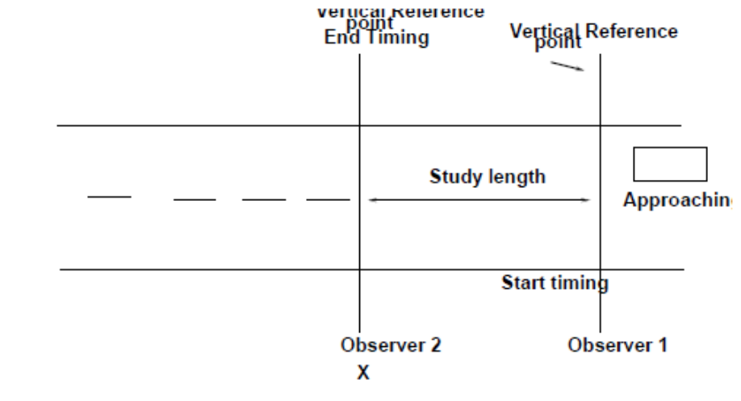
- Enoscope or Mirror box
Enoscope consists of a simple open housing containing a mirror mounted on a tripod at the side of the road in such a way that an observer’s line of sight turned through 90o. The observer stands at one end of section and on the other end enoscope is placed and measure the time taken by the vehicle to cross the section (fig 6.2). Advantages of this method are that it simple and eliminate the errors due to parallax and considerable time is required to time each vehicle, in which lengthen the study period and under heavy traffic condition it may be difficult to relate ostentatious to proper vehicle are the disadvantages of enoscope method.
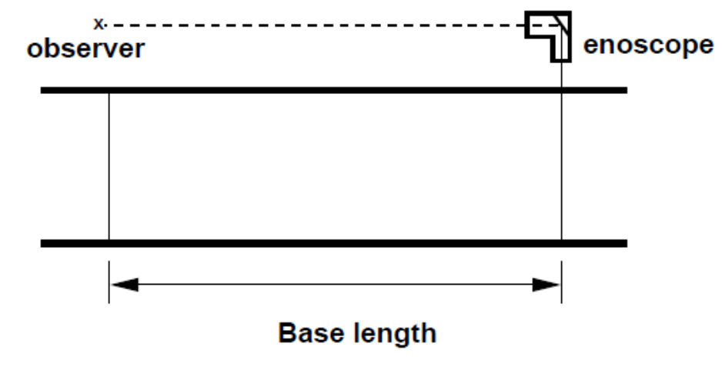
- Road Detector (Pressure contact strips)
Pressure contact strips, either pneumatic or electric, can be used to avoid error due to parallax and due to manually starting and stopping the chronometer or stopwatch. This is the best method over short distance it gives quite relevant data and if it is connected through graphical recorder then it gives continuous data automatically.

- Doppler-Principle Meters (Radar)
This is recently developed method, it automatically records speed, employs a radar transmitter- receiver unit. The apparatus transmits high frequency electromagnetic waves in a narrow beam towards the moving vehicle, and reflected waves changed their length depending up on the vehicles speed and returned to the receiving unit, through calibration gives directly spot speed of the vehicle.

- Electronic-Principle Detectors (Photography)
In this method a camera records the distance moved by a vehicle in a selected short time. In this exposure of photograph should be in a constant time interval and the distance travelled by the vehicle is measured by projecting the films during the exposure interval. The main advantage of method that, it gives a permanent record with 100% sample obtained. This method is quite expensive and generally used in developed cities. In this we can use video recorder which give more accurate result.

5. WRITE IN DETAIL ABOUT DELAY.

DELAY
Delay is a measure that most directly relates driver’s experience and it is measure of excess time consumed in traversing the intersection.
The most common measure of operational quality is delay, although queue length is often used as a secondary measure. While it is possible to measure delay in the field, it is a difficult process, and different observers may make judgments that could yield different results. For many purposes, it is, therefore, convenient to have a predictive model for the estimate of delay. Delay, however, can be quantified in many different ways. The most frequently used forms of delay are defined as follows:
- Stopped time delay
- Approach delay
- Travel time delay
- Time-in-queue delay
- Control delay
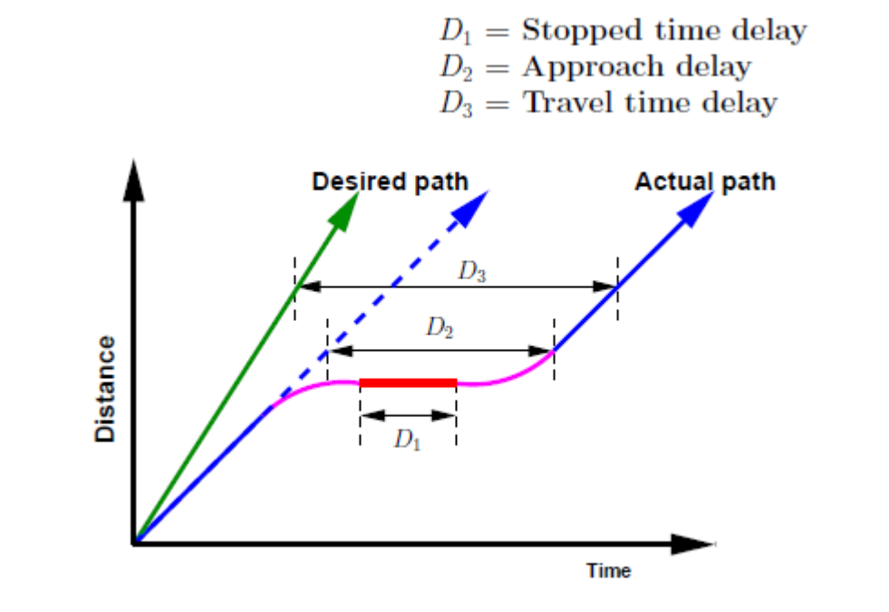
- Stopped Time Delay
Stopped-time delay is defined as the time a vehicle is stopped in queue while waiting to pass through the intersection. It begins when the vehicle is fully stopped and ends when the vehicle begins to accelerate. Average stopped-time delay is the average for all vehicles during a specified time period.
- Approach Delay
Approach delay includes stopped-time delay but adds the time loss due to deceleration from the approach speed to a stop and the time loss due to re-acceleration back to the desired speed. It is found by extending the velocity slope of the approaching vehicle as if no signal existed. Approach delay is the horizontal (time) difference between the hypothetical extension of the approaching velocity slope and the departure slope after full acceleration is achieved. Average approach delay is the average for all vehicles during a specified time period.
- Travel Time Delay
It is the difference between the drivers expected travel time through the intersection (or any roadway segment) and the actual time taken. To find the desired travel time to traverse an intersection is very difficult. So this delay concept is rarely used except in some planning studies.
- Time-in-queue Delay
Time-in-queue delay is the total time from a vehicle joining an intersection queue to its discharge across the STOP line on departure. Average time-in-queue delay is the average for all vehicles during a specified time period. Time-in-queue delay cannot be effectively shown using one vehicle, as it involves joining and departing a queue of several vehicles.

- Control Delay
Control delay is the delay caused by a control device, either a traffic signal or a STOP-sign. It is approximately equal to time-in-queue delay plus the acceleration-deceleration delay component. Delay measures can be stated for a single vehicle, as an average for all vehicles over a specified time period, or as an aggregate total value for all vehicles over a specified time period. Aggregate delay is measured in total vehicle-seconds, vehicle-minutes, or vehicle-hours for all vehicles in the specified time interval. Average individual delay is generally stated in terms of seconds per vehicle for a specified time interval.

Procedure for Calculating Delay time
Delays occurring due to stopping can be conveniently recorded by separate stop – watch. Special watches which can accumulate the delay times as the observer operates buttons will be found convenient for this purpose. The delays that can be measured thus are stopped delays or fixed delays which occur at intersections, railway crossing and stop signs.
In addition to stopped delays, there can be delays caused by the interaction of various factors such as congestion, inadequacy of carriageway widths, mixed traffic conditions, parked cars and heavy pedestrian flow. This kind of delay is called congestion delay or operational delay and is rather difficult to measure precisely.
One method of measuring congestion delay is to determine the average running speed when the traffic conditions are free- moving and vehicles are free to move without any hindrance. The difference between this speed and the actual speed under congested conditions gives an idea of the congestion delay.
Managing travel speeds is a core part of an efficient and safe road transport system. Speed management involves consideration of travel times, safety, fuel use and other environmental issues.
Highway improvements result in speeding up traffic and reducing jamming. Speed and delay studies on the existing facility provide the basis for estimating the causative problems and benefits of the improved facility. The study is conveniently conducted by the "Moving Observer" method.

Moving Observer Method
Consider a stream of vehicles moving in the north bound direction. Two different cases of motion can be considered. The first case considers the traffic stream to be moving and the observer to be stationary.
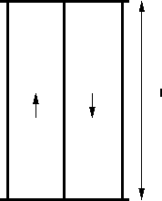
If is the number of vehicles overtaking the observer during a period, , then flow is , or

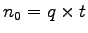 | (1)
The second case assumes that the stream is stationary and the observer moves with speed. If is the number of vehicles overtaken by observer over a length, then by definition, density is , or
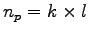 | (2)
Or
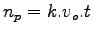 | (3)
Where the speed of the observer and t is is the time taken for the observer to cover the road stretch. Now consider the case when the observer is moving within the stream. In that case vehicles will overtake the observer and vehicles will be overtaken by the observer in the test vehicle. Let the difference is given by m₀ - m_{p}, then from equation 1 and equation 3,

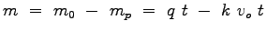 | (4)
This equation is the basic equation of moving observer method, which relates 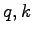 to the counts, and that can be obtained from the test. However, we have two unknowns, and, but only one equation. For generating another equation, the test vehicle is run twice once with the traffic stream and another one against traffic stream, i.e.,
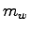 |  | 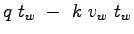 | (5)
 | = | 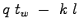
 | = | 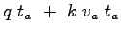 | (6)
 | = | 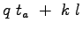
Where, 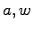 denotes against and with traffic flow. It may be noted that the sign of equation 6 is negative, because test vehicle moving in the opposite direction can be considered as a case when the test vehicle is moving in the stream with negative velocity. Further, in this case, all the vehicles will be overtaking, since it is moving with negative speed. In other words, when the test vehicle moves in the opposite direction, the observer simply counts the number of vehicles in the opposite direction. Adding equation 5 and 6, we will get the first parameter of the stream, namely the flow (q) as:
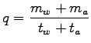 | (7)
Now calculating space mean speed from equation 5,
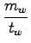 | = | 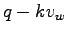
 | = | 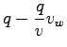
 | = | 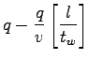
 | = | 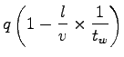
 | = | 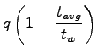
If is the mean stream speed, then average travel time is given by 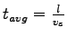. Therefore,
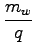 | = | 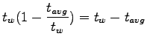
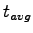 | = | 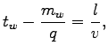
Rewriting the above equation, we get the second parameter of the traffic flow, namely the mean speed and can be written as,
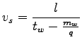 | (8)
Thus two parameters of the stream can be determined. Knowing the two parameters the third parameter of traffic flow density can be found out as
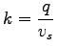 | (9)
For increase accuracy and reliability, the test is performed a number of times and the average results are to be taken.
6. BRIEFLY EXPLAIN THE TERM ORIGIN – DESTINATION WITH IT TYPES AND USES.

ORIGIN-DESTINATION
An origin-destination study is used to determine travel patterns of traffic on an installation during a typical day. They are useful in assisting long-range traffic planning, especially when there are substantial changes anticipated in the installation mission or strength.
This is a study to determine and analyze trips. Trips are defined as one-way movement, from where a person starts (origin) to where the person is going (destination). Trips are further classified as follows:
- Internal--From one point on post to another point on post.
- External--From on-post to off-post or vice versa.
Through--From off-post to off-post, by going through the installation
There are five methods by which an origin-destination study can be made. These are:
1. Registration Questionnaire--Driver lists are obtained from the vehicle registration form and each is sent a questionnaire at his place of duty with a return date requested.
2. Post Card--A prepaid post card with the questionnaire on it is distributed to all drivers entering the installation during a given time. A traffic volume count is made at the time the cards are distributed.
3. Roadside Interview--This method requires advance publicity and a greater number of personnel. Uniformed MPs should conduct the interview. Considerations should include:
- Interview 50 percent of vehicles during non peak hours.
- Interview 25 percent of drivers during peak hours.
- Insure stations are visible and safe. One interview should not take more than 40 seconds, and there should not be more than five (5) interviewers in a file (one lane).
- Approximately 300 drivers can be interviewed per hour. Stations do not have to be operated at the same time.
- A manual count of traffic is made by hour, direction and type of vehicle. By doing this the sample can be expanded into a 24-hour analysis.
4. Tag on Car--This is a limited study good for studying through trips. It is conducted by having all cars counted when they enter the installation. At stations just inside the entrance gates, MPs stop vehicles and affix a piece of colored tape (different for each station) to the car's front bumper. At exit gates of the installation, a tally of cars with each colored tape is made. It provides a rough estimate of through trips on the installation. It's necessary for each installation entrance and exit to be manned during this study.

5. Comprehensive Home Interview--This method is performed by other governmental organizations. It is not normally done on a military installation unless it is near a large city that is under review. It provides the most detailed data.
Origin-destination studies may be augmented with the following studies:
Land Use Study--This study of an installation and the surrounding area concerns residential, industrial, commercial and recreational land use. See AR 210-20 for more information.
Growth Trends Study--This study concerns trends in population, land use and highway travel. It is made in conjunction with planning agencies, utility companies and highway officials. Population trends are classified as military/civilian office workers, civilian maintenance, contractors, hospital personnel, service personnel and visitors.
Off-Post Route Improvements--Studies of new routes or changes in routes off post by local officials should be considered.
Uses
- Information from these studies can be used to anticipate present and future traffic patterns, especially the demand to be placed on the road network in the future. When compiling data the percentage of interviewed should be converted to represent a 24-hour day. The studies provide information concerning:
- The number of trips into, within, and through an installation; and time of day, mode of travel and number of occupants in a vehicle during a trip.
- Present travel patterns; areas that generate the most traffic; and efficiency of traffic lanes concerning flow and safety.
- Evaluation of the general road plan and present or foreseeable problems.
- Determining need for revised flow patterns, alternate routes, new streets and parking areas.
- Help determine parking patterns in major functional areas of the installation.
- Future travel patterns can be determined by being aware of future projects or changes. By anticipating changes, potential traffic problems can be avoided. This might include changes in population, new residential areas or service facilities.
- To determine the amount of by-passable traffic that enters a town, and thus establish the need for a bypass.
- To develop trip generation and trip distribution models in transport planning process.
- To determine the extent to which the present highway system is adequate and to plan for new facilities.
- To assess the adequacy of parking facilities and to plan for future.

Methods and presentation of O-D Survey Results
O-D surveys yield a vast amount of data. To understand them, it is necessary to present them in convenient tabular or pictorial form.
The most convenient form is an O-D matrix, in which the origin zones and destination zones are represented. The horizontal axis of the matrix represents zones and the vertical axis of the matrix represents the origin zones. The zones may be further classified into internal and external zones if the survey covers both the internal and external zones. The numbers of trips are entered in the cells of the matrix. The matrix is represented in the below figure.
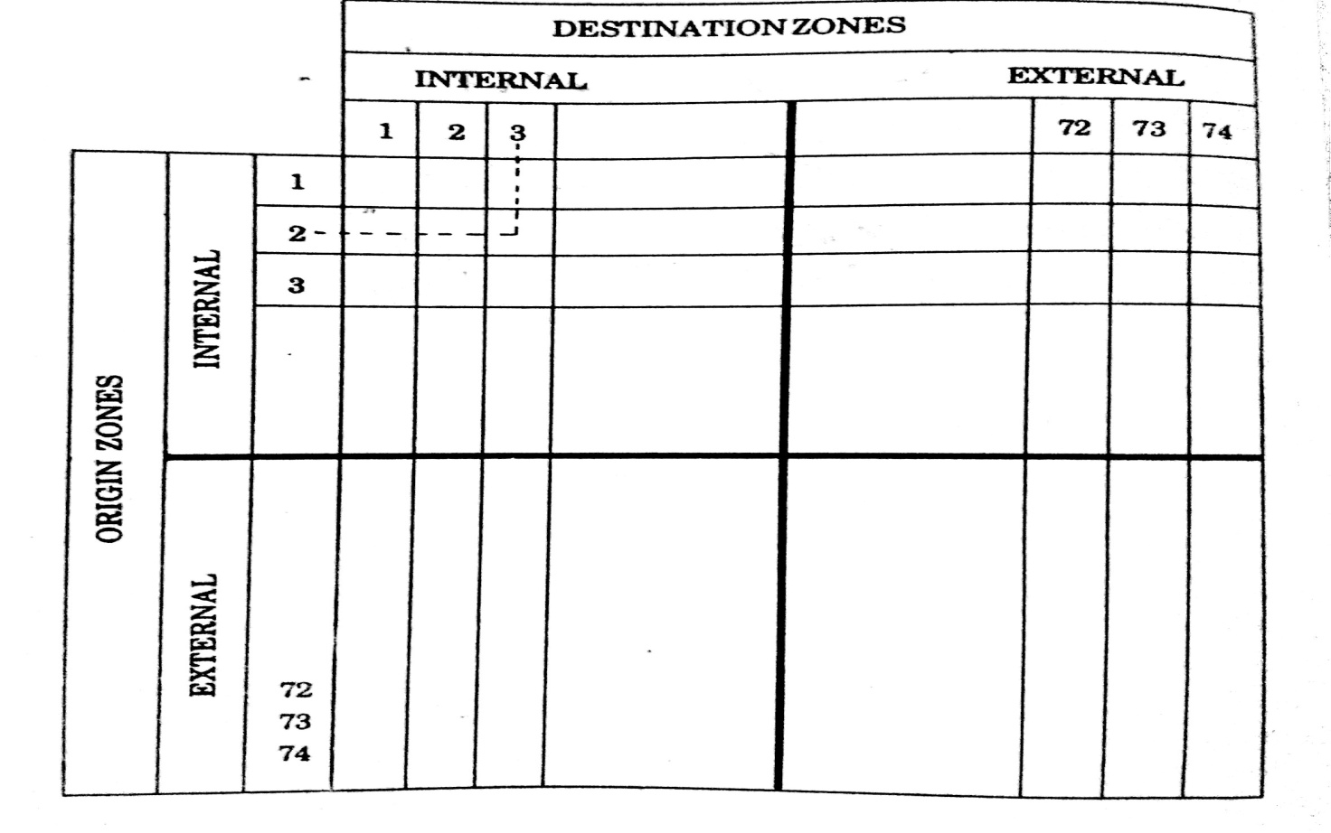
The most popular pictorial representation is by means of a desire line chart. In this chart, the trips between any pair of zones are represented by straight line connecting the centroids of the two zones and having a band width drawn to a suitable scale to represent the actual volume of trips. A typical desire line chart is given in the following figure.
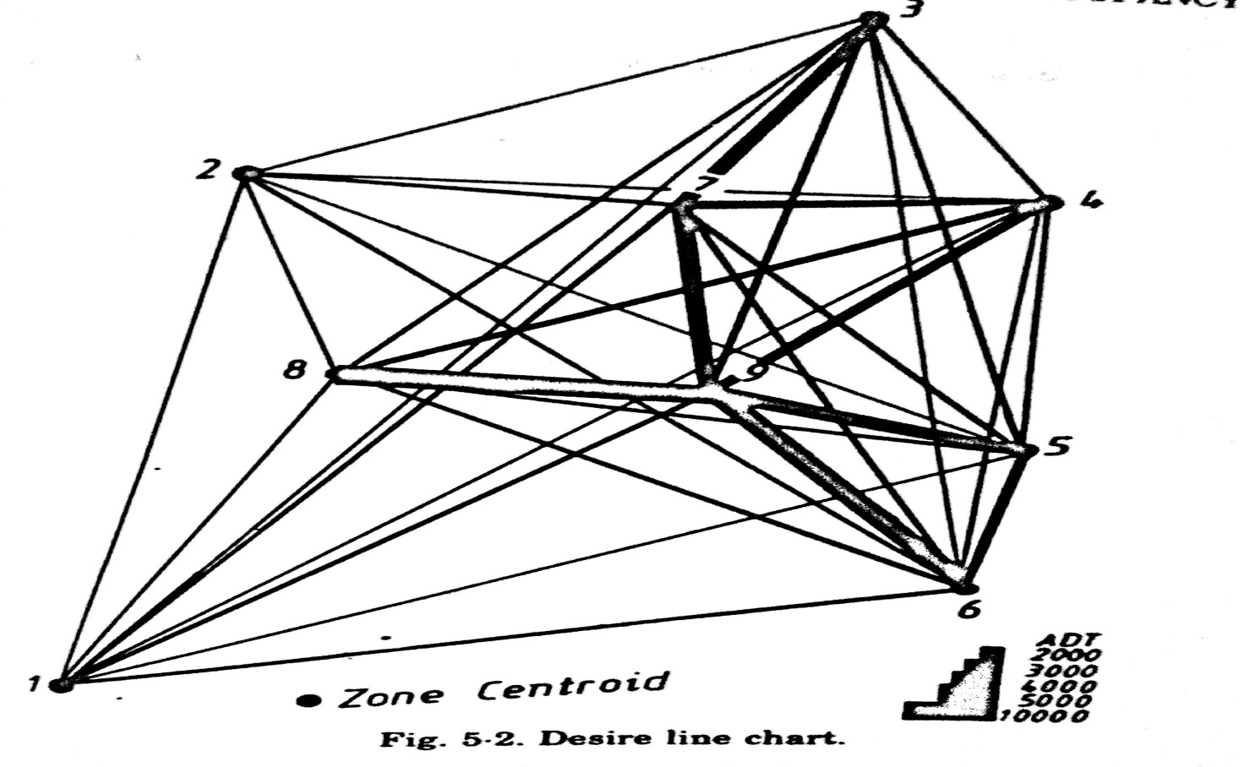

7. WHAT YOU UNDERSTAND THE TERM PARKING? EXPLAIN ITS TYES WITH NECESSARY SKETCHES.

PARKING:
Parking is the act or practice of temporarily leaving a vehicle or managing a vehicle into a certain location.
Parking is one of the major problems that is created by the increasing road traffic. It is an impact of transport development. The availability of less space in urban areas has increased the demand for parking space especially in areas like Central business district. This affects the mode choice also. This has a great economical impact.
Parking System
On street parking
On street parking means the vehicles are parked on the sides of the street itself. This will be usually controlled by government agencies itself. Common types of on-street parking are as listed below. This classification is based on the angle in which the vehicles are parked with respect to the road alignment. As per IRC the standard dimensions of a car is taken as 5× 2.5 meters and that for a truck is 3.75× 7.5 meters.
1. Parallel parking: The vehicles are parked along the length of the road. Here there is no backward movement involved while parking or unparking the vehicle. Hence, it is the safest parking from the accident perspective. However, it consumes the maximum curb length and therefore only a minimum number of vehicles can be parked for a given kerb length. This method of parking produces least obstruction to the on-going traffic on the road since least road width is used. The length available to park N number of vehicles, L = 5.9
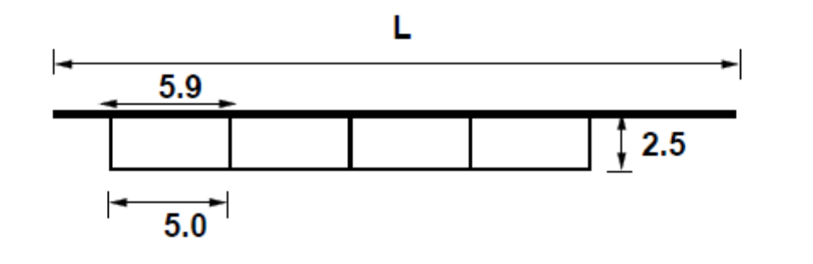
2. 30⁰ parking: In 30⁰ degree parking, the vehicles are parked at 30⁰ with respect to the road alignment. In this case, more vehicles can be parked compared to parallel parking. Also there is better maneuverability. Delay caused by the traffic is also minimum in this type of parking. From the figure,
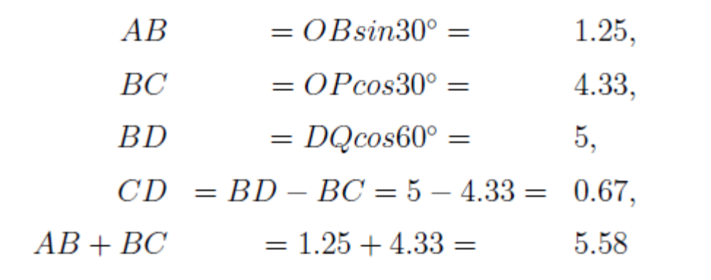
For N vehicles, L = AC + (N-1) CE =5.58+(N-1)5 =0.58+5N
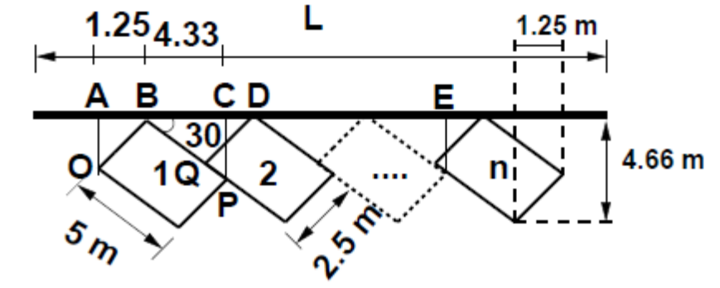
3. 45 ◦ parking: As the angle of parking increases, more number of vehicles can be parked. Hence compared to parallel parking and thirty degree parking, more number of vehicles can be accommodated in this type of parking. From figure 41:3, length of parking space available for parking N number of vehicles in a given kerb is L = 3.54 N+1.77
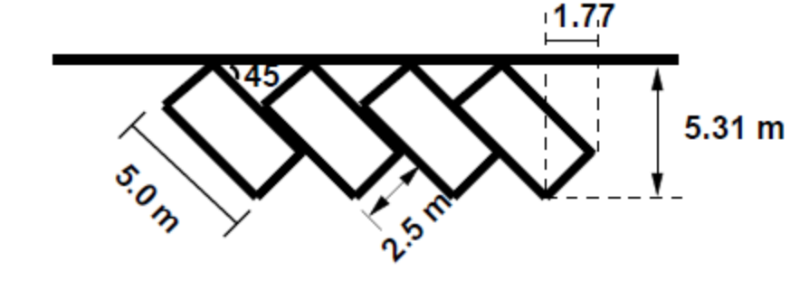
4. 60 ◦ parking: The vehicles are parked at 60 ◦ to the direction of road. More number of vehicles can be accommodated in this parking type. From the figure 41:4, length available for parking N vehicles =2.89N+2.16.
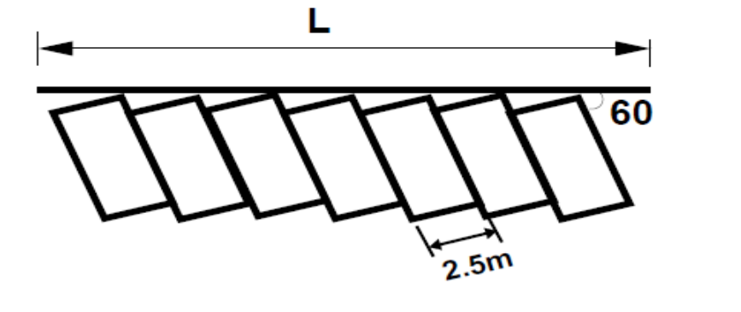
5. Right angle parking: In right angle parking or 90 ◦ parking, the vehicles are parked perpendicular to the direction of the road. Although it consumes maximum width kerb length required is very little. In this type of parking, the vehicles need complex manoeuvring and this may cause severe accidents. This arrangement causes obstruction to the road traffic particularly if the road width is less. However, it can accommodate maximum number of vehicles for a given kerb length. Length available for parking N number of vehicles is L = 2.5N.
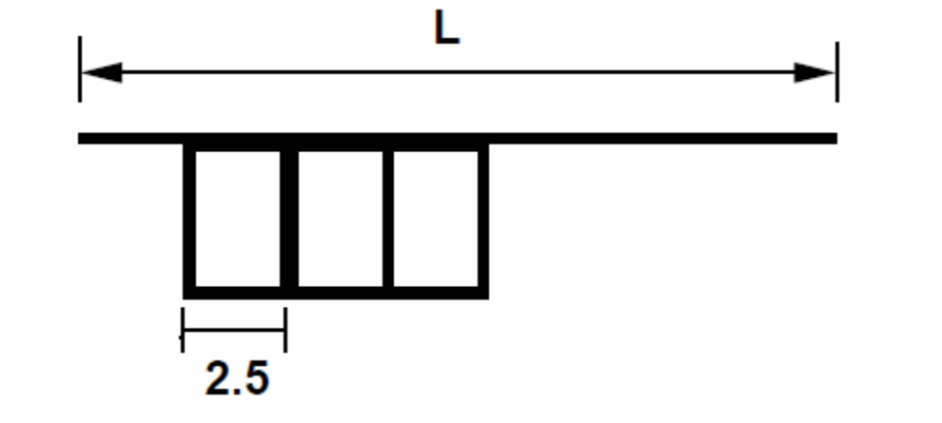
Off street parking
In many urban centres, some areas are exclusively allotted for parking which will be at some distance away from the main stream of traffic. Such a parking is referred to as off-street parking. They may be operated by either public agencies or private firms.
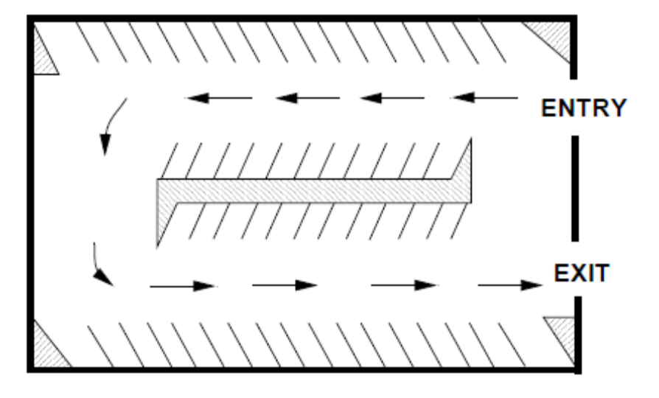
8. MAKE BRIEF NOTE ON PARKING REQUIREMENTS AND ILL EFFECTS WITH TECHNICAL TERMS.

Parking requirements
There are some minimum parking requirements for different types of building. For residential plot area less than 300 sq.m require only community parking space. For residential plot area from 500 to 1000 sq.m, minimum one-fourth of the open area should be reserved for parking. Offices may require at least one space for every 70 sq.m as parking area. One parking space is enough for 10 seats in a restaurant where as theaters and cinema halls need to keep only 1 parking space for 20 seats. Thus, the parking requirements are different for different land use zones.
Ill effects of parking
Parking has some ill-effects like congestion, accidents, pollution, obstruction to fire-fighting operations etc.
1. Congestion: Parking takes considerable street space leading to the lowering of the road capacity. Hence, speed will be reduced; journey time and delay will also subsequently increase. The operational cost of the vehicle increases leading to great economical loss to the community.
2. Accidents: Careless maneuvering of parking and unparking leads to accidents which are referred to as parking accidents. Common type of parking accidents occur while driving out a car from the parking area, careless opening of the doors of parked cars, and while bringing in the vehicle to the parking lot for parking.
3. Environmental pollution: They also cause pollution to the environment because stopping and starting of vehicles while parking and unparking results in noise and fumes. They also affect the aesthetic beauty of the buildings because cars parked at every available space create a feeling that building rises from a plinth of cars.
4. Obstruction to fire fighting operations: Parked vehicles may obstruct the movement of firefighting vehicles. Sometimes they block access to hydrants and access to buildings.
Parking statistics
Before taking any measures for the betterment of conditions, data regarding availability of parking space, extent of its usage and parking demand is essential. It is also required to estimate the parking fares also. Parking surveys are intended to provide all these information. Since the duration of parking varies with different vehicles, several statistics are used to access the parking need. The following parking statistics are normally important.
1. Parking accumulation: It is defined as the number of vehicles parked at a given instant of time. Normally this is expressed by accumulation curve. Accumulation curve is the graph obtained by plotting the number of bays occupied with respect to time.
2. Parking volume: Parking volume is the total number of vehicles parked at a given duration of time. This does not account for repetition of vehicles. The actual volume of vehicles entered in the area is recorded.
3. Parking load: Parking load gives the area under the accumulation curve. It can also be obtained by simply multiplying the number of vehicles occupying the parking area at each time interval with the time interval. It is expressed as vehicle hours.
4. Average parking duration: It is the ratio of total vehicle hours to the number of vehicles parked.
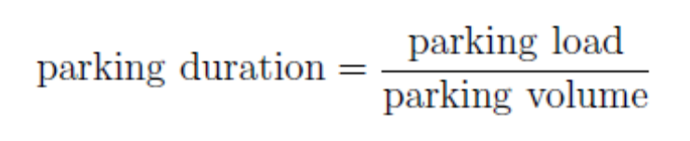
5. Parking turnover: It is the ratio of number of vehicles parked in duration to the number of parking bays available. This can be expressed as number of vehicles per bay per time duration.
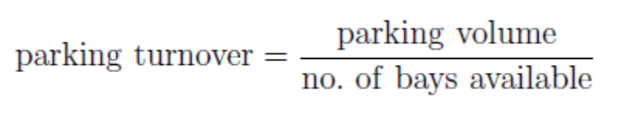
6. Parking index: Parking index is also called occupancy or efficiency. It is defined as the ratio of number of bays occupied in time duration to the total space available. It gives an aggregate measure of how effectively the parking space is utilized. Parking index can be found out as follows
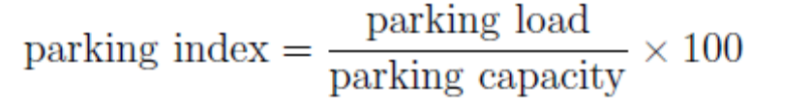

Parking Surveys
Parking surveys are conducted to collect the above said parking statistics. The most common parking surveys conducted is in-out survey, fixed period sampling and license plate method of survey.
In-Out survey
In this survey, the occupancy count in the selected parking lot is taken at the beginning. Then the number of vehicles that enter the parking lot for a particular time interval is counted. The number of vehicles that leave the parking lot is also taken. The final occupancy in the parking lot is also taken. Here the labor required is very less. Only one person may be enough. But we won’t get any data regarding the time duration for which a particular vehicle used that parking lot. Parking duration and turnover is not obtained. Hence we cannot estimate the parking fare from this survey. For quick survey purposes, a fixed period sampling can also be done. This is almost similar to in-out survey. All vehicles are counted at the beginning of the survey. Then after a fixed time interval that may vary between 15 minutes to i hour, the count is again taken. Here there are chances of missing the number of vehicles that were parked for a short duration.
License Plate Method Survey
This results the most accurate and realistic data. In this case of survey, every parking stall is monitored at a continuous interval of 15 minutes or so and the license plate number is noted down. This will give the data regarding the duration for which a particular vehicle was using the parking bay. This will help in calculating the fare because fare is estimated based on the duration for which the vehicle was parked. If the time interval is shorter, then there are less chances of missing short-term parkers. But this method is very labor intensive.

11. WHAT IS ACCIDENT STUDIES? WRITE IN DETAIL.

ACCIDENT STUDIES AND SAFETY
Accident is an unfortunate incident that happens unexpectedly and unintentionally, typically resulting in damage or injury.
The problem of accident is a very acute in highway transportation due to complex flow pattern of vehicular traffic, presence of mixed traffic along with pedestrians. Traffic accident leads to loss of life and property. Thus the traffic engineers have to undertake a big responsibility of providing safe traffic movements to the road users and ensure their safety. Road accidents cannot be totally prevented but by suitable traffic engineering and management the accident rate can be reduced to a certain extent. For this reason systematic study of traffic accidents are required to be carried out. Proper investigation of the cause of accident will help to propose preventive measures in terms of design and control.
Objectives of accident studies
1. To study the causes of accidents and suggest corrective measures at potential location
2. To evaluate existing design
3. To compute the financial losses incurred
4. To support the proposed design and provide economic justification to the improvement suggested by the traffic engineer
5. To carry out before and after studies and to demonstrate the improvement in the problem.
Causes of road accidents
The various causes of road accidents are:
1. Road Users - Excessive speed and rash driving, violation of traffic rules, failure to perceive traffic situation or sign or signal in adequate time, carelessness, fatigue, alcohol,sleep etc.
2. Vehicle - Defects such as failure of brakes, steering system, tyre burst,lighting system.
3. Road Condition - Skidding road surface, pot holes, ruts.
4. Road design - Defective geometric design like inadequate sight distance, inadequate width of shoulders, improper curve design, improper traffic control devices and improper lighting,.
5. Environmental factors -unfavorable weather conditions like mist, snow, smoke and heavy rainfall which restrict normal visibility and makes driving unsafe.
6. Other causes -improper location of advertisement boards, gate of level crossing not closed when required etc..
Accident Analysis
Accident data collection
The accident data collection is the first step in the accident study. The data collection of the accidents is primarily done by the police. Motorist accident reports are secondary data which are filed by motorists themselves. The data to be collected should comprise all of these parameters:
1. General - Date, time, and person involved in accident, classification of accident like fatal, serious, and minor
2. Location - Description and detail of location of accident
3. Details of vehicle involved - Registration number, description of vehicle, loading detail, vehicular defects
4. Nature of accident - Details of collision, damages, injury and casualty
5. Road and traffic condition - Details of road geometry, surface characteristics, type of traffic, traffic density etc..
6. Primary causes of accident - Details of various possible cases (already mentioned) which are the main causes of accident.
7. Accident cost - Financial losses incurred due to property damage, personal injury and casualty
These data collected need proper storing and retrieving for the following purpose. The purposes are as follows:
1. Identification of location of points at which unusually high number of accident occur.
2. Detailed functional evaluation of critical accident location to identify the causes of accidents.
3. Development of procedure that allows identification of hazards before large number of accidents occurs.
4. Development of different statistical measures of various accident related factors to give insight into general trends, common casual factors, driver profiles, etc.
Accident investigation
The accident data collection involves extensive investigation which involves the following procedure:
1. Reporting: It involves basic data collection in form of two methods:
(a) Motorist accident report - It is filed by the involved motorist involved in all accidents fatal or injurious.
(b) Police accident report - It is filed by the attendant police officer for all accidents at which an officer is present. This generally includes fatal accidents or mostly accidents involving serious injury required emergency or hospital treatment or which have incurred heavy property damage.
2. At Scene-Investigation: It involves obtaining information at scene such as measurement of skid marks, examination of damage of vehicles, photograph of final position of vehicles, examination of condition and functioning of traffic control devices and other road equipments.
3. Technical Preparation: This data collection step is needed for organization and interpretation of the study made. In this step measurement of grades, sight distance, preparing drawing of after accident situation, determination of critical and design speed for curves is done.
4. Professional Reconstruction: In this step effort is made to determine from whatever data is available how the accident occurs from the available data. This involves accident reconstruction which has been discussed under Section No.7 in details. It is professionally referred as determining behavioural or mediate causes of accident.
5. Cause Analysis: It is the effort made to determine why the accident occurred from the data available and the analysis of accident reconstruction studies..
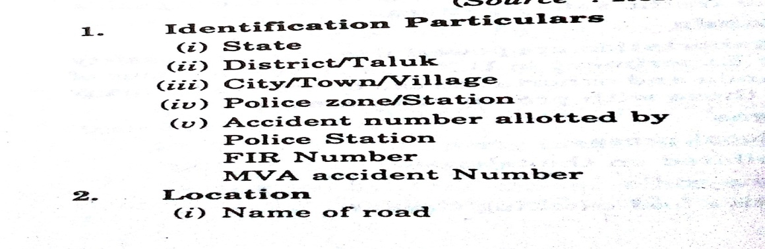
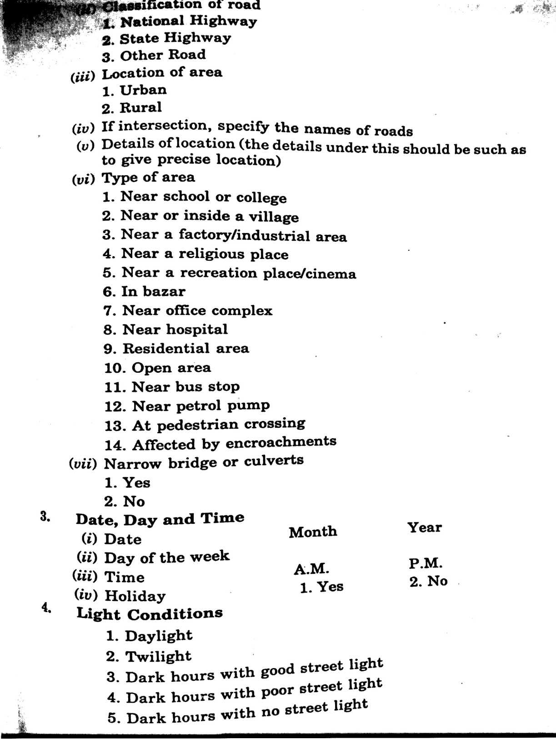
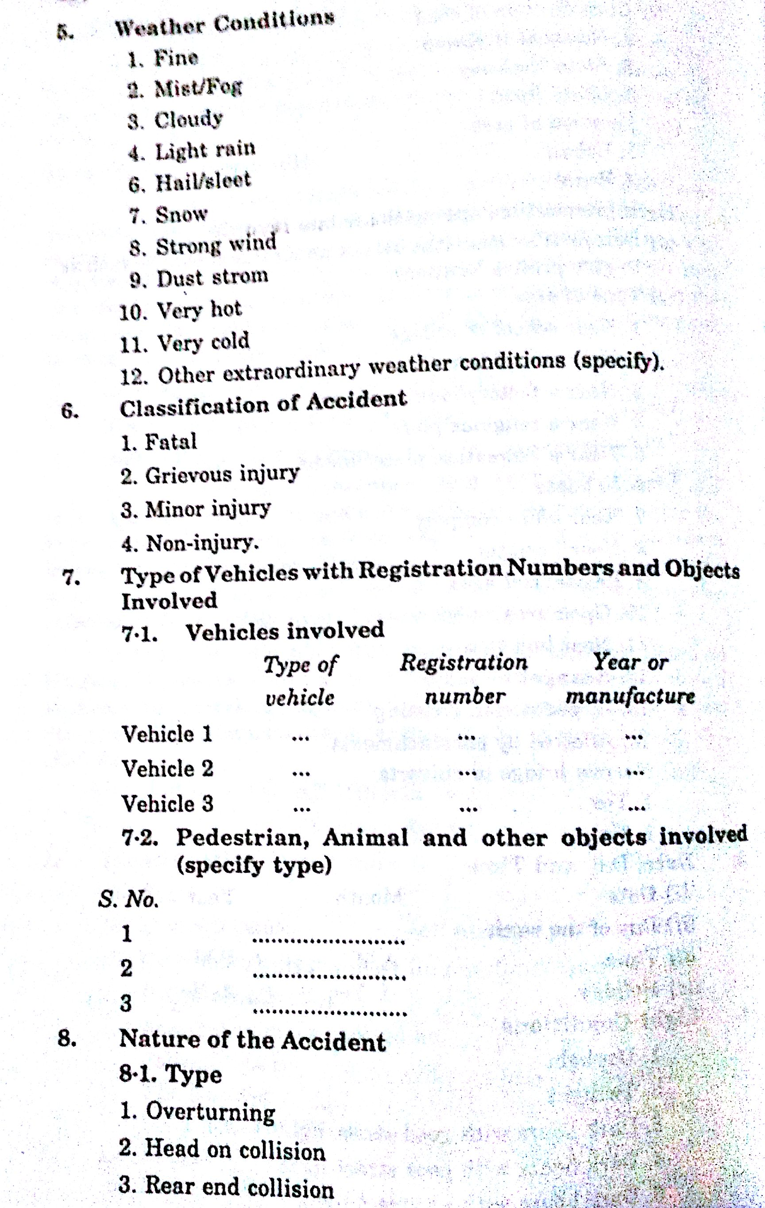
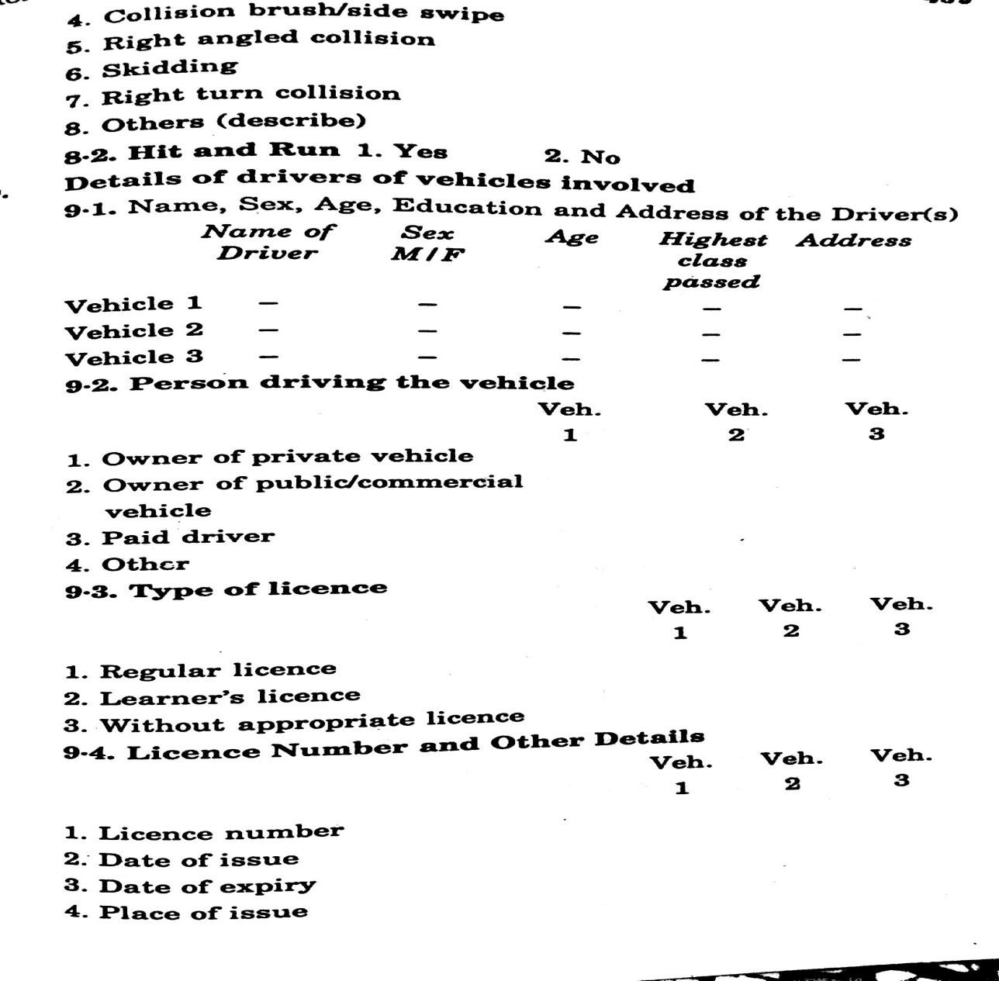
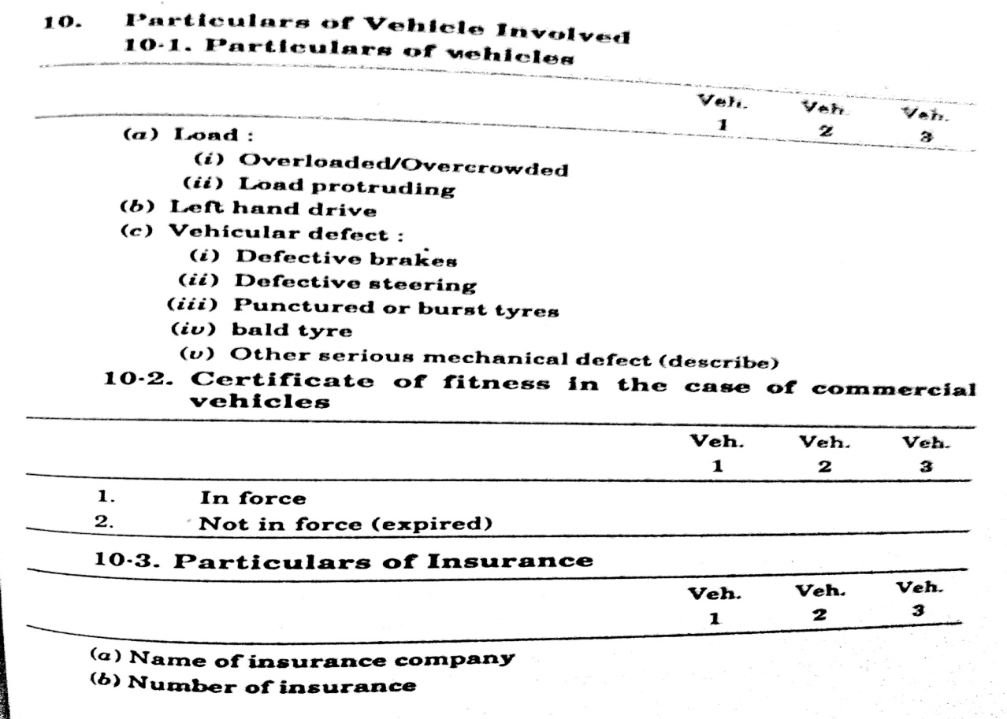
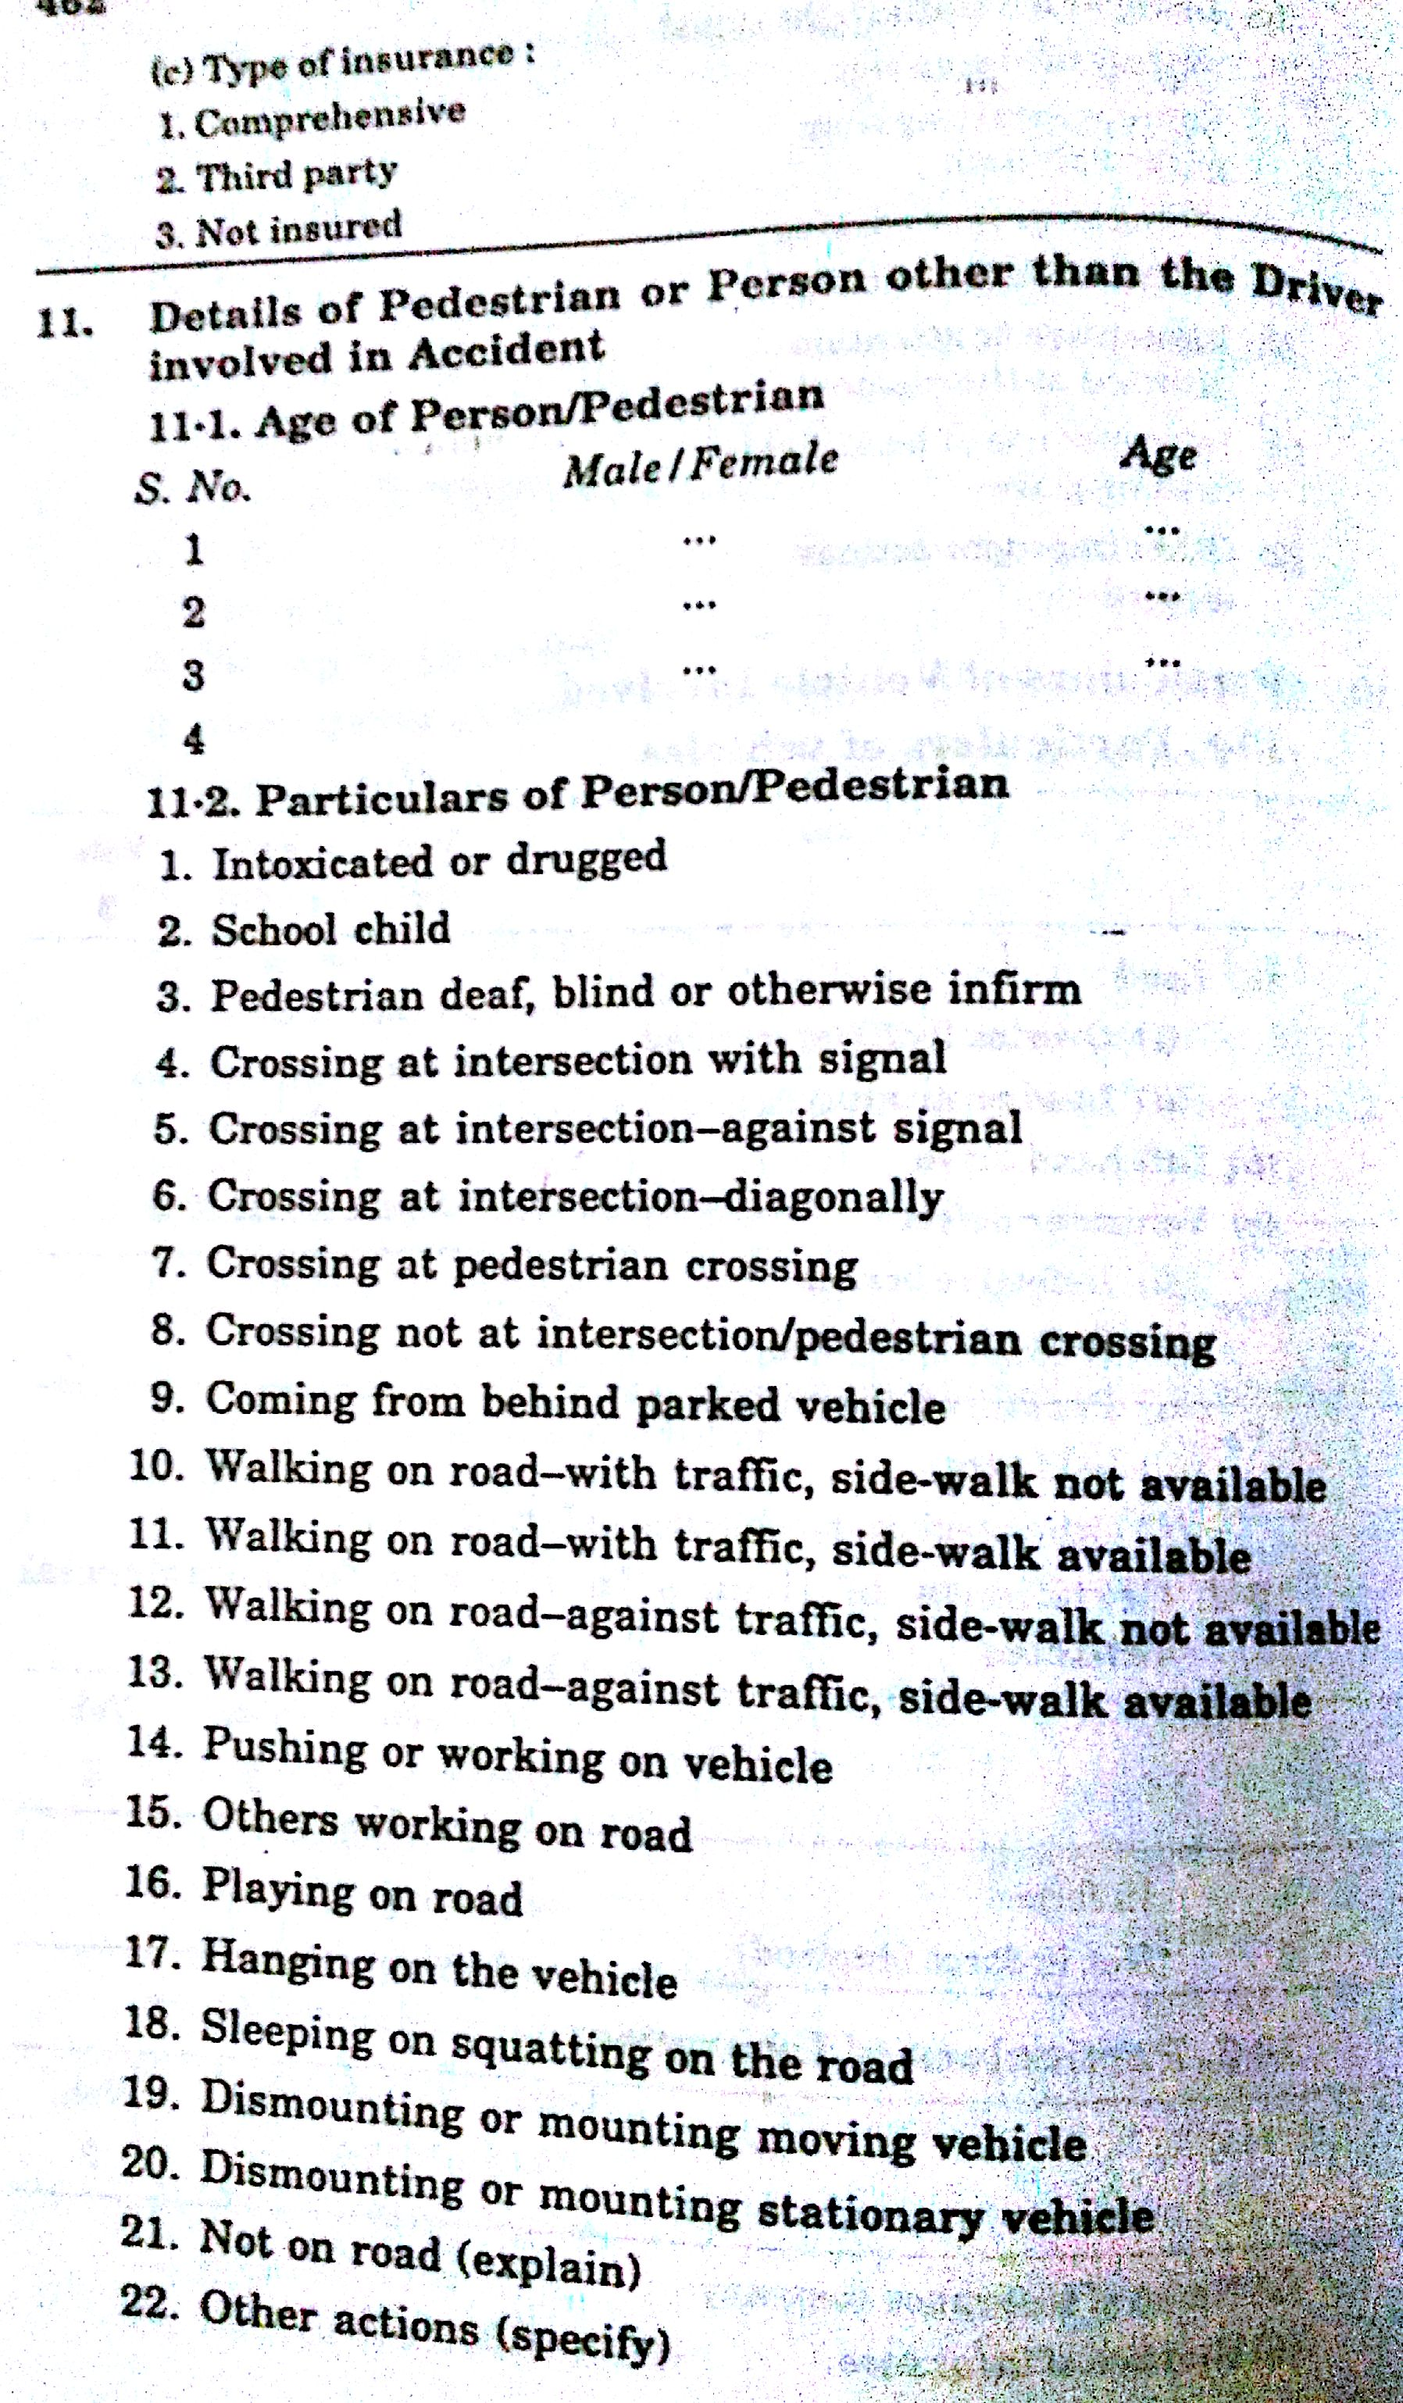

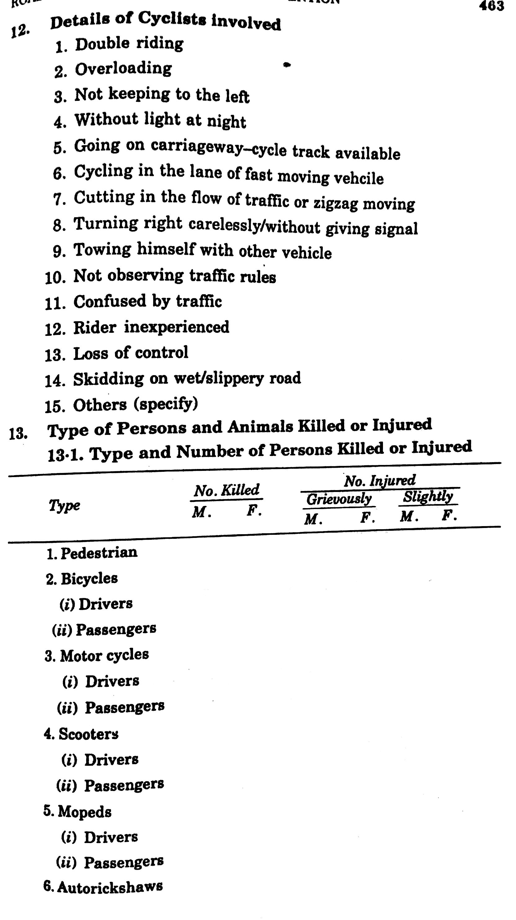
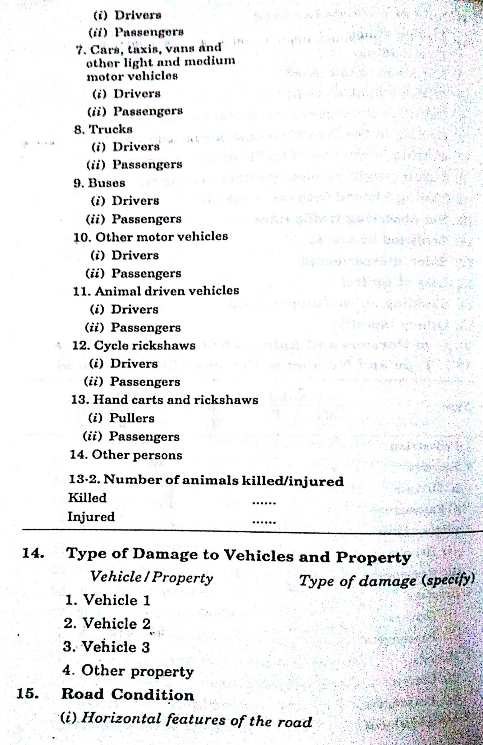
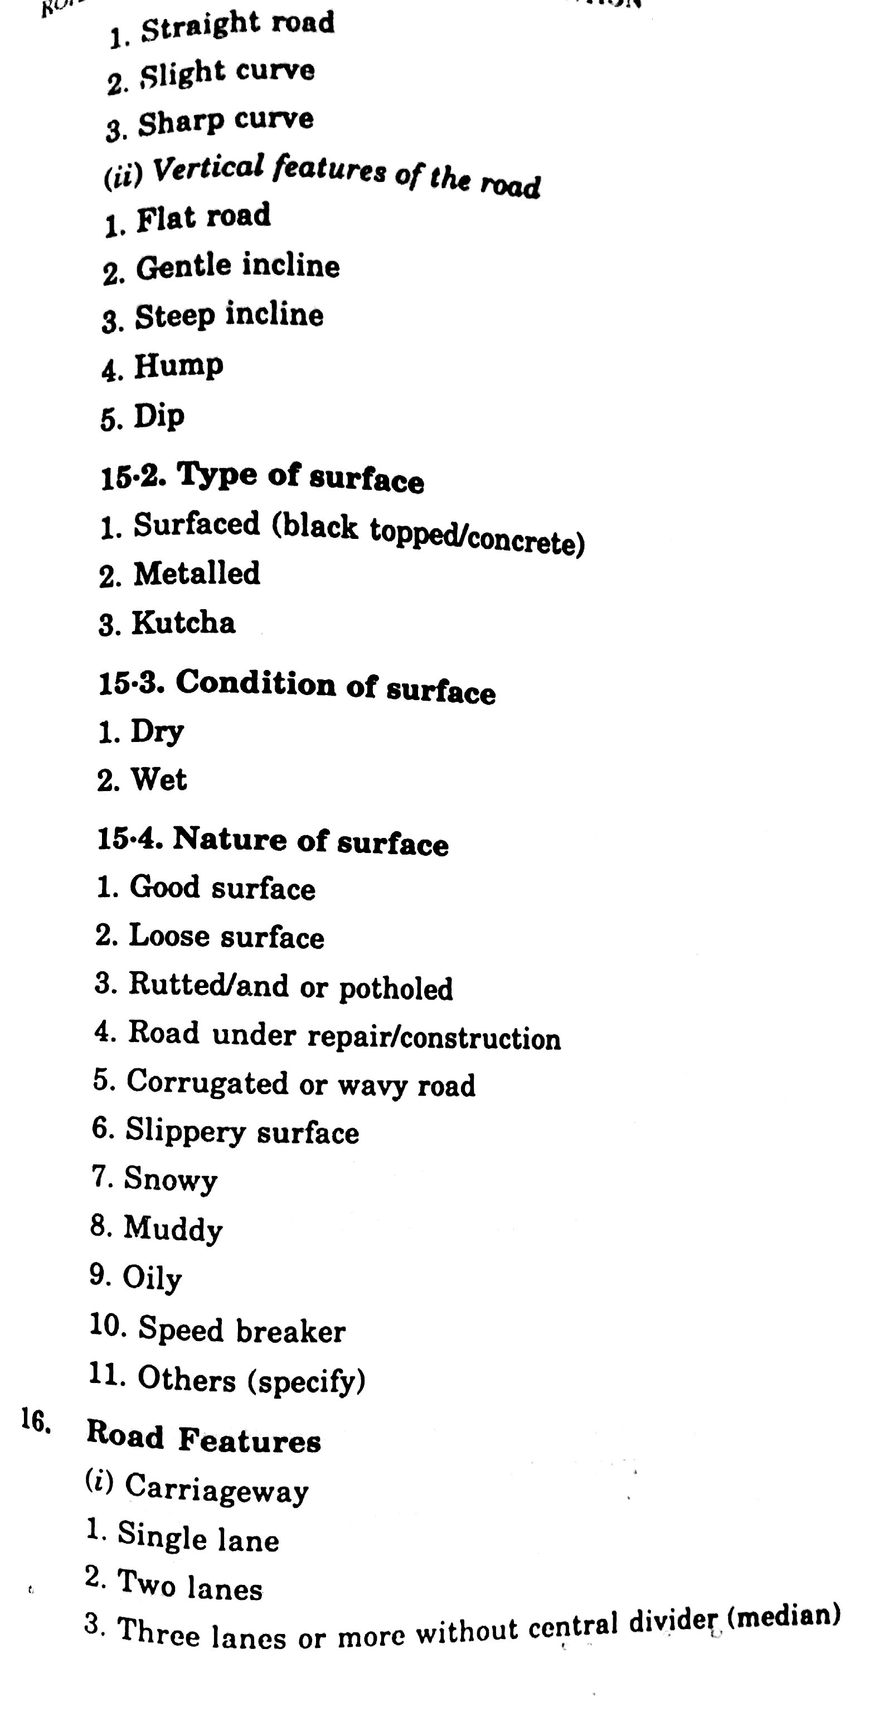
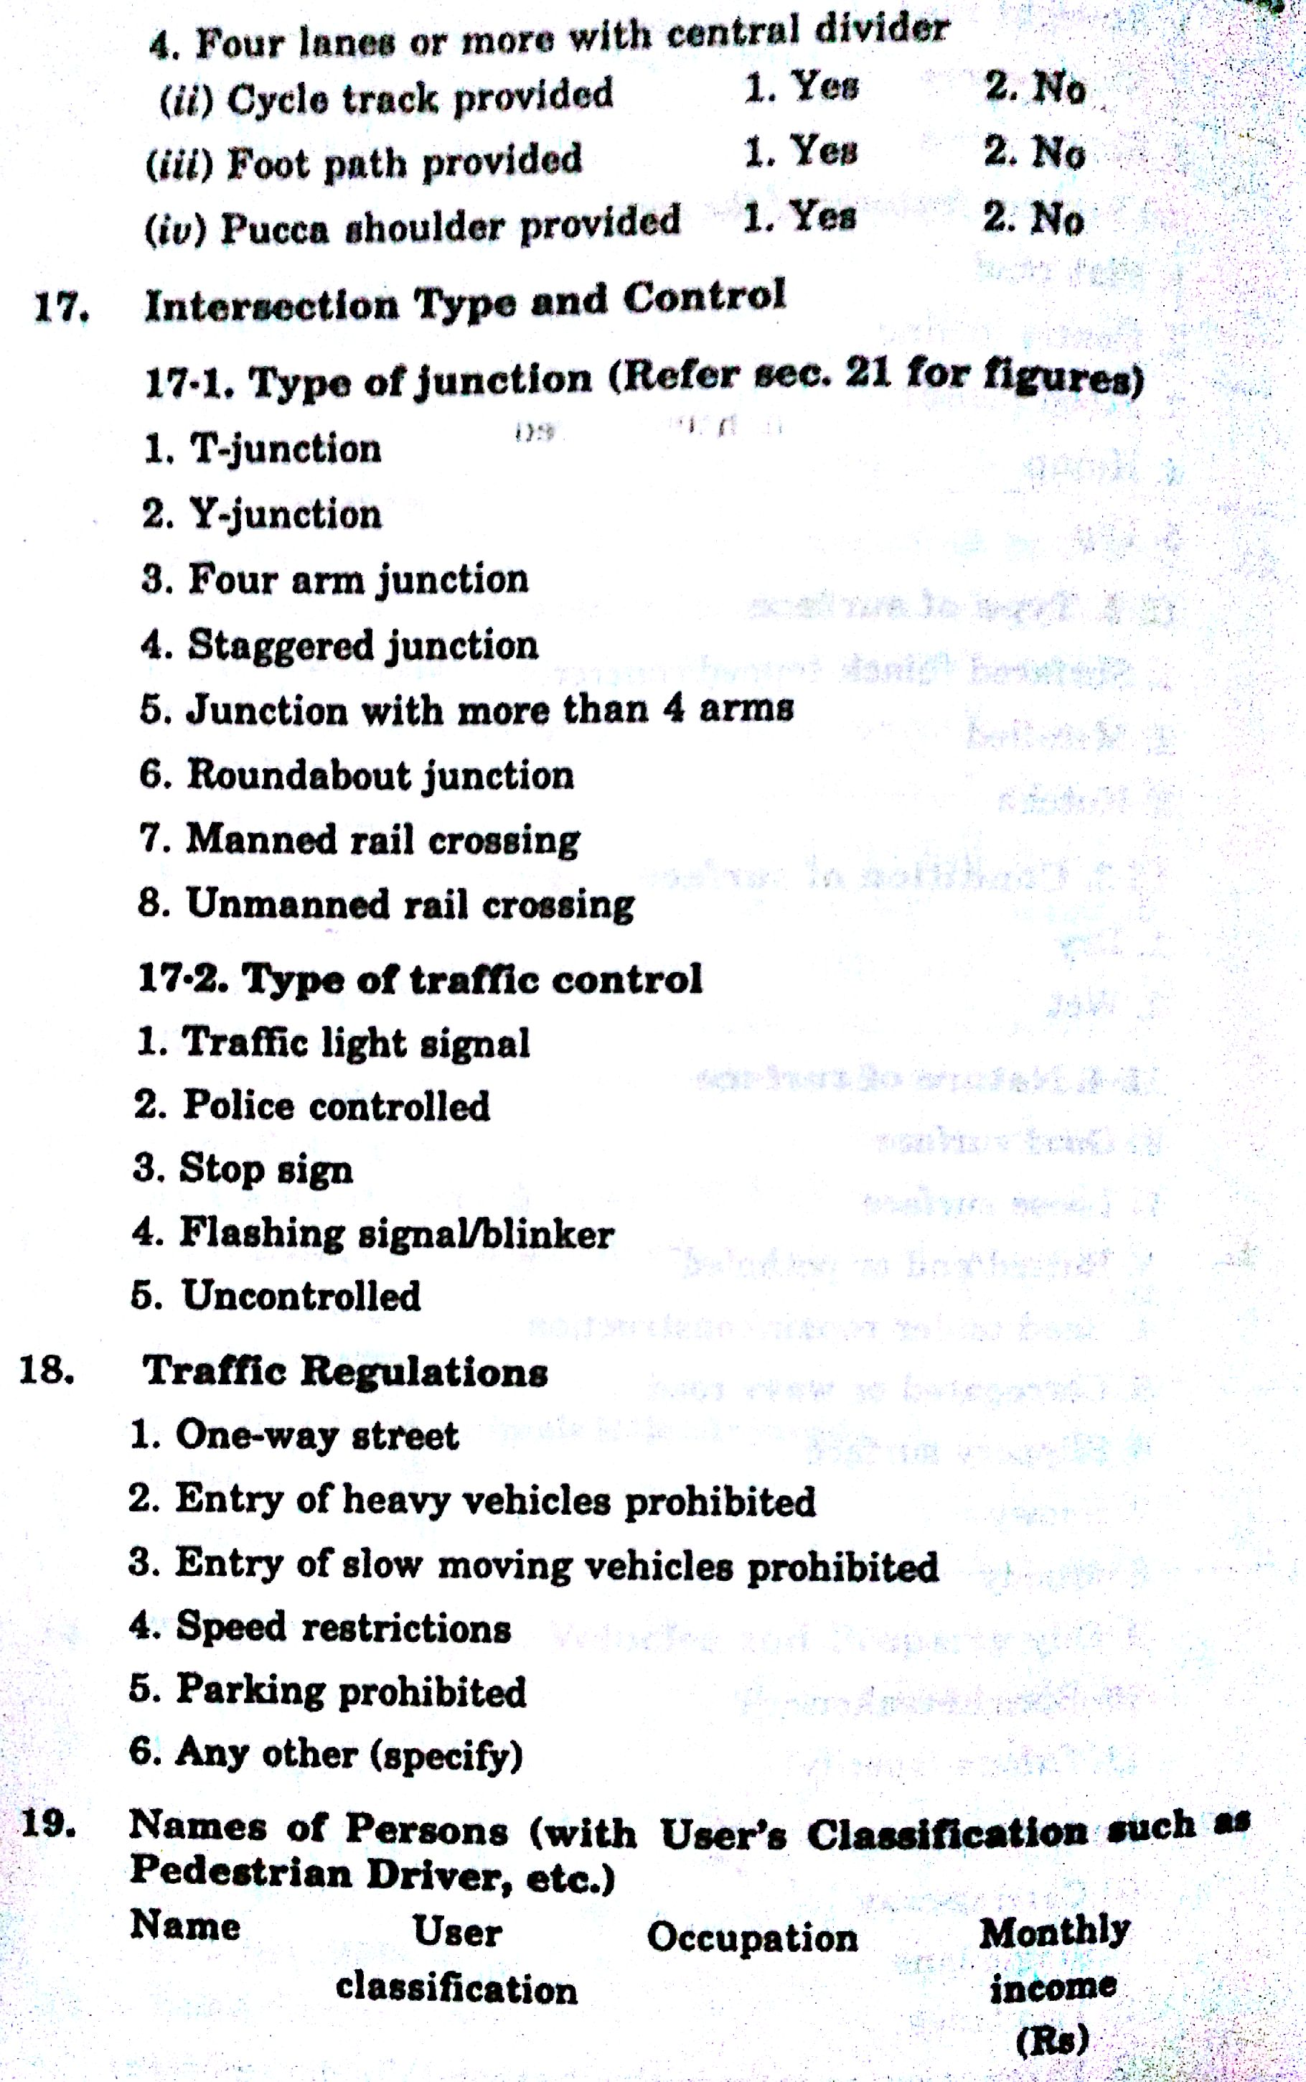

12. HOW WILL YOU MAINTAIN A SAFETY IN THE ROAD?

Safety Measures
The ultimate goal is to develop certain improvement measures to mitigate the circumstances leading to the accidents. The measures to decrease the accident rates are generally divided into three groups engineering, enforcement and education. Some safety measures are described below:
Safety measures related to engineering
The various measures of engineering that may be useful to prevent accidents are enumerated below:
Visual guidance to driver - There is consecutive change of picture in drivers mind while he is in motion. The number of factors that the driver can distinguish and clearly fix in his mind is limited. On an average the perception time for vision is 1/16 th , for hearing is 1/20 th and for muscular reaction is 1/20 th . The number of factors that can be taken into account by organs of sense of a driver in one second is given by the formula below.
E = MV /L
where, M = No. of factors that can be taken into account by the organ of sense of driver for L m long, V = speed of vehicle in m/sec. Factors affecting drivers attention when he is on road can be divided into three groups:
1. Factors relating to the road elements of road that directly affect the driving of a vehicle are traffic signs, changes in direction of road, three legged intersection and various other things.
2. Factors connected with traffic, other vehicles, cycles, pedestrians.
3. Factors related indirectly to the vehicle motion Building and structures that strike the eye, vegetation, landscape, etc.
So using the laws of visual perception certain measures have been suggested:
a) Contrast in visibility of the road should be achieved by provision of elements that differ from its surrounding by colors, pattern such as shoulder strips, shoulder covered with grass, edge markings.
b) Providing road side vegetation is an effective means.
c) The visibility of crown of trees from a distant location is also very useful in visual guiding.
d) The provision of guard rails of different contrasting colors also takes drivers attention and prevent from monotonous driving.
Planting trees along side of roadway which has a turning angle attracts attention of the driver and signals that a turn is present ahead. The figure below is another example, when the direction of road has a hazardous at- grade intersection trees are planted in such a way that it seems that there is dense forest ahead and driver automatically tends to stop or reduce the speed of the vehicle so that no conflicts occur at that point. Driver tends to extrapolate the further direction of the road. So it is the responsibility of the traffic engineer to make the driver psychologically confident while driving that reduces the probability of error and prevent mental strain.
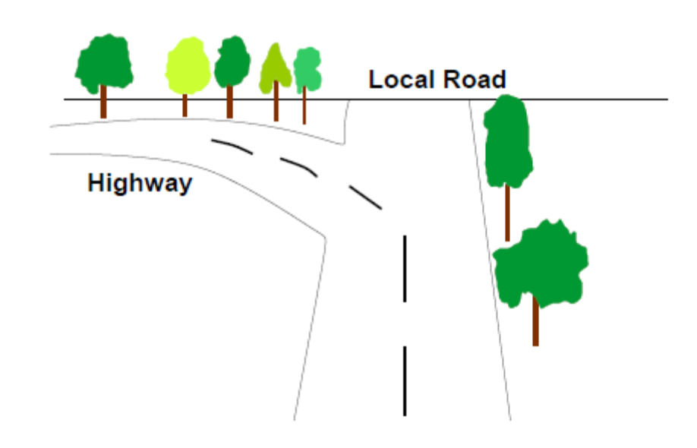
Road reconstruction
The number of vehicles on the road increases from year to year, which introduces complications into organization of traffic, sharply reduces the operation and transportation characteristic of roads and lead to the growth of accident rate. This leads to the need of re constructing road. The places of accidents need to be properly marked so that the reconstruction can be planned accordingly. The Figure shows that there were too many conflict points before which reduced to a few number after construction of islands at proper places. Reconstruction process may also include construction of a new road next to the existing road, renewal of pavement without changing the horizontal alignment or profile of the road, reconstruction a particular section of road.
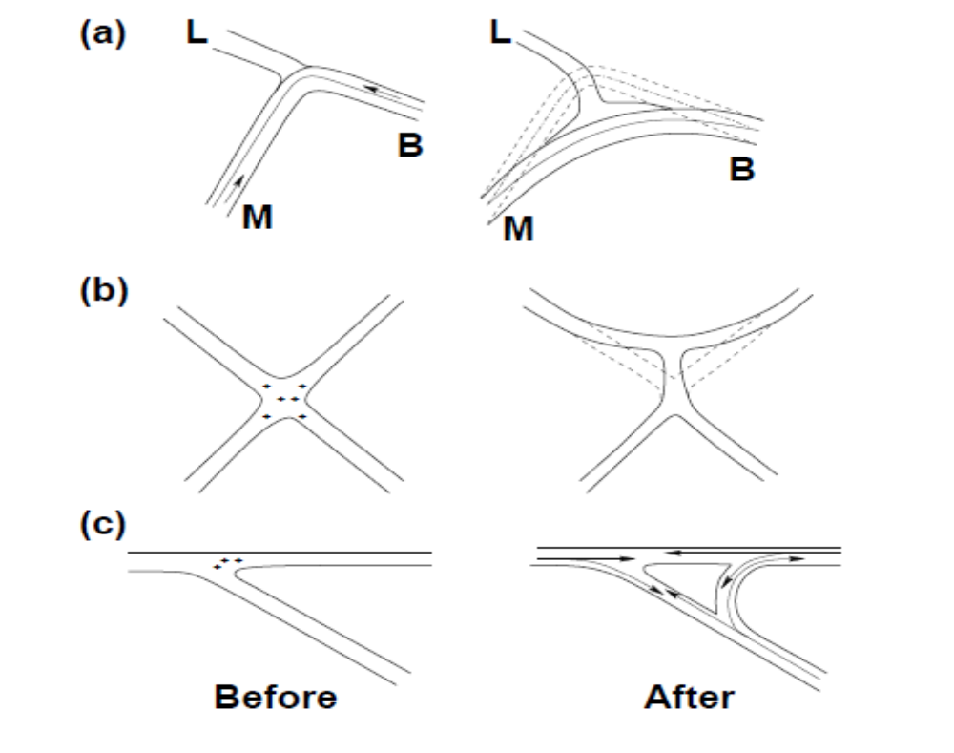
Channelization
The Channelization of traffic at intersection separates the traffic stream travelling in different direction, providing them a separate lane that corresponds to their convenient path and spreading as far as possible the points of conflict between crossing traffic streams. The traffic lanes are separated by marking relevant lines or by constructing slightly elevated islands as shown in Figure. Proper Channelization reduces confusion. The number of decision required to be made by the driver at any time is reduced allowing the driver time to make next decision.

The principles of proper channelized intersection are:-
1. The layout of intersection should be visibly clear, simple and understandable by driver.
2. Should ensure superiority to the vehicles using road of higher class.
3. Layout of intersection makes it necessary for a driver running through it to choose at each moment of time one of not more than two possible direction of travel. This is achieved by visual guidance, islands and markings.
4. The island provided should separate high speed, through and turning traffic flows.
5. The width of traffic lane should ensure unhampered turning to the big vehicles. Width of straight section without kerb should be 3.5 m and that of traffic lane near island is 4.5-5 m at entry and 6 m at exit.
6. Pedestrian crossing should be provided
Road Signs
Road signs are integral part of safety as they ensure safety of the driver himself (warning signs) and safety of the other vehicles and pedestrians on road (regulatory signs). Driver should be able to read the sign from a distance so that he has enough time to understand and respond. It is essential that they are installed and have correct shape, colour, size and location. It is required to maintain them as well, without maintenance in sound condition just their instalment would not be beneficial. According to British investigation height of text in road sign should be
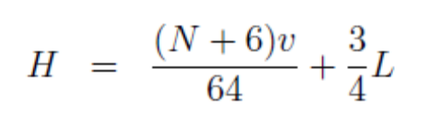
Where, N = No. of words on the sign, v = speed of vehicle (kmph), L = distance from which inscription should be discernible (m)
Other Methods
Various other methods of traffic accident mitigation are described below:
1. Street lighting - Street lightning of appropriate standard contributes to safety in urban area during night time due to poor visibility. Installation of good lighting results in 21% reduction in all accidents, 29% reduction in “all casualty” accidents, 21% reduction in “non pedestrian casualty” accidents, and 57% reduction in “pedestrian casualty” accidents.
2. Improvement in skid resistance - If road is very smooth then skidding of the vehicles may occur or if the pavement is wet then wet weather crashes occur which account about 20-30%. Thus it is important to improve the skid resistance of the road. Various ways of increasing the skid resistance of road are by constructing high-friction overlay or cutting of grooves into the pavement.
3. Road markings - Road markings ensure proper guidance and control to the traffic on a highway. They serve as supplementary function of road sign. They serve as psychological barrier and delineation of traffic path and its lateral clearance from traffic hazards for the safe movement of traffic. Thus their purpose is to provide smooth and safe traffic flow.
4. Guide posts with or without reflector - They are provided at the edge of the roadway to prevent the vehicles from being off tracked from the roadway. Their provision is very essential in hilly road to prevent the vehicle from sliding from top. Guide posts with reflector guide the movement of vehicle during night.
5. Guard rail - Guard rail have similar function as of guide post. On high embankments, hilly roads, road running parallel to the bank of river, shores of lake, near rock protrusion, trees, bridge, abutments a collision with which is a great hazard for a vehicle. It is required to retain the vehicle on the roadway which has accidentally left the road because of fault or improper operation on the part of the driver. Driver who has lost control create a major problem which can be curbed by this measure.
6. Driver reviver stop - Driver reviver stop are generally in use in countries like U.S.A where driver can stop and refresh himself with food, recreation and rest. They play a very important part in traffic safety as they relieve the driver from the mental tension of constant driving. These stops are required to be provided after every 2 hour travel time.
7. Constructing flyovers and bypass - In areas where local traffic is high bypasses are required to separate through traffic from local traffic to decrease the accident rate. To minimize conflicts at major intersections flyovers are required for better safety and less accident rate
8. Regular accident studies - Based on the previous records of accidents the preventive measures are taken and after that the data related to accidents are again collected to check the efficiency of the measures and for future implementation of further preventive measures.
Safety measures related to enforcement
The various measures of enforcement that may be useful to prevent accidents at spots prone to accidents are enumerated below. These rules are revised from time to time to make them more comprehensive.
Speed control - Checks on spot speed of all vehicles should be done at different locations and timings and legal actions on those who violate the speed limit should be taken.
Training and supervision - The transport authorities should be strict while issuing licence to drivers of public service vehicles and taxis. Driving licence of the driver may be renewed after specified period, only after conducting some tests to check whether the driver is fit.
Medical check - The drivers should be tested for vision and reaction time at prescribed intervals of time.
Safety Measures Related to Education
The various measures of education that may be useful to prevent accidents are enumerated below.
Education of road users - The passengers and pedestrians should be taught the rules of the road, correct manner of crossing etc. by introducing necessary instruction in the schools for the children and by the help of posters exhibiting the serious results due to carelessness of road users.
Safety drive - Imposing traffic safety week when the road users are properly directed by the help of traffic police as a means of training the public. Training courses and workshops should be organized for drivers in different parts of the country.
13. write note on statistical methods for traffic studies.

STATISTICAL APPLICATIONS IN TRAFFIC STUDIES AND TRAFFIC FORECASTING
Traffic forecasting is a method to predict the future traffic conditions in an area, city or region.
Traffic engineering is a subject which deals extensively with quantitative data in the planning, design and operation of transportation facilities. Statistical methods are a powerful tool to analyse and interpret these data.
In statistical methods, probability theories are useful in understanding and estimating the properties of population and in testing some hypothesis about the population.
When dealing with a large amount of data on variables, one of the convenient forms of presentation is by means of a frequency table (Mean, Standard Deviation and Variance).
One of the relationships a traffic engineer finds extremely useful in dealing with the random properties of traffic is the Poisson distribution, named after Poisson, a French mathematician.
The Poisson distribution is the limiting case of the more generalised Binomial distribution which describes the probability of occurrence of a particular event in a specified number of trials. (Poisson and Binomial Distribution)
The most important distribution of a continuous variable is the normal distribution. The normal distribution has a number of useful applications in traffic engineering.
The traffic engineer has to collect and analyse data on a variety of subjects such as traffic volume, origins and destinations, travel modes and pattern, speed and delay and parking. Samples can be different types, such as random samples, systematic samples, stratified samples, sequential samples and so on. Most common is the random sampling, where the sampling is done in such a way that each member of the population has the same chance of being chosen. (Sampling Theory and Significance Testing)
14. DESCRIBE THE TERM LOS. WRITE A BRIEF NOTE ON IT.

Level of Services
Level of service (LOS) is a qualitative measure used to relate the quality of traffic service. LOS is used to analyze highways by categorizing traffic flow and assigning quality levels of traffic based on performance measure like speed, density, etc,.
Level of service (LOS) is a quality measure describing operational conditions within a traffic stream, generally in terms of such service measures as speed and travel time, freedom to manoeuvre, traffic interruptions, and comfort and convenience.
A term closely related to capacity and often confused with it is service volume. When capacity gives a quantitative measure of traffic, level of service or LOS tries to give a qualitative measure. A service volume is the maximum number of vehicles, passengers, or the like, which can be accommodated by a given facility or system under given conditions at a given level of service.
Six LOS are defined for each type of facility that has analysis procedures available. Letters designate each level, from A to F, with LOS A representing the best operating conditions and LOS F the worst. Each level of service represents a range of operating conditions and the driver's perception of those conditions. Safety is not included in the measures that establish service levels.
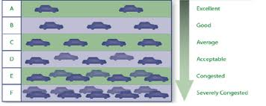

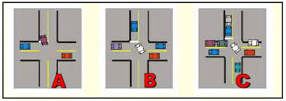

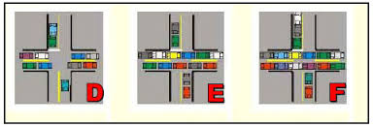

Level of Service A: Free-flow traffic with individual users virtually unaffected by the presence of others in the traffic stream.
Level of Service B: Stable traffic flow with a high degree of freedom to select speed and operating conditions but with some influence from other users.
Level of Service C: Restricted flow that remains stable but with significant interactions with others in the traffic stream. The general level of comfort and convenience declines noticeably at this level.
Level of Service D: High-density flow in which speed and freedom to manoeuvre are severely restricted and comfort and convenience have declined even though flow remains stable.
Level of Service E: Unstable flow at or near capacity levels with poor levels of comfort and convenience.
Level of Service F: Forced traffic flow in which the amount of traffic approaching a point exceeds the amount that can be served. LOS F is characterized by stop-and-go waves, poor travel times, low comfort and convenience, and increased accident exposure.

The following are the factors which might be considered in evaluating the level of service:
- Speed and travel time, including the operating speed and overall travel time consumed in travelling over a section of roadway.
- Traffic interruptions or restrictions, with due consideration to the number of stops per mile, delays involved and the speed changes necessary to maintain pace in the traffic stream.
- Freedom to manoeuvre to maintain the desired operating speeds.
- Driving comfort and convenience reflecting the roadway and traffic conditions in so-far as they affect driving comfort and convenience of the driver.
- Economy, with due consideration operating cost of the vehicle.
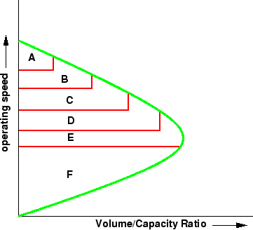

Factors affecting Level of Service
- Roadway factors
- Traffic factors
  - Roadway factors
- Lane Width
- Shoulders
- Lateral Clearance
- Auxiliary Lanes
- Surface Conditions
- Alignment
- Grade
- Lane Width – Lane width of 3.65m is considered as the ideal width for lane.
- Shoulders – The HCM indicates that for lanes less than 3.65 m wide, the paved shoulders of 1.2 m or more width increases the effective width of the adjacent lanes by 0.3 m.
- Lateral Clearance – Lateral clearance such as abutments, signposts, light poles, retaining walls and parked cars are located closer than 1.83 m from the edge of a traffic lane reduces the capacity.
- Surface Conditions – A poorly maintained surface affects the level of services.
- Alignment – The alignment factors such as sharpness of curves, road length etc., affects the capacity and level of service.
- Grade – Grades affect the speed of the vehicles and capacity.
  - Traffic Factors
Traffic factors such as traffic volume, traffic capacity and other traffic factors affect the capacity and level of service.

CE 6006 TRAFFIC ENGINEERING AND MANAGEMENT
UNIT II - TRAFFIC SURVEYS
PART A (2 MARKS QUESTIONS WITH ANSWERS)

- What do you mean by Traffic Survey and Analysis?
Traffic Surveys and Analysis is concerned with the collection and analysis of traffic data for the purpose of traffic management and traffic control within a network.
It provides guidance on the different types of traffic surveys and surveys that can be undertaken, their use and application, and methods for traffic data collection and analysis.
- List the types of Traffic Survey.
1. Road inventory survey
2. Classified traffic volume count survey
3. Origin and destination survey
4. Household interview survey
5. Speed and delay
6. Parking survey
7. Pedestrian survey
8. Intermediate public transport operator survey
9. Intermediate public transport user survey
3. Define Volume Count Survey.
Volume Count Survey is conducted to understand the traffic characteristics in term of average daily traffic, traffic composition, peak hour traffic and directional split at individual survey locations. This survey is carried out result for many types of Highways projects to understand the variety of vehicles that passes over 24 hours a day.
- Enumerate the types of Traffic Count.
- Manual Counts
i) Tally Sheets
ii) Mechanical Counting Boards
iii) Electronic Counting Boards
- Automatic Counts
i) Pneumatic tubes (Portable Counters)
ii) Inductive loops
iii) Weigh-in-Motion Sensor types
iv) Micro-Millimetre wave Radar detectors
v) Video Camera
- What is Manual Count Method?
The most common method of collecting traffic flow data is the manual method, which consists of assigning a person to record traffic as it passes. This method of data collection can be expensive in terms of manpower, but it is nonetheless necessary in most cases where vehicles are to be classified with a number of movements recorded separately, such as at intersections.
- What is Automatic Count Method?
The detection of vehicular presence and road occupancies has historically been performed primarily on or near the surface of the road. The exploitation of new electromagnetic spectra and wireless communication media in recent year, has allowed traffic detection to occur in a non-intrusive fashion, at locations above or to the side of the roadway.
- Write note on Inductive loops.
An induction or inductive loop is an electromagnetic communication or detection system which uses a moving magnet to induce an electrical current in a nearby wire. Induction loops are used for transmission and reception of communication signals, or for detection of metal objects in metal detectors or vehicle presence indicators.
- Differentiate between AADT and AAWT.
S.No | AADT | AAWT
1 | Average Annual Daily Traffic | Average Annual Weekday Traffic
2 | The average 24-hour traffic volume at a given location over a full 365-day year, i.e. the total number of vehicles passing the site in a year divided by 365. | The average 24-hour traffic volume occurring on week- days over a full year. It is computed by dividing the total weekday traffic volume for the year by 260.

- Differentiate between ADT and AWT.
S.No | ADT | AWT
1 | Average Daily Traffic | Average Weekday Traffic
2 | An average 24-hour traffic volume at a given location for some period of time less than a year. It may be measured for six months, a season, a month, a week, or as little as two days. An ADT is a valid number only for the period over which it was measured. | An average 24-hour traffic volume occurring on weekdays for some period of time less than one year, such as for a month or a season.

- Define Capacity.
Capacity is defined as the maximum number of vehicles, passengers, or the like, per unit time, which can be accommodated under given conditions with a reasonable expectation of occurrence.
- What is Highway Capacity?
Highway capacity or vehicles can be given time period certain conditions is defined by the Highway Capacity Manual as the maximum hourly rate at which persons reasonably expected to traverse a point or a uniform segment of a lane or roadway during a under prevailing roadway, traffic and control conditions.
- List the factors influencing the Highway Capacity.
- Traffic conditions
- Road way characteristics
- Control conditions
- Define Speed.
Speed is an important measure of the quality of travel and safety of road network. Speed by definition rate of movement of vehicle in distance per unit time. A typical unit of speed is kilometer per hour (KMPH) or miles per hour (mph)
Mathematically speed or velocity v is given by,
v = d / t
Where,
v - Speed of the vehicle in m/s,
d - Distance travelled in m
t - Time t seconds.
- Define Spot Speed.
Spot speed is the instantaneous speed of a vehicle at a specified location. Spot speed can be used to design the geometry of road like horizontal and vertical curves, super elevation etc.
- What do you understand the term Running Speed?
Running speed is the average speed maintained over a particular course while the vehicle is moving and is found by dividing the length of the course by the time duration the vehicle was in motion.
Running Speed = Length of course/ Running Time
= Length of course / (Journey time - delay)
- Write note on Journey speed.
Journey speed is the effective speed of the vehicle on a journey between two points and is the distance between the two points divided by the total time taken for the vehicle to complete the journey including any stopped time.
Journey Speed = Distance / Total Journey Time (Including Delays)
- Differentiate between Time Mean Speed and Space Mean Speed.
Time Mean Speed | Space Mean Speed
Time mean speed is defined as the average speed of all the vehicles passing a point on a highway over some specified time period. | Space mean speed is defined as the average speed of all the vehicles occupying a given section of a highway over some specified time period.

- What is Flow?
Flow is defined as the number of vehicles that pass a point on a highway or a given lane or direction of a highway during a specific time interval.
The measurement is carried out by counting the number of vehicles, n_{t}, passing a particular point in one lane in a defined period t. Then the flow q expressed in vehicles/hour is given by,
q = n_{t}/t
- What are all the Methods available for measuring Spot Speed?
The methods available for measuring spot speeds can be grouped as under:
- Those that requires observation of the time taken by a vehicle to cover a known distance.
- Those in which vehicles are timed over a long distance (long base)
- Direct timing Procedure
- Enoscope
- Pressure contact tube
- Those in which vehicles are timed over a short distance (short base)
- Radar speed meter which automatically records the instaneous speed.
- Photographic method.
- Write the Guidelines for Selecting the Site of the Spot Speed Survey.
- The location at which measurements are taken is governed by the specific purpose for which the data are required. For example, if the data is likely to be used to analyse the accident pattern, the survey will be needed at high accident frequency locations.
- The site selected should reduce to a minimum the influence of the study team and equipment upon the vehicle speeds. For this purpose, the study team and the equipment should be located as inconspicuously as possible.
- Generally straight, level and open sections of highways should be selected so as to minimise the influence of geometric features of the highways, road – side development and intersections.
- List the Methods for Measuring Spot Speed.
- Pavement Markings
- Enoscope or Mirror box
- Road Detector (Pressure contact strips)
- Doppler-Principle Meters (Radar)
- Electronic-Principle Detectors (Photography)
- What is Delay?
Delay is a measure that most directly relates driver’s experience and it is measure of excess time consumed in traversing the intersection.
- What are all the types of Delay?
- Stopped time delay
- Approach delay
- Travel time delay
- Time-in-queue delay
- Control delay
- What is Stopped Time Delay?
Stopped-time delay is defined as the time a vehicle is stopped in queue while waiting to pass through the intersection. It begins when the vehicle is fully stopped and ends when the vehicle begins to accelerate. Average stopped-time delay is the average for all vehicles during a specified time period.
- Write short note on Approach Delay.
Approach delay includes stopped-time delay but adds the time loss due to deceleration from the approach speed to a stop and the time loss due to re-acceleration back to the desired speed.
- What do you mean by Travel Time Delay?
It is the difference between the drivers expected travel time through the intersection (or any roadway segment) and the actual time taken. To find the desired travel time to traverse an intersection is very difficult. So this delay concept is rarely used except in some planning studies.
- Define the term Time-in-queue Delay
Time-in-queue delay is the total time from a vehicle joining an intersection queue to its discharge across the STOP line on departure. Average time-in-queue delay is the average for all vehicles during a specified time period.
- What is Control Delay?
Control delay is the delay caused by a control device, either a traffic signal or a STOP-sign. It is approximately equal to time-in-queue delay plus the acceleration-deceleration delay component.

- What is the purpose of Origin – Destination Study?
An origin-destination study is used to determine travel patterns of traffic on an installation during a typical day. They are useful in assisting long-range traffic planning, especially when there are substantial changes anticipated in the installation mission or strength.
- What is Trip?
Trips are defined as one-way movement, from where a person starts (origin) to where the person is going (destination).
- Write the methods for Conducting Origin – Destination Study.
  - Registration Questionnaire
  - Post Card
  - Roadside Interview
  - Tag on Car
  - Comprehensive Home Interview
- What is parking?
Parking is the act or practice of temporarily leaving a vehicle or managing a vehicle into a certain location.
- What are all the types of Parking?
- On Street Parking
- Off Street Parking
- Define On Street Parking.
On street parking means the vehicles are parked on the sides of the street itself. This will be usually controlled by government agencies itself.
- Write the types of On Street Parking.
- Parallel parking
- 30⁰ parking
- 45⁰ parking
- 60⁰ parking
- Right angle parking
- What is Off street parking?
In many urban centres, some areas are exclusively allotted for parking which will be at some distance away from the main stream of traffic. Such a parking is referred to as off-street parking. They may be operated by either public agencies or private firms.

- Draw the neat Sketch for Parallel Parking.
- Draw the neat Sketch for 30⁰ parking.
- Draw the neat Sketch for 45⁰ parking.
- Draw the neat Sketch for 60⁰ parking.

- Draw the neat Sketch for Right angle parking.
- Define Parking accumulation.
It is defined as the number of vehicles parked at a given instant of time. Normally this is expressed by accumulation curve. Accumulation curve is the graph obtained by plotting the number of bays occupied with respect to time.
- What is Parking volume?
Parking volume is the total number of vehicles parked at a given duration of time. This does not account for repetition of vehicles. The actual volume of vehicles entered in the area is recorded.
- What is Parking load?
Parking load gives the area under the accumulation curve. It can also be obtained by simply multiplying the number of vehicles occupying the parking area at each time interval with the time interval. It is expressed as vehicle hours.
- Define Average parking duration.
It is the ratio of total vehicle hours to the number of vehicles parked.
- What is Parking turnover?
It is the ratio of number of vehicles parked in duration to the number of parking bays available. This can be expressed as number of vehicles per bay per time duration.
- Define Parking index.
Parking index is also called occupancy or efficiency. It is defined as the ratio of number of bays occupied in time duration to the total space available. It gives an aggregate measure of how effectively the parking space is utilized. Parking index can be found out as follows
- List the types of Parking Survey.
- In-Out survey
- License Plate Method Survey
- Define Traffic Forecasting.
It is the method to estimate the future traffic condition of an area, city or country.
- What do you mean by Accident?
Accident is an unfortunate incident that happens unexpectedly and unintentionally, typically resulting in damage or injury.
- What are the major Objectives of accident studies?
- To study the causes of accidents and suggest corrective measures at potential location
- To evaluate existing design
- To compute the financial losses incurred
- To support the proposed design and provide economic justification to the improvement suggested by the traffic engineer
- To carry out before and after studies and to demonstrate the improvement in the problem.
- Define Level of Services.
Level of service (LOS) is a qualitative measure used to relate the quality of traffic service. LOS is used to analyze highways by categorizing traffic flow and assigning quality levels of traffic based on performance measure like speed, density, etc,.

