CE 2026 TRAFFIC ENGINEERING AND MANAGEMENT
UNIT III
TRAFFIC DESIGN AND VISUAL AIDS
Traffic signs, Road markings, Design of Traffic signals and Signal co-ordination (Problems), Traffic control aids and Street furniture, Street Lighting, Computer applications in Signal design
Intersection Design - channelization, Rotary intersection design – Signal design – Coordination of signals –– Grade separation - Traffic signs including VMS and road markings – Significant roles of traffic control personnel - Networking pedestrian facilities & cycle tracks.

1. Explain in detail about traffic signs with neat sketch.

(NOV/DEC 2011)
TRAFFIC SIGNS
Importance of Traffic Signs
- Traffic signs perform a number of functions:
- They give timely warning of hazardous situations when they are not self evident.
- They are of great help in regulating traffic by imparting messages to the drivers about the need to stop, give way and limit their speeds.
- They give information as to highway routes, directions and points of interest.
In view of the above, traffic signs occupy a significant place in traffic engineering.
Need for International Standardization
In order to facilitate people travelling from one country by road in another country where the language may be different, standardization of traffic signs assumes considerable importance.
Adaptation of a uniform system of traffic signs by various countries is best with a number of problems, one of the principles commonly agreed to by all the signatory countries is the adoption of graphic symbols to convey messages, rather than lettered messages.

Types of Traffic Signs
- Danger signs, also known as Warning Signs or Cautionary Signs
- Signs giving definite instruction, also known as Regulatory Signs in some countries
- Prohibitory Signs
- Mandatory Signs
- Information Signs
- Indication Signs
- Advance direction signs and direction signs
- Place and route identification signs
- Danger Signs (Warning Signs or Cautionary Signs)
Danger signs are used when it is deemed necessary to warn traffic of exiting of potentially hazardous conditions on or adjacent to a highway or street.
Warning signs are of great help in ensuring safety of traffic. The use of warning signs should be kept to a minimum, however, because their unnecessary use tends to breed disrespect for all signs.
The U.N. Protocol recommends an equilateral triangle with one point upwards.
The side of the triangle, as per the I.R.C. Standard, is 900mm for a standard size and 600mm for a reduced size.
These signs have a red border and the symbols indicated therein are in black colour against a white background.
The warning signs recommended by the I.R.C. Standard are illustrated in Figure, along with the message they intend to convey.
General Design of Warning Sign
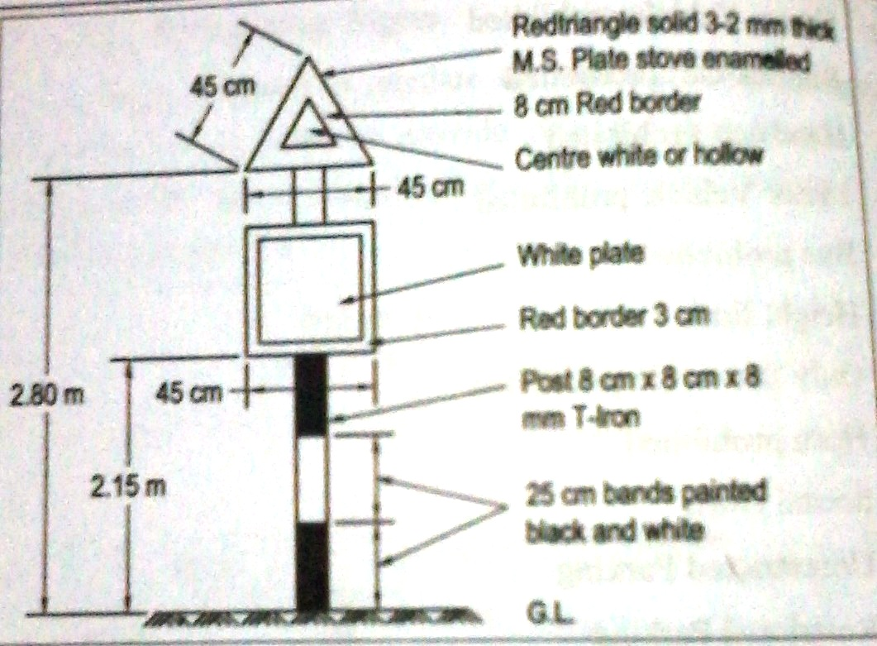
Warning Signs

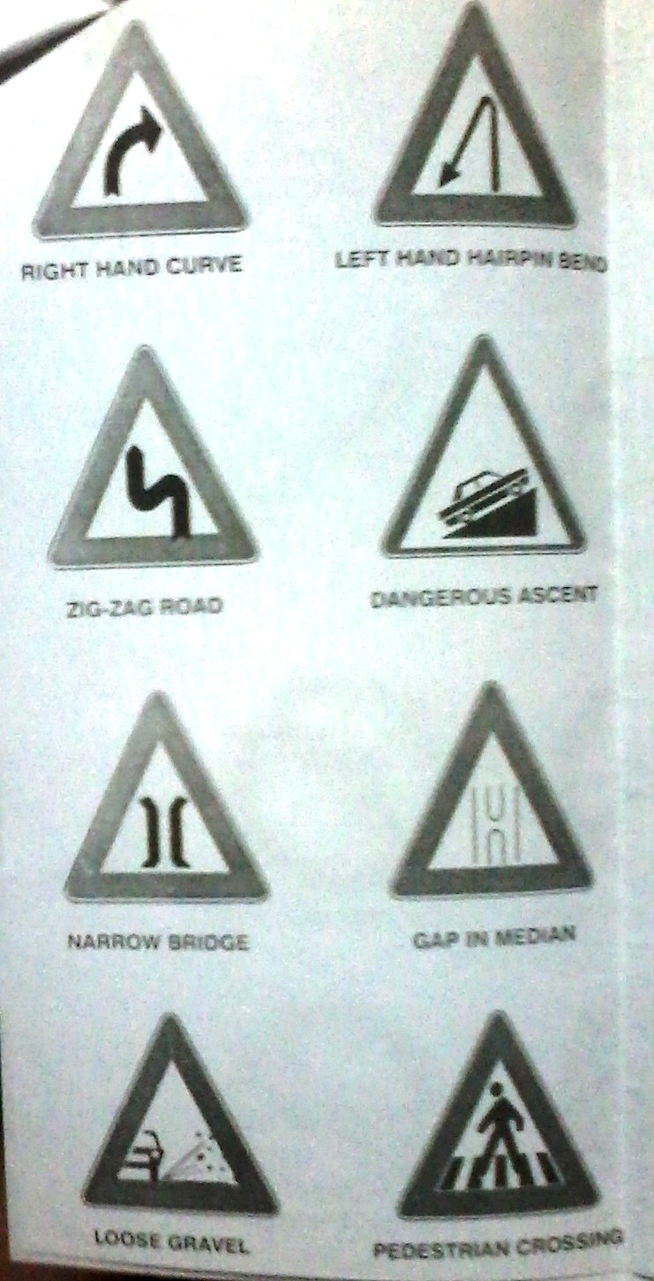
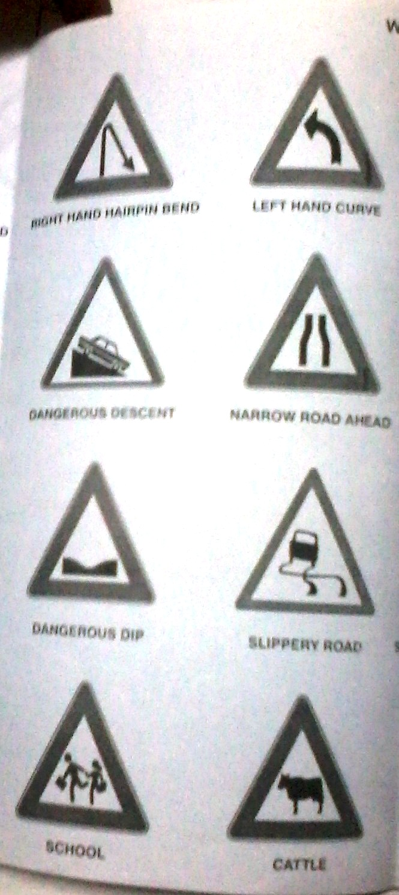
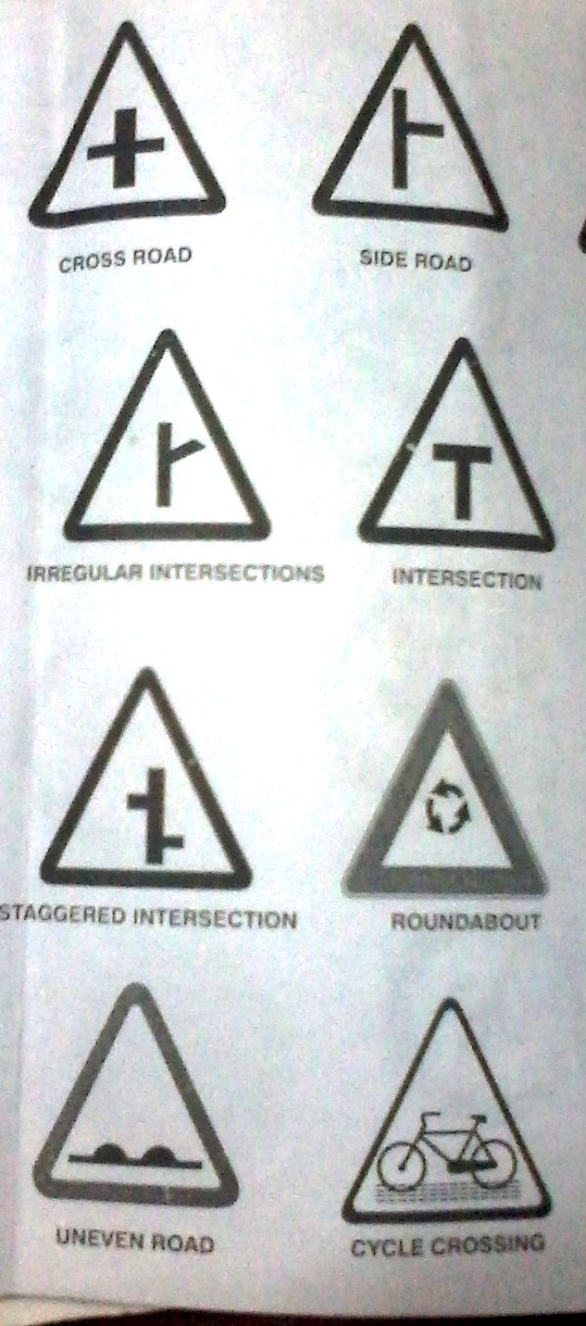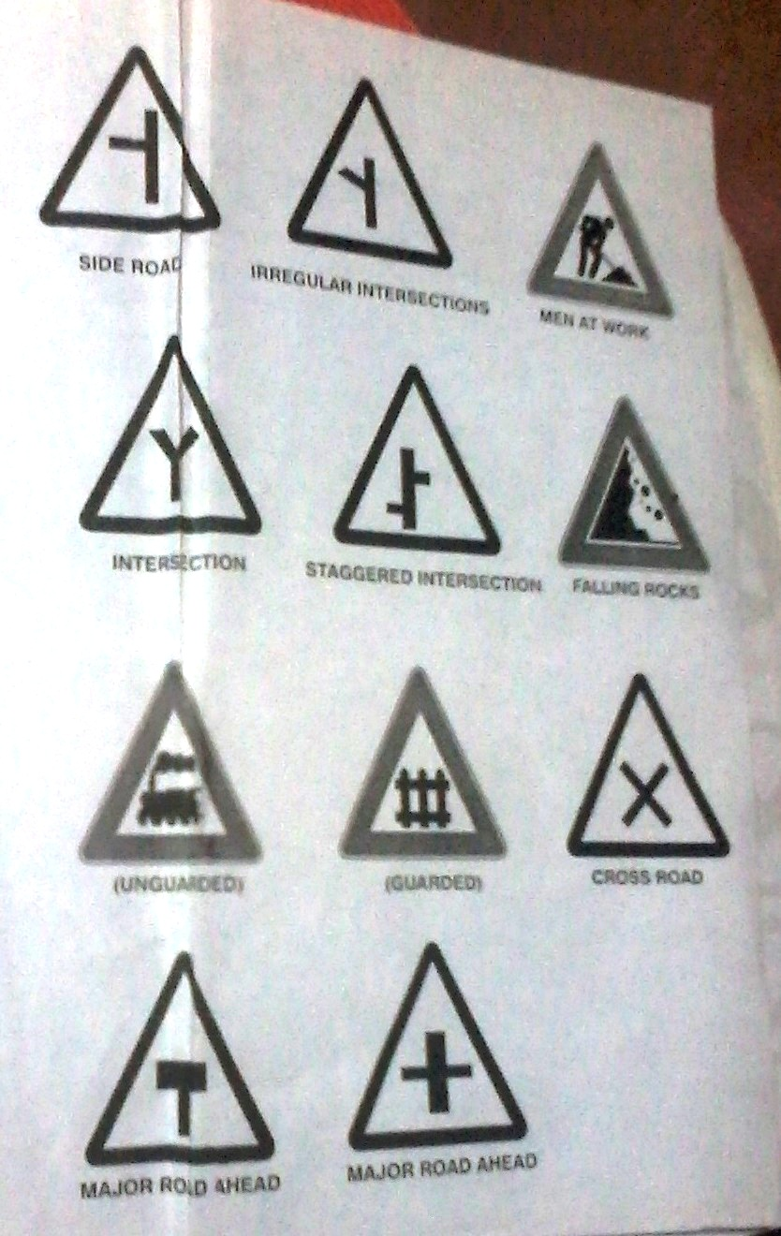

- Prohibitory Signs
These signs are part of the regulatory signs, which are intended to inform the highway users of traffic laws or regulations. The prohibitory signs give definite negative instruction prohibiting motorist from making particular manoeuvres. They may be of following types:
- Movement prohibition, such as prohibition of certain turns, prohibition of entry, prohibition of overtaking, one-way traffic, exclusion of certain types of vehicles or all vehicles etc.
- Waiting restriction signs, such as prohibited waiting etc.
- Restrictions on dimensions, weight or speed of vehicle.
According to the I.R.C Standards, the prohibitory signs are of a circular shape, with a diameter of 0.60m for signs of the standard size and 0.40 m for the reduced size.
The signs have a red border. The colour of the background is white for speed control, blue for waiting and parking restrictions.
The symbols are in black colour for prohibitory signs and white in colour for direction control signs.
Prohibitory Signs/ Information Signs
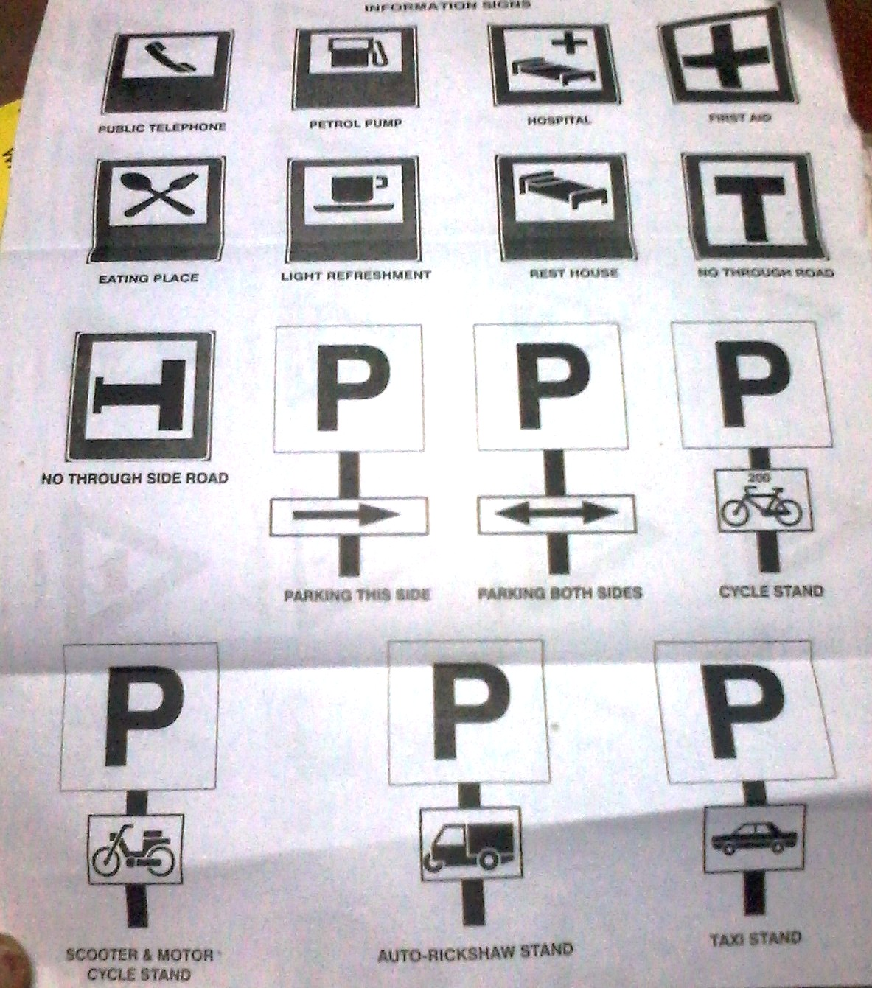
- Mandatory Signs
Mandatory signs are part of regulatory signs and are intended to convey definite positive instructions when it is desired that motorists take some positive action. The two most important mandatory signs are the,
- STOP sign and
- YIELD or GIVEWAY
The STOP sign requires all vehicles to come to a halt before the stop line. Because it causes a substantial inconvenience to motorists, it should not be indiscriminately used. It is generally used at an intersection where the following conditions exist.
- Intersection of a less important road with a main road where the application of the normal right-of –way rule is unduly hazardous.
- Street entering a through highway or street.
- Unsignalized intersection in a signalized area.
- Other intersections where a combination of high speed, restricted view and serious accident record indicates a need for control by the STOP sign.
The STOP sign should not be used.
- On through roadways or expressways
- For speed control
- At signalized intersections
American Practice: Octagon with written message ‘STOP’ in white on a red background with white border.
European Practice: Octagon with written message ‘STOP’ and border in white or yellow on a red background.
U.N Practice: Red triangle with point downwards inscribed within a red circle, the word ‘STOP’ may be written in the triangle.
I.R.C Standards: Octagon with a white border and red back ground, the side of the octagon being 900mm for the standard sized sign, and 600 mm for the smaller sized sign. It shall be used in combination with a definition plate carrying the message STOP.
The YIELD or GATEWAY sign is used to assign right-of-way to traffic on certain approaches to an intersection. Vehicles controlled by a YIELD sign need stop only when necessary to avoid interference with other traffic that is given the right-of-way.
It is used under the following conditions:
- On a minor road at the entrance to an intersection where it is necessary to assign right-of-way to the major road, but where a stop is not necessary at all times.
- On the entrance ramp to an express-way when an acceleration lane is not provided.
- Within an intersection with a divided highway where a STOP sign is present at the entrance to the first roadway and further control is necessary at the entrance to the second roadway and where the median width between the two roadways exceeds 9m.
- Where there is a separate or channelized left-turn lane, without an adequate acceleration lane.
- At any intersection where a special problem exists and where an engineering study indicates the problem to be susceptible correction by the use of YIELD sign.
The YIELD sign should not be used,
- To control the major flow of traffic at an intersection.
- On the approaches of more than one of the intersection streets or highways or at any section where there are STOP signs on one or more of the approaches, except, under special circumstances, to provide minor movement control within complex intersections.
- On the through roadways or expressways.
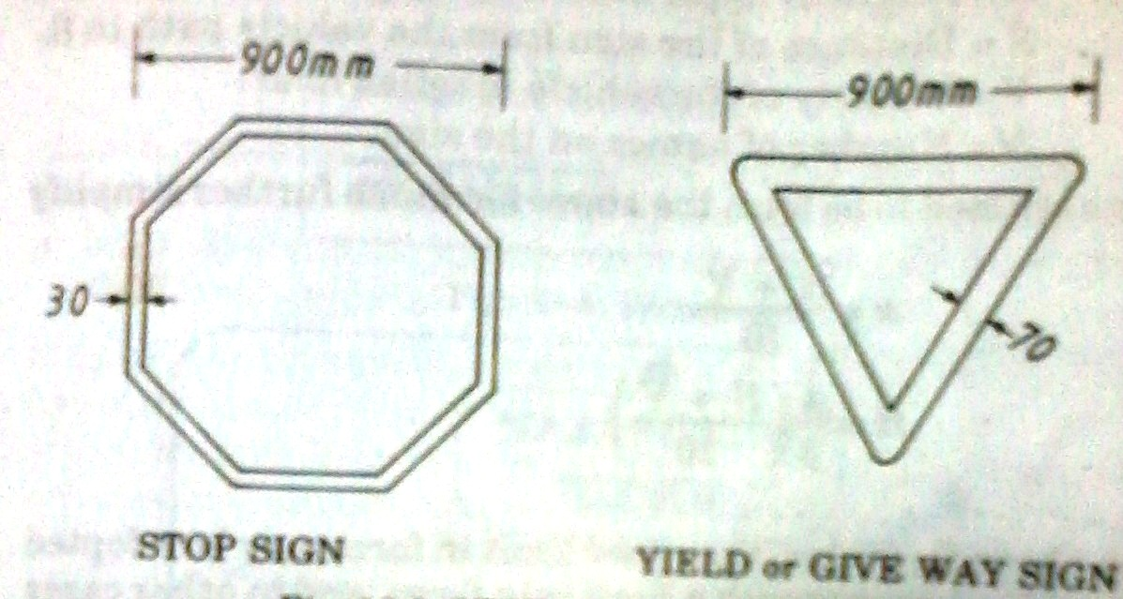

Mandatory Signs/ Regulatory Signs

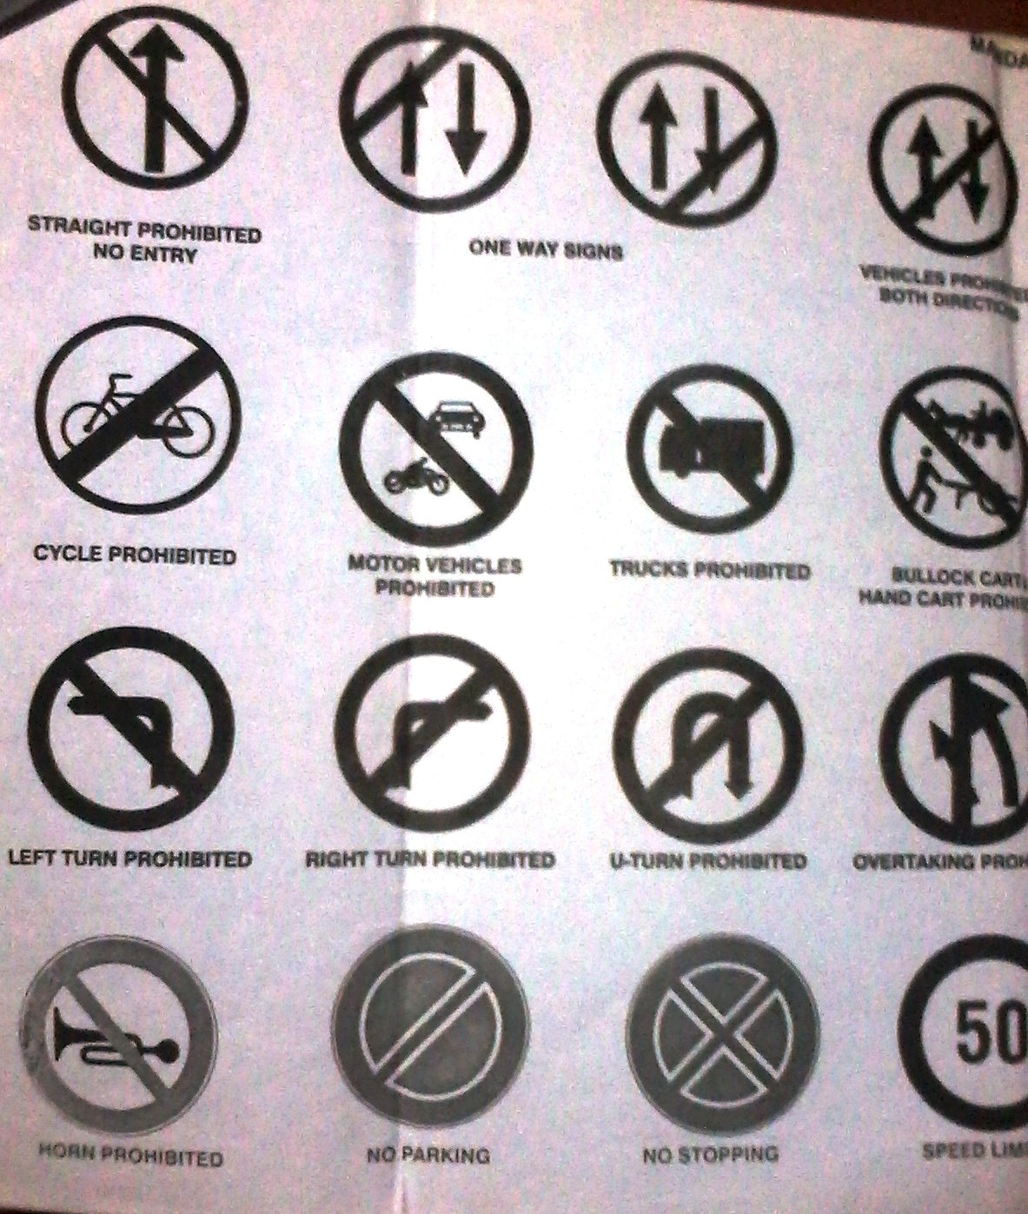

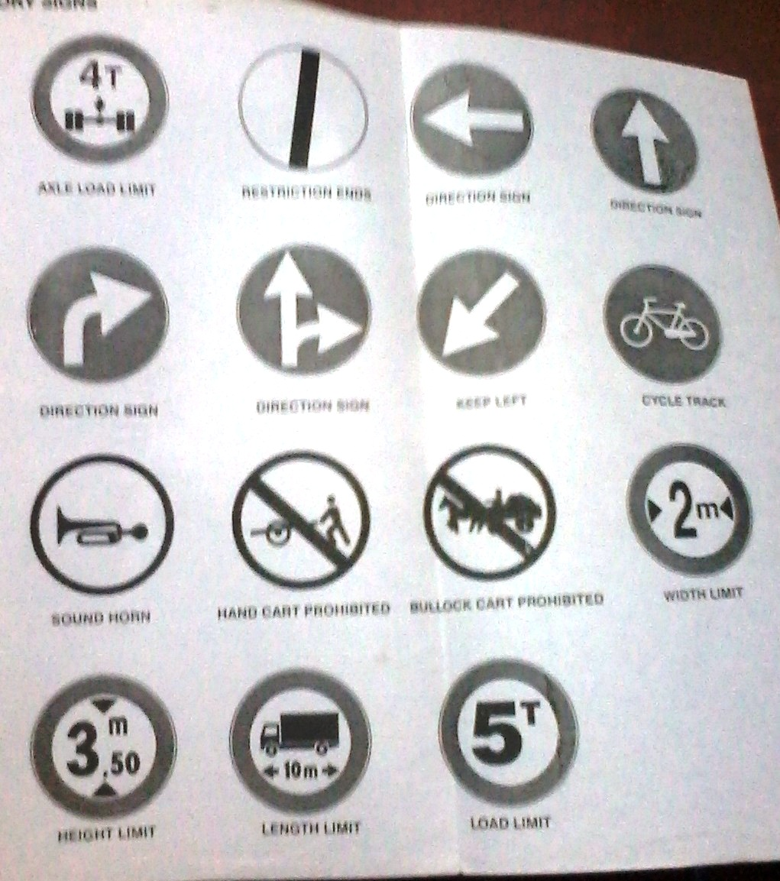
General Design of Regulatory Sign
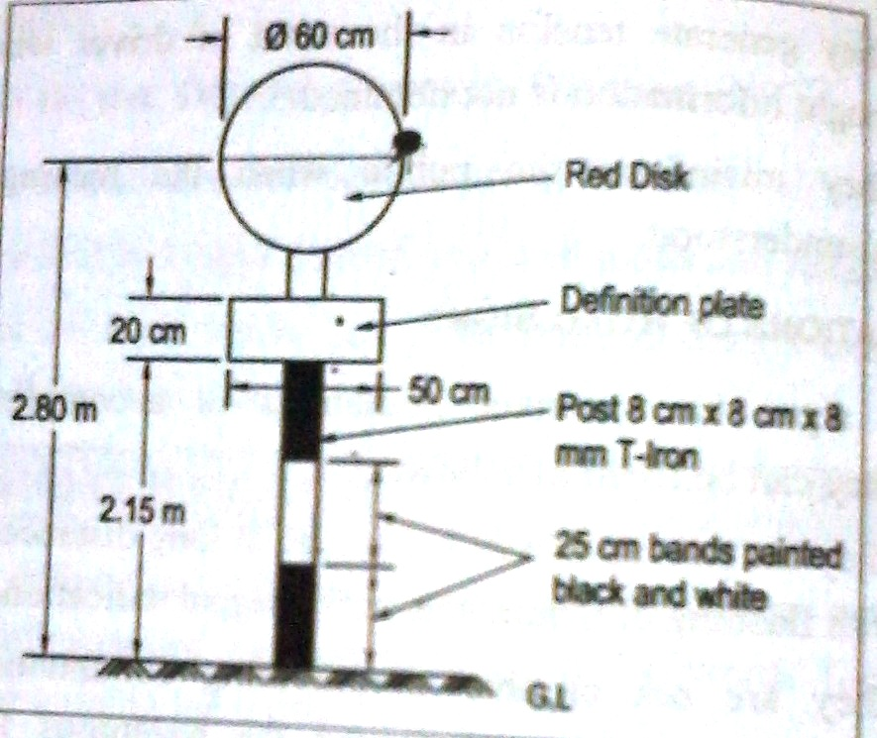
- Informatory Signs
Informatory signs are intended to guide the motorist along streets and highways, to inform him of intersecting routes, to direct him to cities, towns, villages or other important destinations, to identify nearby rivers and streams, parks, forests and historical sites and generally to give him such information as will help him along his way in the most simple, direct manner possible.
Informatory signs do not lose their effectiveness by over-use and it is desirable to erect them as frequently as is necessary, and in any case, at locations where the motorist would be in doubt.
The letters should be of such a size as can be easily read when the vehicles are moving at speed. Road Research Laboratory, U.K has resulted in the following formulae for height of letters.
$x=\frac{S}{10}+\frac{V}{100}(N+6)$ inches
$H=\frac{S}{10}+\frac{V}{100}(N+6)$ inches
Where, x – Height of small lower case letters such as x and z
H- Height of upper case letters such H and I
S- Distance of the sign from the vehicle path in feet
V- Velocity of the vehicle in miles/hour
N- Number of names on the sign
If N is assumed to be four, the above formulae further simplicity to,
$$x=\frac{S+V}{10}$$
$$H=\frac{4}{3}(\frac{S+V}{10})$$
In the above formulae, the speed limit in force may be adopted as the value of V wherever such a limit is in force, and in other cases the design speed may be used as the value of V.
The size of letters depends also upon the type of signs. For advance direction signs on rural roads, the letter size may be 8 to 15 cm. In urban areas, the letter size is 8 to 10 cm. For overhead signs, the letter size is in the range of 20-25cm; the numerical are slightly larger and are in the range of 25-30cm.
- Indication Signs
One of the sub-classes of Informatory signs is Indication signs. They generally provide information of facilities such as hospital, filling station, telephone, eating place, rest house, first-aid post etc.,
They are generally rectangular in shape.
The I.R.C Standard provides for a size of 600 mm X 450mm with a black symbol, against a white rectangle and blue background
- Direction Signs, Advance Direction Signs and Place Identification Signs
Direction signs indicate the name of the place and are rectangular in shape, terminating in the form of an arrow head. A typical form is shown in figure.
Advance direction signs are necessary at intersections of roads. They are generally rectangular in shape.
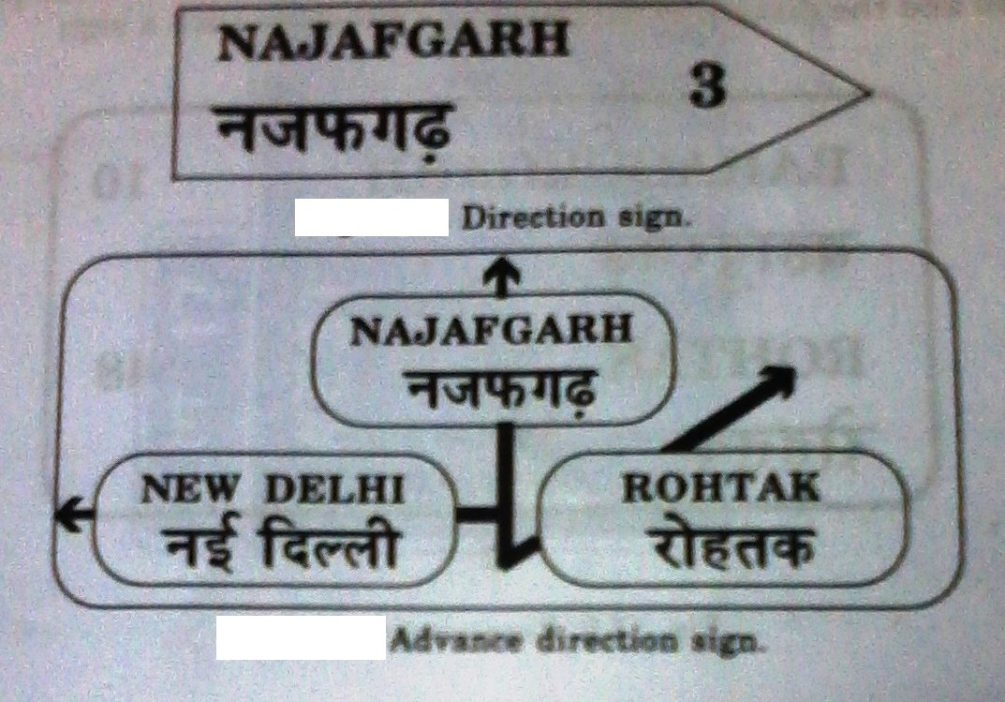
- Overhead Signs
Overhead signs are provided at locations where the following considerations exist:
- Traffic Volume at or near capacity
- Complex interchange
- Three or more lanes in each direction
- Restricted sight distance
- Closely spaced interchanges
- Multi – lane exits
- Large percentage of trucks
- Street lighting background
- High speed traffic
- Consistency of sign message location through a serious of interchanges
- Insufficient space for ground mounted signs
- Junction of an interstate route with another freeway
- Right exit ramps
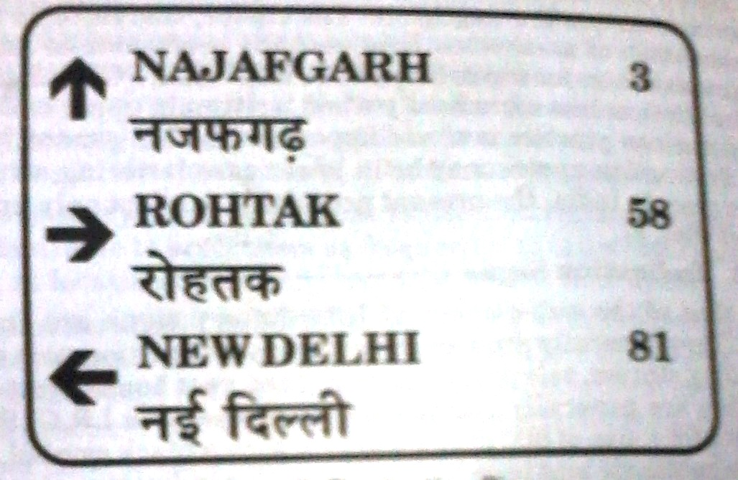

2. List out the general principles to be followed while installing traffic sign board.

(NOV/DEC 2011)
General Principles to be followed in the location of Road Signs:
- Traffic signs should be installed only by the authority of law. Unofficial and non-essential signs should not be permitted.
- For imparting a sense of respect towards signs, proper enforcement measures should be undertaken.
- Signs should be put up only after traffic engineering studies and sound engineering judgement.
- Excessive use of signs should not be resorted to. A conservative use of regulatory and warning signs is recommended as these signs, if used in excess, tend to lose their effectiveness.
- The signs should be designed for the foreseeable traffic conditions and speeds on the roads on which they are proposed to be used.
- The basic requirements of a sign are that it be legible to those using it and that it be understood in time to produce a proper response. This means,
- High visibility, both during night and day.
- Lettering or symbols of adequate size for being read from far away by a speeding driver without diverting the gaze through too great an angle.
- Location at a conspicuous position to be able to be seen by drivers, without being obscured by vehicles and other objects.
- Simplicity and uniformity in design, position and applications.
- It is desirable that there should be two sizes for each type of sign, namely, a) Standard size and b) a reduced size where conditions do not permit or the safety of road users does not require the erection of the standard size.
- The Road Signs to be located on Kerbed roads should be,
- Adjacent to the highways, should not be less than 60 cm away from the edge of the kerb.
- The bottom edge of the lowest design should not be less than 2m above the kerb (or) crown of the pavement.
- The Road signs be located on unkerbed roads should be,
- The extremely edge of the sign adjacent to the highway should be at a distance of 2 to 3 m from the edge of the carriageway depending on local conditions but in no case should any part of the sign come in the way of any vehicular traffic.
- The bottom edge of the lowest design should not be less than 1.5m above the kerb (or) crown of the carriageway.
- The dimensions for the each type of traffic sign should be used, as per the standards given.
- Necessary definition plates are to be used with the suitable word written in ‘English’ and other languages, if necessary.
- The traffic signs should fulfil the requirement completely for what it is imposed.
- The traffic sign should be provided at the following distances in advance of the hazard warned against.

S.No | Road Type | Plain/Rolling Terrain | Hilly/Mountain Terrain
1 | NH and SH | 120 m | 60 m
2 | MDR | 90 m | 50 m
3 | ODR | 60 m | 40 m
4 | Village Roads | 40 m | 30 m

3. WITH NEAT SKETCHES, EXPLAIN THE VARIOUS TYPES OF ROAD MARKINGS COMMONLY USED.

(NOV/DEC 2012), (MAY/JUNE 2013), (NOV/DEC 2013)
ROAD MARKINGS
Road markings are used as a means of controlling and guiding traffic. They are highly important on roads and intersections as they promote road safety and bring about smooth and harmonious flow of traffic along guided paths of travel.
They also serve to supplement the messages conveyed by road signals and signs. In some case, they are used alone to convey certain regulation, information or warning that cannot otherwise be effectively made known to the road users.
Despite certain limitations inherent in them, such as obliteration by snow, poor visibility when wet and the need for frequent renewals when painted on surface exposed to traffic, road markings have a useful role to play in traffic engineering.
One advantage with road markings is that they convey the required information to the driver without distracting his attention from the carriageway.

Types of Road Markings
Road markings are basically of two types: carriageway markings and object markings.
As the name implies, the former type of marking are those that are applied to the carriageway itself.
The latter type covers markings on objects such as abutment, piers, kerbs, traffic islands, culverts headwalls, etc.,
Carriageway markings are of the following categories:
- Center line
- Traffic lane lines
- No- overtaking zone markings
- Pavement edge lines
- Carriageway width reduction transition markings
- Obstruction approach markings
- Stop lines
- Pedestrian crossings cyclist crossings
- Route direction arrows etc
- Word message
- Markings at approaches to intersection
- Parking space limits
- Bus stops
Object markings are of the following categories:
- Objects within the carriageway
- Kerb marking fir visibility
- Kerb marking for parking restriction
- Objects adjacent to the carriageway
General principles of Longitudinal Pavement Markings:
The practice of pavement markings in different countries varies. However, some general principles of longitudinal pavement markings are common in many countries. Some of these are:
- Solid lines are restrictive in nature and it is an offence to cross or straddle such a line.
- Broken lines are restrictive in character and vehicles can cross such a line provided this can be done with safety.
- When a combination of a solid and broken lines is used, in countries where the traffic moves to the left (right), a vehicle should not cross the continuous line adjacent to and to the left (right) of a broken line on the right (left) of the lane in which it is moving.
- Double line indicates maximum restrictions.
Material and Colour
The material commonly used for pavement markings is paint. Ordinary paints for road markings are covered by Indian Standards IS:164-1981.
Those paints do not have a good degree of brightness and hence fail to catch instantaneously the driver’s eyes. They also have short life. The better alternative is hot applied thermoplastic paints, which are now-a-days specified for roads.
Improved night visibility is obtained by the use of minute glass beads incorporated in the markings to produce a ‘retro-reflective’ surface.
The commonly used colours for road markings are white and yellow. The usage of these colours in India is summarised in the table below.
Colour | Uses
White | All carriageway markings except those intended for parking restrictions.
Yellow | Markings intended for parking restrictions  Continuous centre and barrier line markings
Alternate bands of white and black | Kerb and object markings.

Centre lines
It is provided to demarcate the centre of a carriageway and to separate traffic in opposite directions.
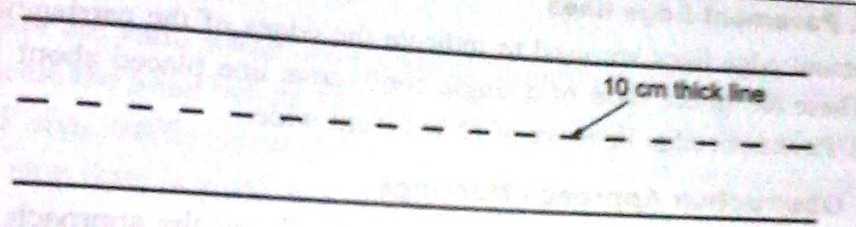
The pattern of centre line markings depends upon whether the road is in an urban section or rural section. On rural sections, the segments and gaps are double in length than for an urban location.
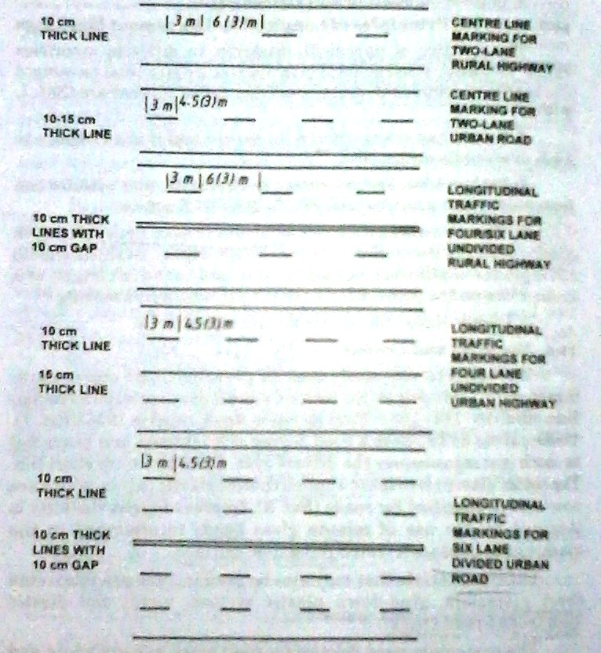

Traffic Lane Line
The division of the carriageway into separate Lanes for traffic travelling in the same direction on either side of the centre line or median strip helps to promote travel in proper lanes and curb the meandering tendency of the drivers, thus promoting safety and ensuring maximum capacity.
Traffic lane lines are broken lines which permit lane changing with caution.
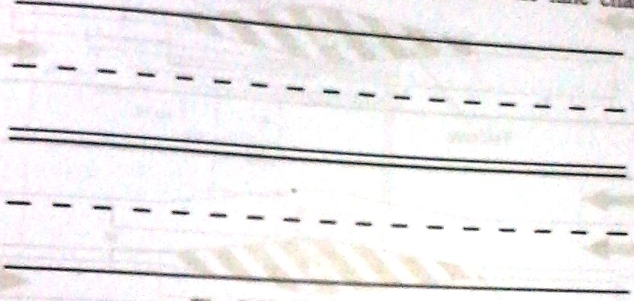
No Overtaking Zone Marking
These are provided on summit curves, horizontal curves and elsewhere in two and three lane highways where overtaking and passing manoeuvres must be prohibited because of non-availability of safe overtaking sight distances or other hazardous conditions.
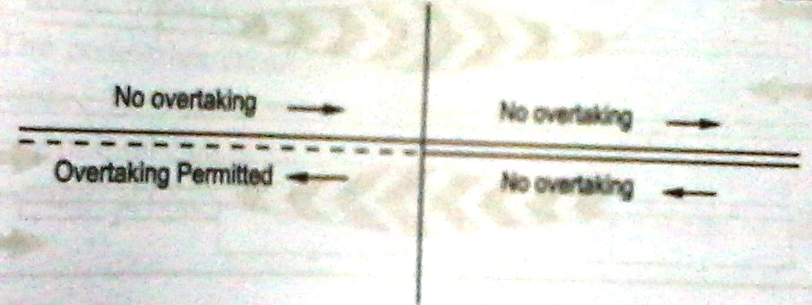
Stop Lines
Stop lines are solid white lines provided transversely to the carriageway and used to indicate the point behind which vehicles are required to stop in compliance with a STOP sign, traffic signal or traffic police. The width of the stop line as per current Indian Practice is,
Urban and sub-urban roads : 20 cm
Rural roads : 30 cm
Stop lines are ordinarily located not less than 2m and not more than 3m in advance and parallel to the nearest boundary of the pedestrian crossing marking. Where there is no pedestrian crossing, the stop line is placed not less than 1.25m and not more than 9m from the nearest carriageway edge of the intersecting road.
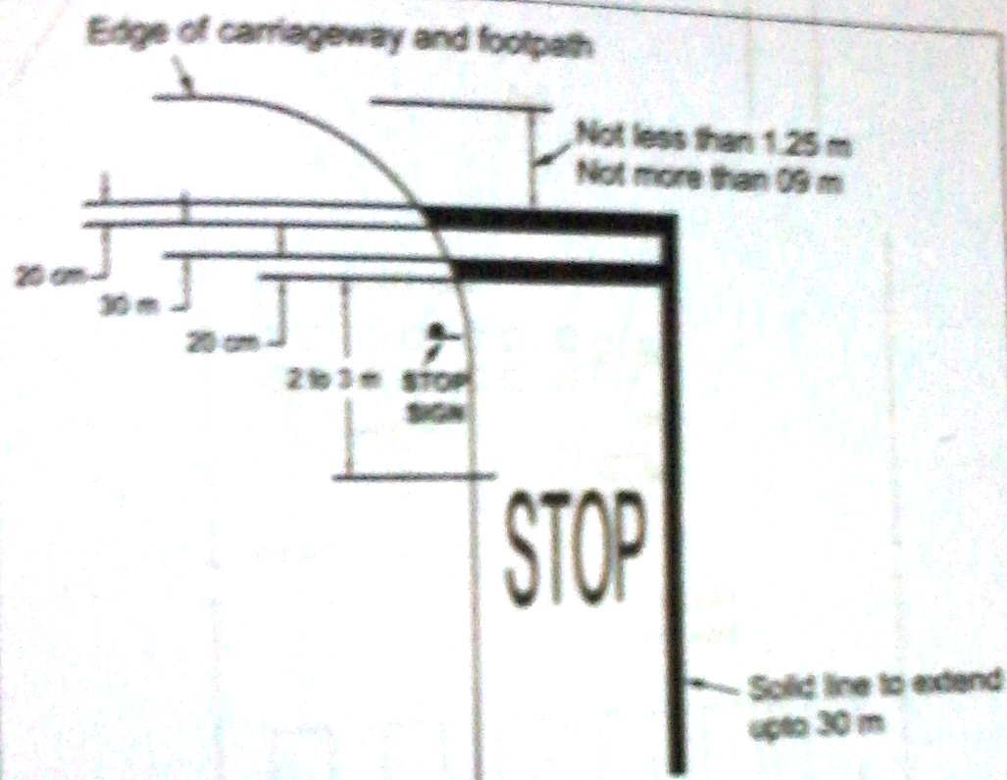
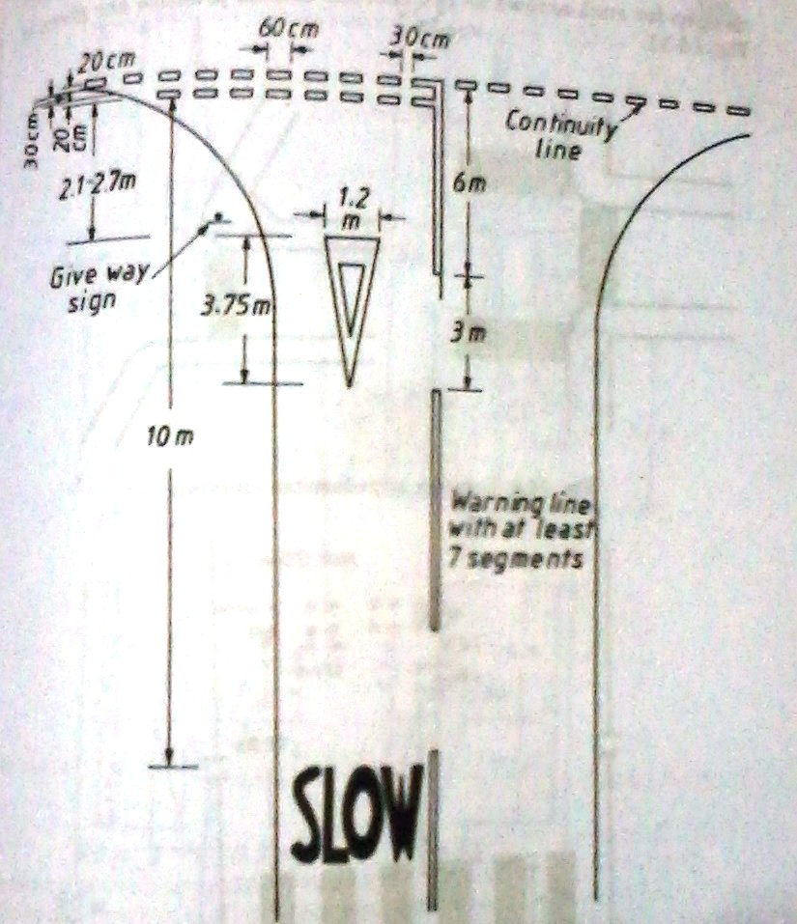
Pedestrian Crossing
They are very important for pedestrian safety as they guide pedestrians in the proper paths. They are marked at all intersections where there is substantial conflict between vehicle and pedestrian movements.
As per current Indian requirements the minimum width of the pedestrian crossing should be 2m and the maximum width should be 4m.
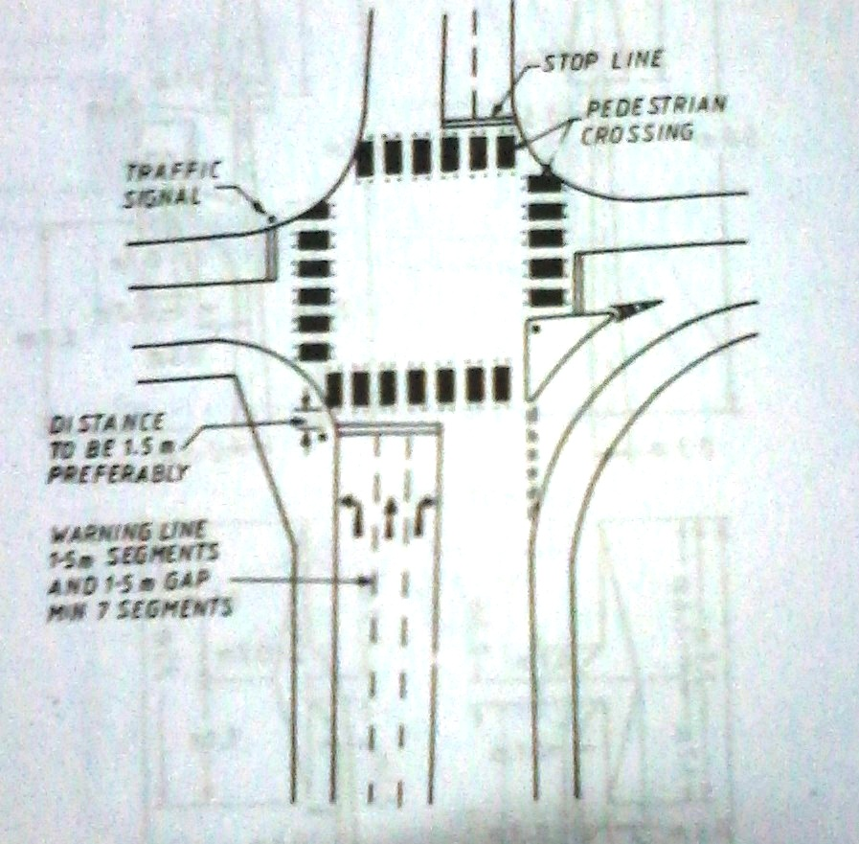

Word Message
Word messages are used to convey information to guide, warn or regulate traffic. Some of the common messages are: STOP, SLOW, SPEED 25 etc., Standard designs for letterings and numerals are available for different speeds.

4. BRIEFLY EXPLAIN ABOUT TRAFFIC SIGNALS AND THEIR ADVANTAGES AND DISADVANTAGES.

(MAY/JUNE 2013)
DESIGN OF TRAFFIC SIGNALS AND SIGNAL CO-ORDINATION
Traffic Signals:
Traffic Signals are defined as the power operated traffic control devices (or a sign) by which the traffic is controlled (or diverted) to take some specific action. A traffic control signal used to direct the traffic and to stop and permit.
At important road junctions or intersections, to control the traffic flow, the automatic traffic signals are arranged in major cities. Generally the traffic signals are in three colours namely red, amber and green.
The following figure shows the traffic signal diagram, the red colour indicates the stopping of vehicle and the green colour indicates the movement of vehicle. The amber indicates the impending change or clearance time.
In addition to the traffic signal arrows, lightings are used to indicate the directions with the traffic. Generally automatic signal system is used in the traffic signal.
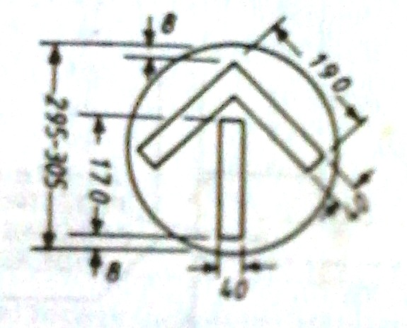
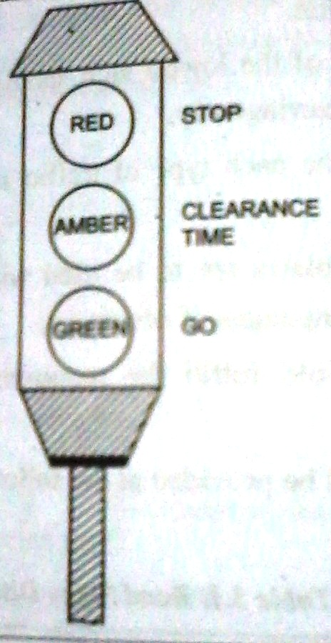
Advantages of Traffic Signals
- There is increase in the traffic handling capacity at the road junctions.
- There is overall improvement in the quality of traffic flow at the road junctions
- They allow safe crossing of the heavy traffic
- They help in reducing certain types of accidents especially those at the right angled collisions
- They permit the pedestrians to cross the roads safely and with confidence
- They prove to be economical as compares to the manual control
- They provide for the orderly movement of traffic
Disadvantages of Traffic Signals
It is found that may traffic signals have been installed where no actual need exists. The installation of an unwarranted signal generally leads to increased hazards and traffic delays and thus worsens the traffic operation rather than its improvement.
The major drawback of an automatic fixed time traffic signal is that does not adjust itself to unusual circumstances such as long processions, big crowds etc. Hence, the presence of traffic police near such signals becomes essential and necessary.
If the design and location of signals are improper, it may lead to violations of the control system.
If the signals stop working due to electric power failure or any other reason, there will be confusion among the road users.
There are chances of rear-end collisions.

Technical terms used in Traffic Signal Design
Time Cycle-It is defined as the time required for one complete sequence of signal indications
Phase- It is defined as a part of the signal cycle allocated to a traffic movement or a combination of traffic movements
Interval-it is the duration of signal cycle in which signal indications do not change
Load Factor- it is the measure of the degree of utilization of an intersection approaching roadway during one hour of traffic flow. It is the ratio of number of number of green phases that are loaded (or fully utilized by traffic) to the total number of green phases available for that approach, during that period.
Peak Hour Factor- It is the measure of consistency of demand. For intersections, it is defined as the ratio between the number of vehicles counted during the highest 15 consecutive minutes. The peak hour factor reflects variations in peaking characteristics of approach roads and provides a means of more accurately evaluating their operating characteristics. Peak hour factor can vary from 0.25 to 1. But the most common values are in the range of 0.7 to 0.9.
Queue Length- this is level of service of a signalized intersection. It involves the number of waiting vehicles which accumulate during each signal cycle.
Offset- it is the time difference between the beginning of a green phase at the intersection and the beginning of a green phase at the next intersection, in seconds.
Approach- it is the portion of an intersection leg that is used by traffic approaching the intersection.
Time spacing- it is the average time between two vehicles following each other.

5. EXPLAIN THE VARIOUS TYPES OF TRAFFIC SIGNALS AND THEIR FUNCTIONS.

(NOV/DEC 2012)
Types of Traffic Signals
- Traffic Control Signals
- Fixed time signals
- Manually operated signals
- Traffic actuated (automatic) signals
- Pedestrian Signals
- Linked Signals
- Flashing Signals
Design of Signal
- The Stop Time (or) Red Phase Time (R₁) of a signal is the sum of ‘Go’ and ‘Clearance’ intervals (or) Green and Amber phases for the cross-flow. [G2 + A2 at a two phase Signal]. During this time the pedestrian crossing time may also be incorporated for the road, if turning moment is not permitted.
- Towards the end of the Red Phase Time (R₁), there may be a short duration when the amber lights are put on along with red light signal in order to indicate get set to go. This is the final part of the Red Phase itself and it is called Red-Amber Phase or Initial Amber Phase. The vehicles are not supposed to cross the stop line during Red Amber Period.
- Clearance Amber Phase (or) Clearance Time is provide immediately just after the green phase before the red phase, for the following two purposes.
- Stopping time for approaching vehicle to stop at stop line, after the signal changes from green to amber and not to cross the line by the time signal changes to red phase.
- Clearance time for the vehicles, which is approximately the stop line at legal speed, when the signal changes from green to amber.

Design Methods
The traffic signal system can be designed by the following four methods.
- Trial Cycle Method
- Approximate Method
- Webster’s Method
- IRC Method
- Trial Cycle Method
- The 15 minutes traffic counts N₁ and N₂ on road 1 and 2 are noted, during the ‘Design Peak Hour Flow’
- Some suitable trail cycle ‘C₁’ second is assumed and the number of assumed cycles in the minutes (or 15 x 60 = 90 seconds) period is $\frac{900}{C1}$
- Assuming average time headway 2.5 seconds, the Green periods G₁ and G₂ of the road 1 and the road 2 are calculated to clear the traffic during the trial cycle.
$$G1= \frac{2.5 N1 C1}{900} G2= \frac{2.5 N2 C1}{900}$$
- The Amber periods, A₁ and A₂ are either calculated or assumed suitably (2 to 5 seconds) and the length C₁ is calculated and it is equal (G₁+G₂+A₁+A₂)
- If the calculated Cycle Length C₁ works out to be approximately equal to the assumed cycle length C₁, the cycle length is accepted as the design cycle. Otherwise the trials are repeated till the trial cycle worked out approximately equal to the calculated value.
- Approximate Method
According to the traffic requirements, timing of a single signal can be determined. The cycle time of a single signal should be normally 40 sec to 60 sec. The maximum cycle time should be 120 seconds. The following procedure may be adopted to calculate the cycle time,
- Determine the pedestrian crossing time. It is done in all approaches and it is based on the average walking speed of the pedestrian. (Average Value of pedestrian walking speed is 1 m/sec)
- These values will be minimum Green plus Amber time for every phase.
- Compute the Green plus Amber time in proportion to approach volumes per approach lane and no phase should be less than 15 sec
- Adjust Cycle Time (Sum of all phases) to next higher 5 sec interval and recomputed the phase values.
- Select amber periods based on approach roads. The following table is used for the selection of Amber Periods.

S.No | Approach Speed (Kmph) | Amber Period (Sec)
1 | 0 to 50 | 3
2 | 50 to 65 | 4
3 | 65 to 80 | 5
4 | Above 80 | 5(Plus all red Periods)

- Calculate percentage value for all phases. (Total Value should be 100%)
- Computed timing should be installed in the controller and the operation of the intersection observed especially during peak conditions
- Field correction of the timings may be used to prove smooth flow.
- Webster’s Method
In this method, the Optimum Signal Cycle Time (C₀) corresponding to the least total delay to the vehicles at the intersection (with signal) has been worked out. This is rational method and the field study for this method consists of the following:
- The saturation flow ‘S’ per unit time
- The normal flow, on its approach during the design hour (f1)
Based on the higher value of normal and the ratio $x1=\frac{f1}{S1}$ and $x2=\frac{f2}{S2}$ are determined on the approach road 1 and approach road 2.
In case .of mixed traffic, it is necessary to convert all the normal flow and saturation flow values in terms of suitable PCU Values which should be determined separately.
The saturation flow ‘S’ is to be calculated from the detailed studies by counting the number of vehicles in the traffic flow of compact flow, during the Green Phases and the corresponding time intervals.
In the absence of data, the approximate value of the saturation flow is estimated by assuming 160 PCU per 0.3 m width of the approach. The normal flow of the traffic is also determined on the approach roads from the field studies for the design period.
Optimum Cycle Period,$C0= \frac{1.5 T+5}{1-X}$ sec
Where, T – Loss in time due to the starting time and termination time
X – x₁+x₂+...........+x_{n} and
$x1=\frac{f1}{S1}$ $x2=\frac{f2}{S2}$ and $xn=\frac{fn}{Sn}$
And T = 2n + R
n – Number of Phases
R – All Red time in seconds
F1,f2... – flow in legs 1,2......
S1,s2,... – Saturation flow in legs 1,2...
The amber time is assumed to be 2 to 5 seconds and generally 3 seconds
The saturation flow, $S=525 W$ PCU/hr
Where,
W- Width of the roadway (in m)
- IRC Method
- The pedestrian green time, required for the major and minor roads are calculated based on minimum green walking speed 1m/sec and the initial walking time of 0.7 sc. These are the minimum green time required for the vehicular traffic on the minor and major roads respectively.
- The green time required for the vehicular traffic on the major road is increased in proportion to the traffic on the two approach roads.
- The cycle time is calculated after allowing the amber time of 2 seconds each
- The minimum green time required for clearing vehicles arriving during a cycle, vehicle will take 6 seconds. The minimum green time required for the vehicular traffic on any one of the approaches is limited to 16 seconds
- The optimum signal time is calculated using the Webster’s formula. The lost time is calculated from the amber time; inter green and the initial delay of 40 seconds, for the first vehicle on each leg.
- The signal cycle time and the phases may be revised keeping in view the green time required for clearing the vehicles and the optimum cycle length determined in step 4 and 5 above.
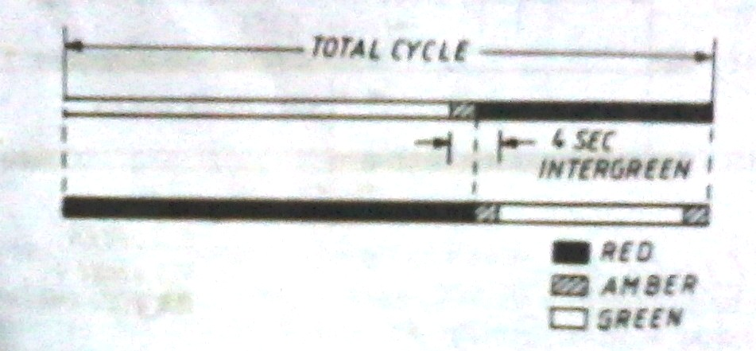
Signal Coordination
Need for co-ordinated control of signals arises on a main traffic route when it is desirable to reduce delays and avoid main traffic from having to stop at every junction. When a signal indicates a stop aspect at a junction, a queue of vehicles is formed behind the stop line. When the signal changes to green, the vehicles start moving in a platoon. If this platoon is made to meet a green aspect at the next junction no delay is caused to the vehicles. This principle of linking adjacent signals so as to secure maximum benefits to the flow of traffic is called co-ordinated control of signals.
The co-ordination of signals is sought for with the following objectives in view:
- To pass the maximum amount of traffic without enforced halts
- To have minimum overall delay to traffic streams, both in the main and side roads.
- To prevent the queue of vehicles at one intersection from extending and reaching the next intersection.

6. WRITE BRIEF NOTE ON TRAFFIC CONTROL AIDS AND STREET FURNITURE.

TRAFFIC CONTROL AIDS AND STREET FURNITURE
Traffic Control Aids
- Roadway delineators
- Barricades & Channelisers
- Safety Barriers
- Railings
- Traffic signs
- Overhead traffic signs
- Traffic signal posts
- Traffic impact attenuators
- Traffic aid posts
- Hazard markers and object markers
- Speed breakers
Road Beautification
- Tree guards
- Planters

Facilities
- Bus stands
- Taxi stands
- Roadside toilets
- Roadside rest areas

Information Providers
- Roadside advertisements

Principles of Street Furniture Design
The following are the general principles to be in mind while selecting and designing street furniture items:
- Only these items which are absolutely necessary should be provided. Superfluous items clutter the streetscape. Sometime it is possible to combine light poles and signal posts.
- The initial cost and cost of maintaining the facilities must be given due consideration
- The materials selected should be durable
- The design should be vandal proof
- The designs should be aesthetically pleasing and match with the surroundings

Roadway Delineators
These are intended to provide visual aids to drivers concerning the alignment of the road, especially at night. They are effective in locations where the horizontal and vertical geometry change and during severe weather conditions such as rain, fog or snow. Generally delineators are reflectorised for better visibility during night.
Roadway delineators are generally in the form of guide-posts of metal, concrete, timber or cut stone, having a circular, rectangular or triangular cross section.
The side facing the traffic should have a dimension not less than 10 cm. They should be 80-100cm high.
As an alternative, empty bitumen drums, suitably pained may also be used.
Hazard Markers
Hazard markers are intended to define obstructions like guard-rails and abutments adjacent to the carriageway.
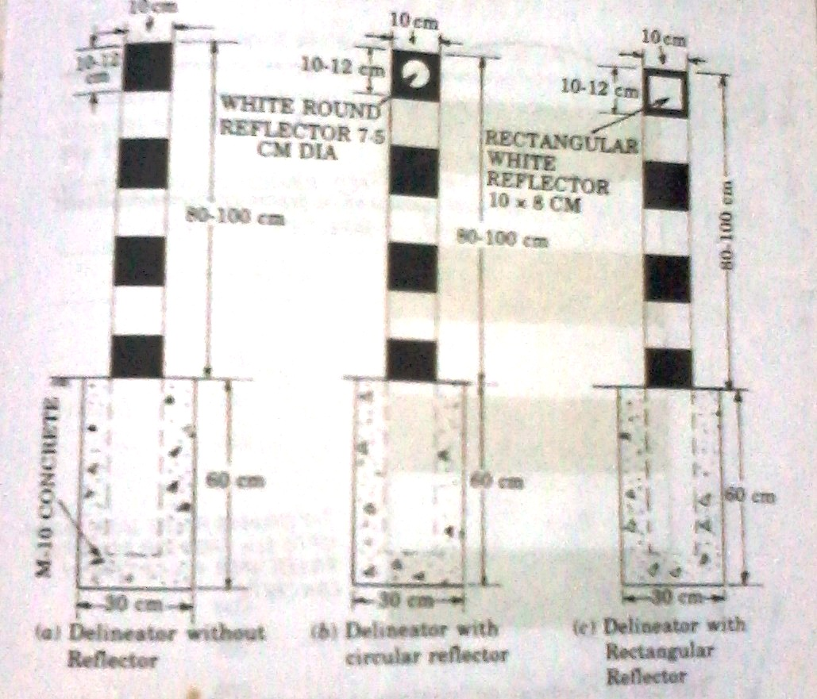
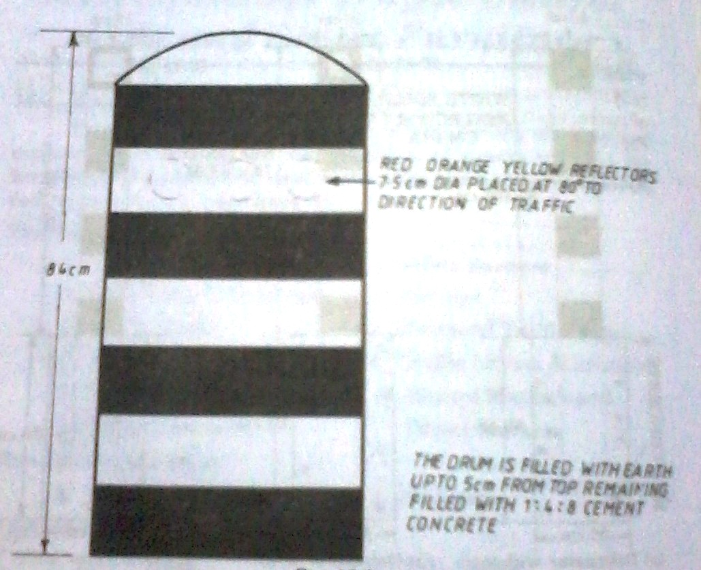
Object Markers
Object markers are used to indicate hazards and obstructions within the vehicle path for example channelizing islands close to the intersections. Typical applications are in the following locations:
- Traffic Islands at approaches to intersections
- Around periphery of rotary islands
- Median openings
- Facing approaching traffic at islands forming left infiltration lane
- On medians/islands on far side of the intersections
- At points where traffic divides into different directions e.g., down ramps of a grade separated intersection
- On far side of T-Junctions and street dead-ends.
- The markers should be set back from the face of the kerb at least by 50 cm.
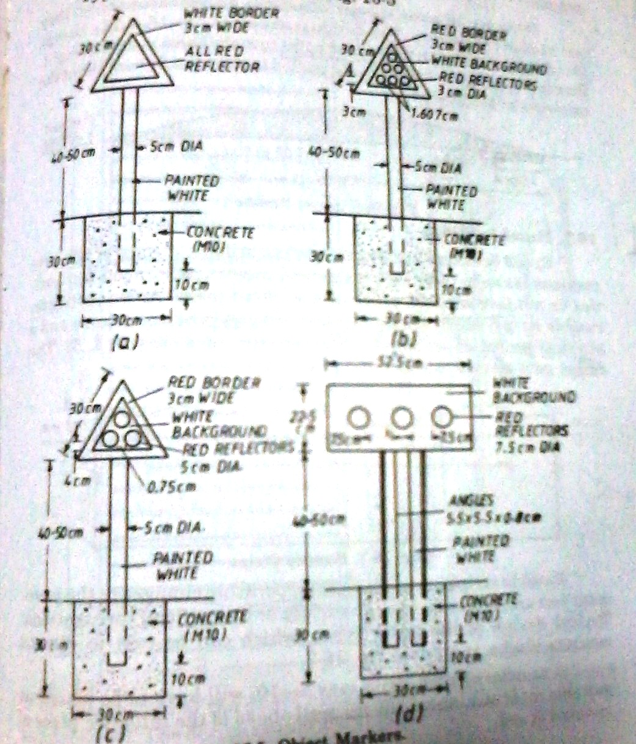
Speed Breakers
Speed breakers also known as speed control humps which are commonly used on private access roads and near schools and universities in urban situations.
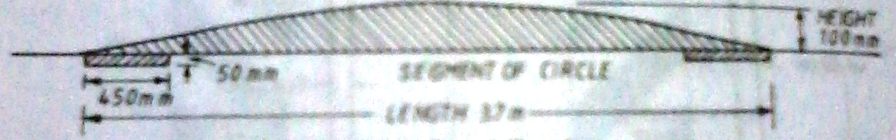
The humps should also be posted to alert the drivers about the existence of the humps.
Barricades and Channelisers
Barricades and Channelisers are required by controlling and diverting traffic on construction zones and temporary diversions.

7. with necessary sketch, explain in detail about STREET lighting.

STREET LIGHTING
Necessity of Street Lighting:
Street lighting is primarily intended to enable the road users (motorists, cyclists and pedestrians) to see accurately and easily the carriageway and the immediate surroundings in darkness. A large proportion of the road accidents are caused in the night and one of the chief reasons is the unsatisfactory lighting.
Driving in the night is facilitated by the head-lights. But it is always not possible to depend on head-lights. For instance, in city streets if all vehicles were to drive with the full head-lights on, the glare problem would become acute and severe accidents could be caused.
Improved visibility at night by means of artificial lighting lessens the strain on driving and ensures comfort. The drivers feel more confident in their manoeuvres and avoid jerky and dangerous driving.
Since the speed of traffic generally improves with better lighting, traffic flow conditions also improve. Favourable headway and lateral placements are brought about and the ability of the road to handle traffic is vastly improved.
Indirect benefits include reduction in crime, promotion of the aesthetic appearance of the surroundings and extension of business hours after sun set.
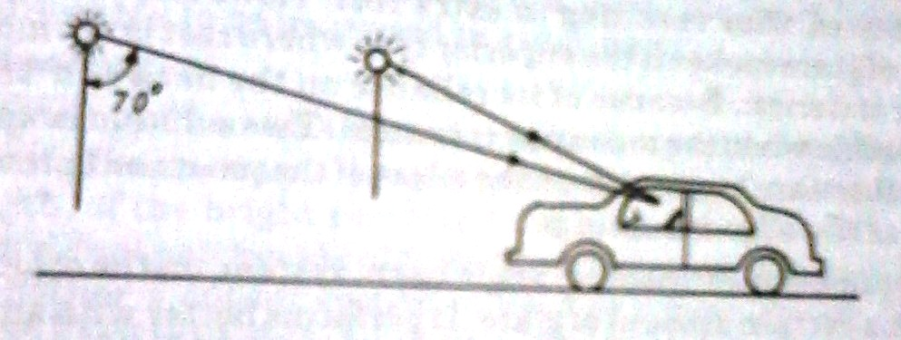
Note: Light rays emitted at angles less than about 70⁰ from the downward vertical cannot cause glare.
Types of Lamps
The principle energy sources employed for street lightings are gas and electricity. Gas used to be a popular source some years ago, but the versatility and convenience of electricity has made it the widely used energy source of the present day.
There is a large variety of electric lamps available for street lighting purpose. Considerations such as initial cost, life, colour, rendering, wattage, brightness, efficiency etc., govern the choice. The following are the main types of lamps:
- Tungsten filament
- Tabular fluorescent
- Sodium vapour discharge
- High pressure mercury discharge
Maintenance of Lighting Installation
For ensuring safety, a very high standard of maintenance of lighting installations is called for cleaning of lamps and replacement of faulty lamps should carried out at regular intervals.
Factors affecting the Street Lighting
- Distribution of Light
- Position of Posts
- Types of Power of Sources
- Spacing of Lamps
- Overhang
- Avoidance of glare
- Mounting Height etc.,

Arrangement of Lamps at Junctions
Lamp Arrangement in Square Junction
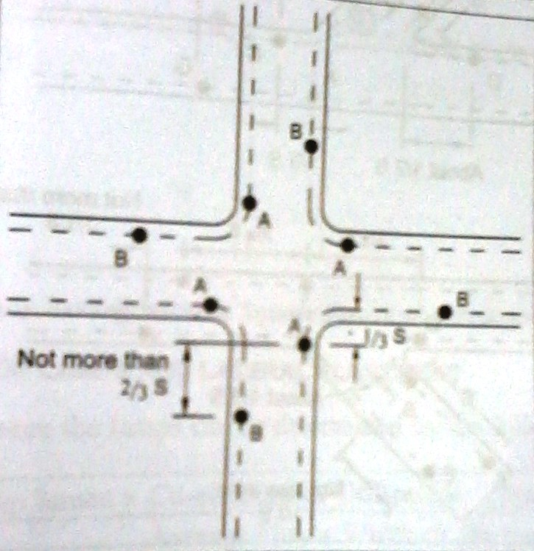
Lamp Arrangement in T- Junction
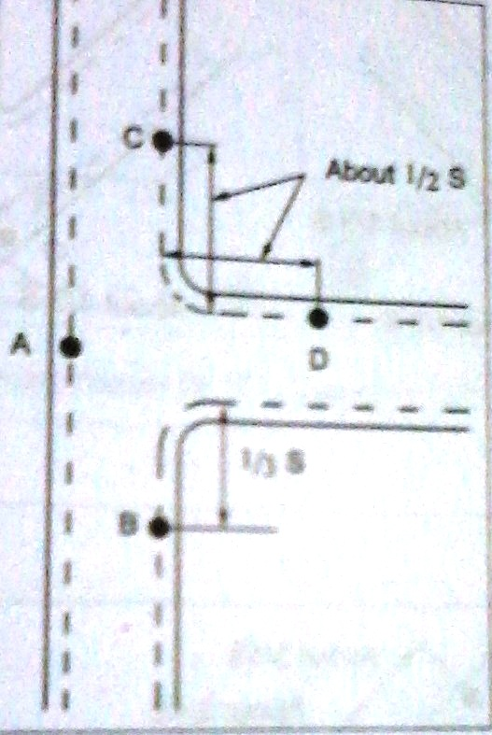

Lamp Arrangement in Y- Junction
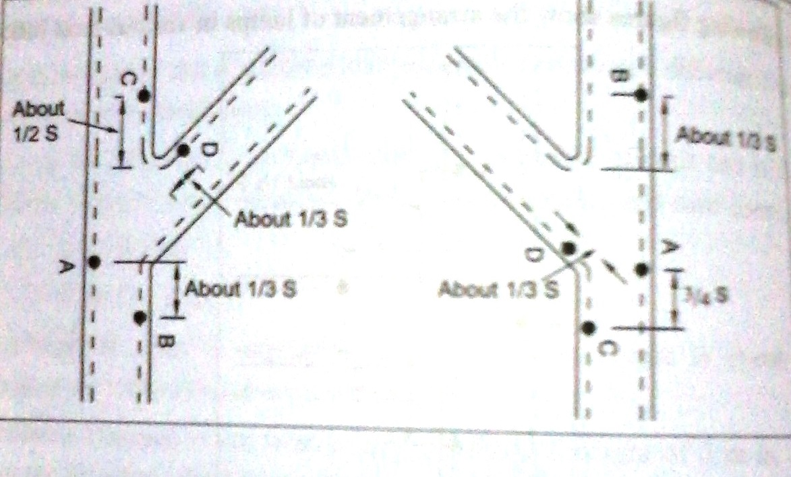
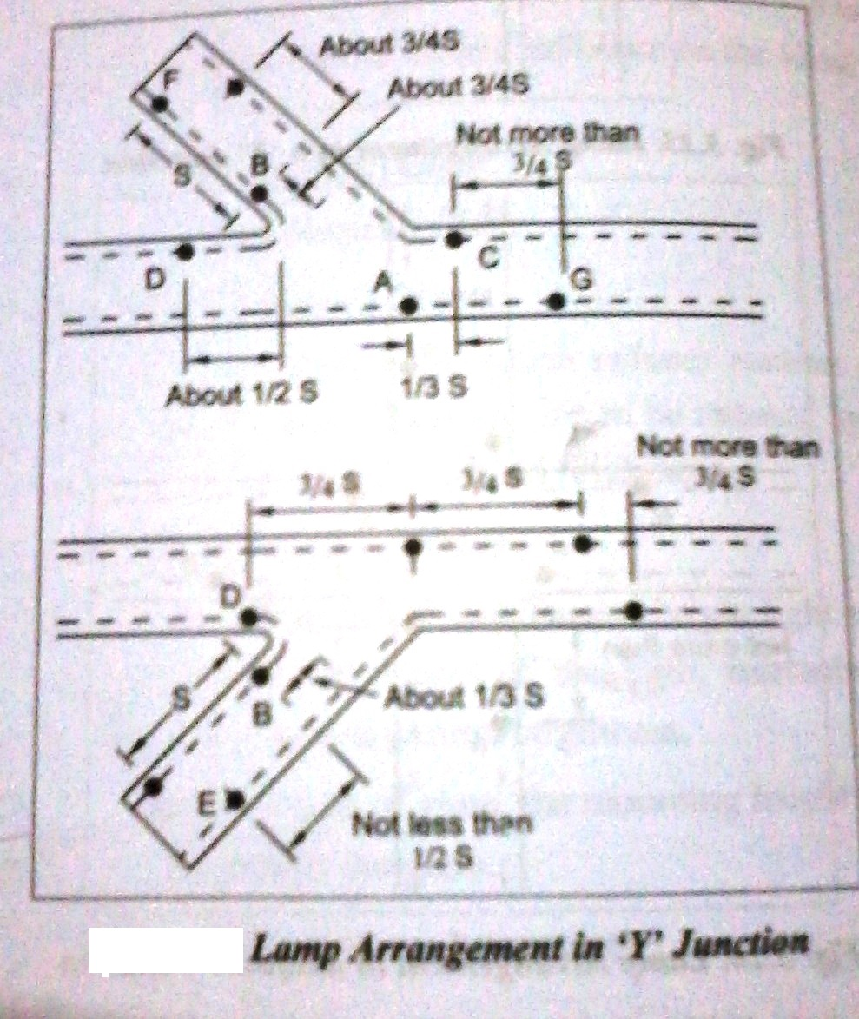

Lamp Arrangement in Square Junction of Pedestrian Crossing
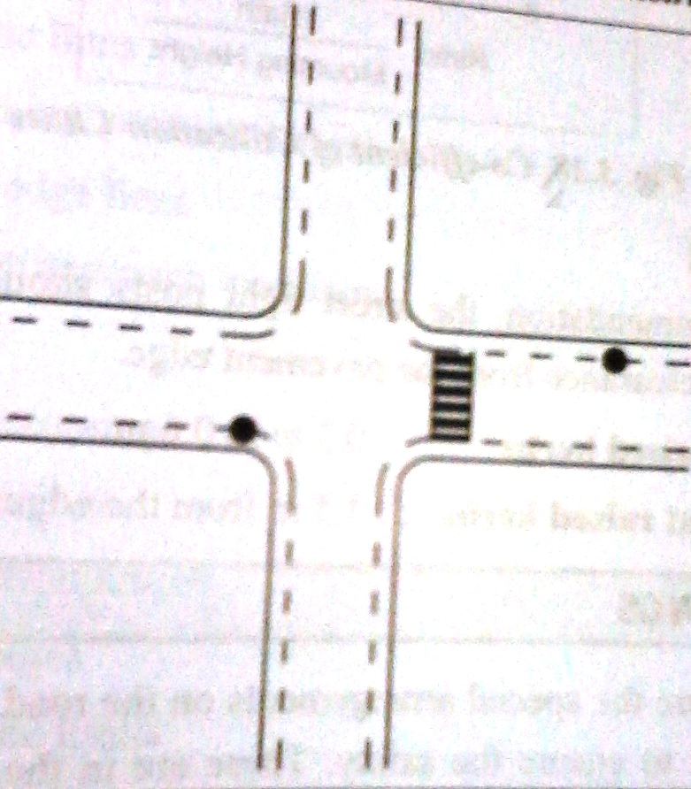
Lamp Arrangement in T-Junction of Pedestrian Crossing
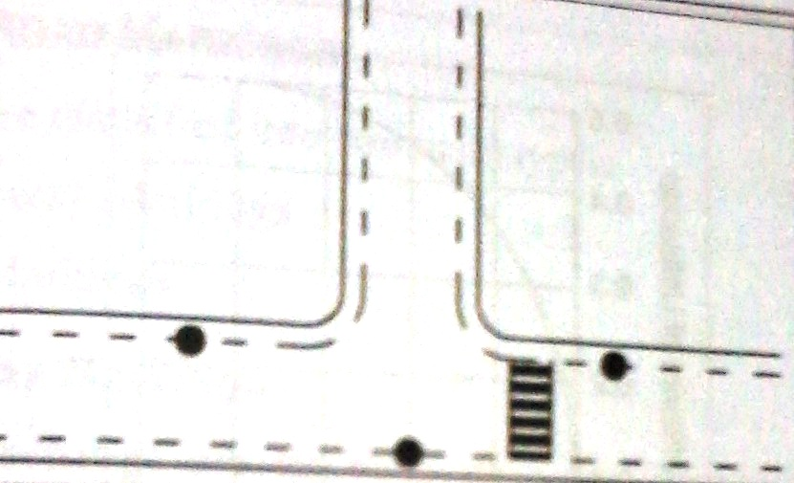

8. Explain in detail about COMPUTER APPLICATIONS IN SIGNAL DESIGN
.

COMPUTER APPLICATIONS IN SIGNAL DESIGN
A computer application in road traffic has received increasing attention in the last decade. There are many problems, such as congestion and incident management, signal control optimization, public transport priority.
1. Traffic Controls such as :
. Traffic lights   | b. Speed Cameras  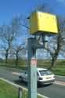 | c. Road Sensors  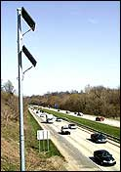 | d. Electronic Signs  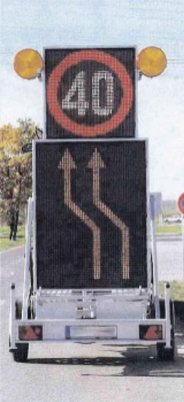
2. Road/Traffic Information
 |  | National Traffic Information | California Road Information
The main Source for Road/Traffic Information is the Internet. There are many web pages which provide real-time information about the roads and traffic throughout the country.
3. Road traffic management:
Reducing Congestion through Visualization
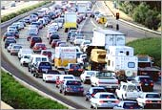
Most major cities have become virtually impenetrable because of heavy traffic conditions. To combat this problem, improve safety on the roads and reduce air pollution, cities are equipping their road traffic controllers with visualization systems like those built with ILOG software. ("Intelligence" and "LOGiciel”)
Visualization solutions powered by ILOG clearly and accurately display the flow of automobiles through the cities and surrounding areas. Information such as number of vehicles, average speed and road conditions are shown in a map-based display. Controllers can make quick decisions, using signaling systems -- stoplights and information boards -- to manage traffic glow to prevent or reduce road congestion and air pollution, moving cars through areas faster.
Real-time monitoring
Today's road traffic controllers need highly reliable and intuitive graphical user interfaces (GUIs) that enable real-time monitoring of traffic and on-screen interaction with data sources and signaling equipment. These GUIs must consolidate information, taking data from diverse sources -- sensors, cameras and databases, for example -- and display it in a well-organized, highly ergonomic graphical environment. The traffic controller needs to be able to spot potential congestion points and immediately take steps to prevent traffic jams from occurring.
Fully interactive displays Major cities around the world have adopted ILOG visualization technology to manage traffic in real time. ILOG supplies everything necessary for quickly building fully interactive GUIs. (Graphical User Interface)
4. Parking Access and Revenue Control Solutions:
a. ScanNet Parking Management System
The ScanNet parking software management system processes information that is collected in parking lanes. This management system is a user-friendly software package that allows operators to generate and process reports on all activities that are taking place in the parking facility. All information that is collated from various information sources can be processed using ScanNet.
b. License Plate Readers
License Plate Recognition is an example of a system we offer that has a wide range of revenue control and security applications. You can use the extracted plate information and images to create automated solutions for various problems. The plate number is used to:
- Reduce ticket fraud
- Calculate parking time
- Calculate fees for lost tickets
- Control traffic
- Verify access and exit through extracted images
- Control access in secured areas
- Provide license plate data to local and federal law enforcement agencies when requested

CE 2026 TRAFFIC ENGINEERING AND MANAGEMENT
UNIT III - TRAFFIC CONTROL
PART A (2 MARKS QUESTIONS WITH ANSWERS)

- Write the Importance of Traffic Signs.
- Traffic signs perform a number of functions:
- They give timely warning of hazardous situations when they are not self evident.
- They are of great help in regulating traffic by imparting messages to the drivers about the need to stop, give way and limit their speeds.
- They give information as to highway routes, directions and points of interest.
- What is the need for International Standardization in Traffic Signs?
In order to facilitate people travelling from one country by road in another country where the language may be different, standardization of traffic signs assumes considerable importance.
Adaptation of a uniform system of traffic signs by various countries is best with a number of problems, one of the principles commonly agreed to by all the signatory countries is the adoption of graphic symbols to convey messages, rather than lettered messages.
- List the any four General Principles of Traffic Signing.
- Traffic signs should be installed only by the authority of law. Unofficial and non-essential signs should not be permitted.
- For imparting a sense of respect towards signs, proper enforcement measures should be undertaken.
- Signs should be put up only after traffic engineering studies and sound engineering judgement.
- The signs should be designed for the foreseeable traffic conditions and speeds on the roads on which they are proposed to be used.
- Enlist the types of Traffic Signs.
- Danger signs, also known as Warning Signs or Cautionary Signs
- Signs giving definite instruction, also known as Regulatory Signs in some countries
- Prohibitory Signs
- Mandatory Signs
- Information Signs
- Indication Signs
- Advance direction signs and direction signs
- Place and route identification signs

- Write the Necessity of Danger Signs.
Danger signs (Warning Signs or Cautionary Signs) are used when it is deemed necessary to warn traffic of exiting of potentially hazardous conditions on or adjacent to a highway or street.
Warning signs are of great help in ensuring safety of traffic. The use of warning signs should be kept to a minimum, however, because their unnecessary use tends to breed disrespect for all signs.
- What is the purpose of Prohibitory Signs?
These signs are part of the regulatory signs, which are intended to inform the highway users of traffic laws or regulations. The prohibitory signs give definite negative instruction prohibiting motorist from making particular manoeuvres.
- Write note Mandatory Signs.
Mandatory signs are part of regulatory signs and are intended to convey definite positive instructions when it is desired that motorists take some positive action. The two most important mandatory signs are the,
- STOP sign and
- YIELD or GIVEWAY
- Define Informatory Signs.
Informatory signs are intended to guide the motorist along streets and highways, to inform him of intersecting routes, to direct him to cities, towns, villages or other important destinations, to identify nearby rivers and streams, parks, forests and historical sites and generally to give him such information as will help him along his way in the most simple, direct manner possible.
- List any Four Regulatory Signs. (NOV/DEC 2012)
- Direction
- Keep Left
- No turn
- Overtaking Prohibited
- What is Road Markings?
Road markings are used as a means of controlling and guiding traffic. They are highly important on roads and intersections as they promote road safety and bring about smooth and harmonious flow of traffic along guided paths of travel.
- What are the types of Road Markings?
Road markings are basically of two types: carriageway markings and object markings.
As the name implies, the former type of marking are those that are applied to the carriageway itself. The latter type covers markings on objects such as abutment, piers, kerbs, traffic islands, culverts headwalls, etc.,
- Define Traffic Signals.
Traffic Signals are defined as the power operated traffic control devices (or a sign) by which the traffic is controlled (or diverted) to take some specific action. A traffic control signal used to direct the traffic and to stop and permit.
- Write any four Advantages of Traffic Signals.
- There is increase in the traffic handling capacity at the road junctions.
- There is overall improvement in the quality of traffic flow at the road junctions
- They allow safe crossing of the heavy traffic
- They permit the pedestrians to cross the roads safely and with confidence
- Write any three Disadvantages of Traffic Signals.
If the design and location of signals are improper, it may lead to violations of the control system.
If the signals stop working due to electric power failure or any other reason, there will be confusion among the road users.
There are chances of rear-end collisions.
- Define Queue Length.
This is level of service of a signalized intersection. It involves the number of waiting vehicles which accumulate during each signal cycle.
- What are all the types of Traffic Signals?
- Traffic Control Signals
- Fixed time signals
- Manually operated signals
- Traffic actuated (automatic) signals
- Pedestrian Signals
- Linked Signals
- Flashing Signals

- What is Red-Amber Phase?
Towards the end of the Red Phase Time (R₁), there may be a short duration when the amber lights are put on along with red light signal in order to indicate get set to go. This is the final part of the Red Phase itself and it is called Red-Amber Phase or Initial Amber.

- What is Phase?
It is defined as a part of the signal cycle allocated to a traffic movement or a combination of traffic movements.
- Write down the formula to calculate Optimum Cycle Time. (NOV/DEC 2011)
Optimum Cycle Period,$C0= \frac{1.5 T+5}{1-X}$ sec
Where, T – Loss in time due to the starting time and termination time
X – x₁+x₂+...........+x_{n} and
$x1=\frac{f1}{S1}$ $x2=\frac{f2}{S2}$ and $xn=\frac{fn}{Sn}$
And T = 2n + R
n – Number of Phases
R – All Red time in seconds
F1,f2... – flow in legs 1,2......
S1,s2,... – Saturation flow in legs 1,2...

- What is meant by saturation flow? (NOV/DEC 2011)
The saturation flow rate crossing a signalized stop line is defined as the number of vehicles per hour that could cross the line if the signal remained green all of the time. It is not practical to measure this quantity directly in the field because the signal does not usually remain green for more than a minute or so on each cycle.
The units of saturation flow rate are “vehicles per hour of green” (vphg). This is sometimes expressed on a per-lane basis as “vehicles per hour of green per lane.”

- What are the objectives of Signal Co-ordination? (NOV/DEC 2011)
The co-ordination of signals is sought for with the following objectives in view:
- To pass the maximum amount of traffic without enforced halts
- To have minimum overall delay to traffic streams, both in the main and side roads.
- To prevent the queue of vehicles at one intersection from extending and reaching the next intersection.
- Write down any two advantages of Vehicle Actuated Signal. (NOV/DEC 2013)
These signals are automatically adjusted to meet the requirements of the traffic. This system is the best method of signalling at intersections, subjected to variation in volume. This system is used to minimise the vehicle delay, to increase intersection capacity and to reduce the accident rates and collisions of vehicles.

- Write the necessity of Street Lighting.
Street lighting is primarily intended to enable the road users (motorists, cyclists and pedestrians) to see accurately and easily the carriageway and the immediate surroundings in darkness. A large proportion of the road accidents are caused in the night and one of the chief reasons is the unsatisfactory lighting.

- List the types of Lamps.
- Tungsten filament
- Tabular fluorescent
- Sodium vapour discharge
- High pressure mercury discharge

- List the Factors affecting the Street Lighting.
- Distribution of Light
- Position of Posts
- Types of Power of Sources
- Spacing of Lamps
- Overhang
- Avoidance of glare
- Mounting Height etc.,

- What are the different methods by which Street Light arrangement can be done? (NOV/DEC 2011)
- Two –way lateral Distribution (Type 1)
- Narrow Asymmetrical Lateral Distribution (Type 2)
- Narrow width Asymmetrical Lateral Distribution (Type 3)
- Width Asymmetrical Lateral Distribution (Type 4)
- Normal Symmetrical Distribution (Type 5)

- State the factors governing the spacing of lanterns in Street Lighting. (NOV/DEC 2012)
- Shape of the lanterns
- Length of the lanterns
- Brightness of the lanterns

- Differentiate between “Silhouette and Reverse silhouette” in Street Lighting. (NOV/DEC 2013)

Silhouette | Reverse silhouette
When a unit object on the roadway is discerned, due to the object appears darker than the background discernment is by Silhouette | When the object brighter than its background, discernment is given by Reverse silhouette

- List the computer Applications in Signal Design.
- Traffic Controls such as: Traffic lights, Speed Cameras, Road Sensors and Electronic Signs
- Road/Traffic Information
- Road traffic management
  - Reducing Congestion through Visualization
  - Real-time monitoring
- Parking Access and Revenue Control Solutions
  - ScanNet Parking Management System
  - License Plate Readers

