CE 6006 TRAFFIC ENGINEERING AND MANAGEMENT
UNIT IV
TRAFFIC SAFETY AND ENVIRONMENT

Road accidents – Causes, effect, prevention, and cost – Street lighting – Traffic and environment hazards – Air and Noise Pollution, causes, abatement measures – Promotion and integration of public transportation – Promotion of non-motorized transport.

1. write the causes and effects of road accidents.

ROAD ACCIDENTS – CAUSES, EFFECT
Accident is an unfortunate incident that happens unexpectedly and unintentionally, typically resulting in damage or injury.
The problem of accident is a very acute in highway transportation due to complex flow pattern of vehicular traffic, presence of mixed traffic along with pedestrians. Traffic accident leads to loss of life and property. Thus the traffic engineers have to undertake a big responsibility of providing safe traffic movements to the road users and ensure their safety. Road accidents cannot be totally prevented but by suitable traffic engineering and management the accident rate can be reduced to a certain extent. For this reason systematic study of traffic accidents are required to be carried out. Proper investigation of the cause of accident will help to propose preventive measures in terms of design and control.
Objectives of accident studies
1. To study the causes of accidents and suggest corrective measures at potential location
2. To evaluate existing design
3. To compute the financial losses incurred
4. To support the proposed design and provide economic justification to the improvement suggested by the traffic engineer
5. To carry out before and after studies and to demonstrate the improvement in the problem.
Causes of road accidents
The various causes of road accidents are:
1. Road Users - Excessive speed and rash driving, violation of traffic rules, failure to perceive traffic situation or sign or signal in adequate time, carelessness, fatigue, alcohol, sleep etc.
2. Vehicle - Defects such as failure of brakes, steering system, tyre burst, lighting system.
3. Road Condition - Skidding road surface, pot holes, ruts.
4. Road design - Defective geometric design like inadequate sight distance, inadequate width of shoulders, improper curve design, improper traffic control devices and improper lighting,.
5. Environmental factors -unfavorable weather conditions like mist, snow, smoke and heavy rainfall which restrict normal visibility and makes driving unsafe.
6. Other causes -improper location of advertisement boards, gate of level crossing not closed when required etc.

Speeding

Drunk Driving

Reckless Driving

Rain

Teenage Drivers

Night Driving

Design Defects

Unsafe Lane Changes

Wrong-Way Driving

Improper Turns

Tailgating

Driving Under the Influence of Drugs

Potholes

Drowsy Driving

Animal Crossings

Effects of road accidents

1. Shattering of dreams
2. Handicap
3. Death
4. Loss in the family
5. Near and dear ones grievance
6. Hospitalization
7. Errors in Hospital treatments
8. Side effects and much more

2. explain in detail about prevention of road accidents.

PREVENTION OF ROAD ACCIDENTS
1. As they say speed thrills and also kills. Keep a rein on your speed, so that one is in better control of the vehicle. Find out what causes you to speed up? Is there an urge to speed when you have a driver close behind? Or, is it an effort to keep up with the traffic flow. Or, do you simply enjoy over-taking? It is especially important to lower speed while nearing schools, on narrow roads, hilly areas, rural areas and when visibility is poor. Wet roads and speed is a perfect recipe for an accident.
2. Obey traffic rules. Traffic rules have been designed with safety foremost in mind. It takes into account safety for all, including pedestrians. Follow the lane, and keep the required distance between vehicles. It is important to display appropriate indications/signals especially while changing lanes or before a turn. Respect for other drivers on the road is sacrosanct to road safety.
3. Wear seat belts. Seat belts are life saving. A statistic has revealed that 63% of those who died in accidents had not strapped on their seat belts. According to the National Highway Transportation Safety Administration (NHTSA), lap-shoulder belt systems cut the risk of serious injury and fatality by 50 percent. Seat belts help in protecting the internal organs in a crash as it restrains the forward movement of the body to a great extent. It protects against head and neck injuries by minimizing head contacts and keeps the passenger in place.
4. Pedestrians and children come first – Preference is to be given to pedestrians and children crossing the road.
5. Read caution signs: Caution signs are very important as they warn about accident prone spots so that the driver can reduce the speed of the vehicle. Signboards on the road are vital clues about road design so that the person behind the wheel can exercise caution.
6. Adopt antiskid break systems in the cars, so that the risk of cars skidding can be reduced.
7. Air bags in vehicles are a must to cushion the impact in case of accidents.
8. Reflectors to be used on the rear of the vehicle. Ensure all lamps are in working condition. Hazard lamp should be switched on when the vehicle is parked on a highway.
9. Vehicle must be in good working condition- there should be no compromise on the quality of brakes and tyres. Further, it is imperative to inflate tyres with the right air pressure to avoid tyre bursts on road.
10. Roads should be in good condition with proper sign boards. It is vital to install reflectors on roads so that deviations and medians are clearly visible to drivers.
11. Avoid drugs and alcohol while driving. Drugs and alcohol can slow down reflexes, disrupt accurate judgments, and cause mental alertness to dip. They have been the reason behind many fatal road accidents.
12. Falling asleep behind the wheel has led to many grave mishaps on the road. Drivers must rest well as the lack of it can have an adverse effect on mental alertness, slow down reflexes, and even cause momentary sleepiness behind the wheel. What follows is a disaster.

3. write note on accident cost.

ACCIDENT COST
The effect on the child
Serious injuries suffered in a road accident can have an impact on a child for the rest of their life – they can affect physical and cognitive abilities, as well as psychological wellbeing. The child may have to spend a significant amount of time in hospital and require long-term treatment as an outpatient. Their physical abilities after the accident may be altered, for example if they have sustained a spinal injury or lost limbs or sight. Head injuries can result in changes to cognitive abilities and personality. Our article on the costs of head injuries explores the effects of these injuries in more detail.
Individuals can experience vivid, traumatic flashbacks of the accident. Post-traumatic stress, depression and anxiety are all common after a serious road accident, and children who suffer any of these conditions will need ongoing psychological care to achieve good mental health.
Children and young people who are left with facial or bodily disfigurement from a road accident may experience social and psychological problems that can have far-reaching effects. Coming to terms with their changed appearance and other people’s reactions can be difficult; the child may have to learn how to cope with staring, insensitive comments, name-calling and bullying. They may develop social anxieties and low-self esteem which can have an impact on their education and future employment.

The effect on families
Road accidents can also be life-changing for the families of children and young people who sustain serious injuries. It might involve caring for their child during ongoing hospital treatment, which may require significant amounts of time away from home.
It can also mean attending regular outpatient appointments and providing practical long-term care at home. Some families will have to help their child to adapt to living with a changed appearance or different abilities. Depending on the child’s injuries, the family may need to make changes to their home, car and lifestyle to accommodate their child’s needs.
Families may have to provide a lot of emotional support for their child, for example if they suffer from flashbacks or other psychological issues after the accident, or to help them cope with the effect that the accident has had on their life and their aspirations. If their child sustained serious head injuries, this could mean adjusting to changes in their personality. Having a child seriously injured in a road accident can create a lifetime of guilt for parents and they may be at risk of post-traumatic stress themselves.
Losing a child in a road accident is devastating for families – for some, it can lead to family breakdown, job loss and depression. Some parents never recover from the trauma of a sudden and violent death of a child. Bereaved families need ongoing support to cope with their loss and to guide them through procedures such as inquests and court hearings.

4. with necessary sketch, explain in detail about STREET lighting.

STREET LIGHTING
Necessity of Street Lighting:
Street lighting is primarily intended to enable the road users (motorists, cyclists and pedestrians) to see accurately and easily the carriageway and the immediate surroundings in darkness. A large proportion of the road accidents are caused in the night and one of the chief reasons is the unsatisfactory lighting.
Driving in the night is facilitated by the head-lights. But it is always not possible to depend on head-lights. For instance, in city streets if all vehicles were to drive with the full head-lights on, the glare problem would become acute and severe accidents could be caused.
Improved visibility at night by means of artificial lighting lessens the strain on driving and ensures comfort. The drivers feel more confident in their manoeuvres and avoid jerky and dangerous driving.
Since the speed of traffic generally improves with better lighting, traffic flow conditions also improve. Favourable headway and lateral placements are brought about and the ability of the road to handle traffic is vastly improved.
Indirect benefits include reduction in crime, promotion of the aesthetic appearance of the surroundings and extension of business hours after sun set.
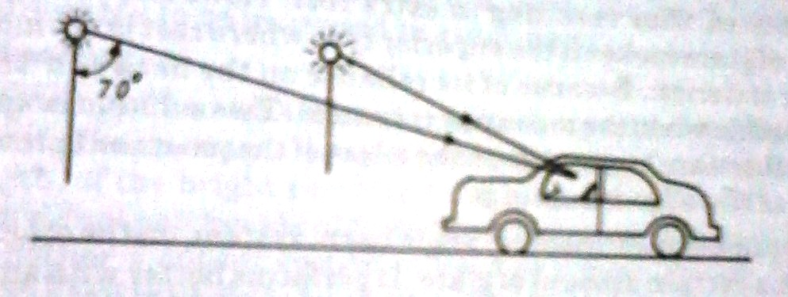
Note: Light rays emitted at angles less than about 70⁰ from the downward vertical cannot cause glare.
Types of Lamps
The principle energy sources employed for street lightings are gas and electricity. Gas used to be a popular source some years ago, but the versatility and convenience of electricity has made it the widely used energy source of the present day.
There is a large variety of electric lamps available for street lighting purpose. Considerations such as initial cost, life, colour, rendering, wattage, brightness, efficiency etc., govern the choice. The following are the main types of lamps:
- Tungsten filament
- Tabular fluorescent
- Sodium vapour discharge
- High pressure mercury discharge

Maintenance of Lighting Installation
For ensuring safety, a very high standard of maintenance of lighting installations is called for cleaning of lamps and replacement of faulty lamps should carried out at regular intervals.
Factors affecting the Street Lighting
- Distribution of Light
- Position of Posts
- Types of Power of Sources
- Spacing of Lamps
- Overhang
- Avoidance of glare
- Mounting Height etc.,
Arrangement of Lamps at Junctions
Lamp Arrangement in Square Junction
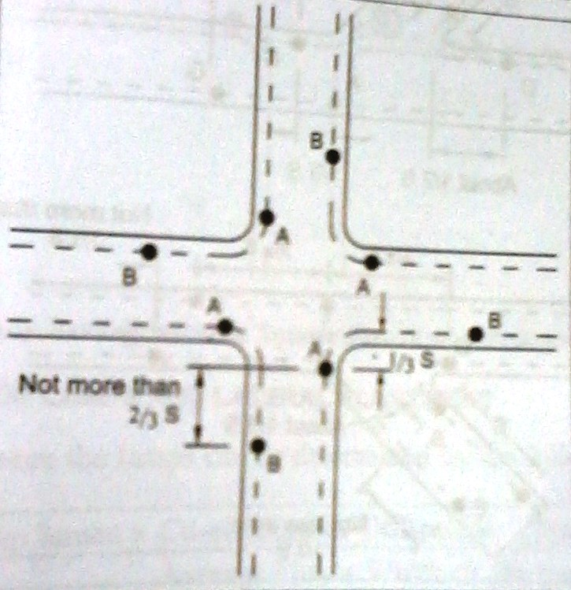

Lamp Arrangement in T- Junction
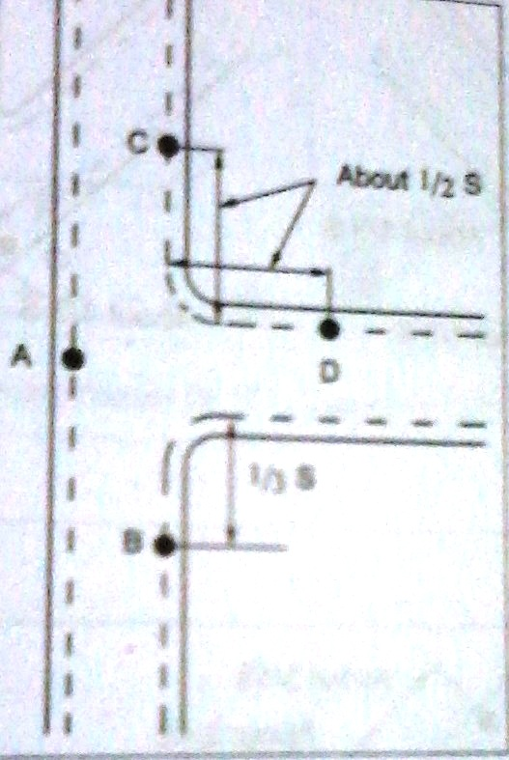
Lamp Arrangement in Y- Junction
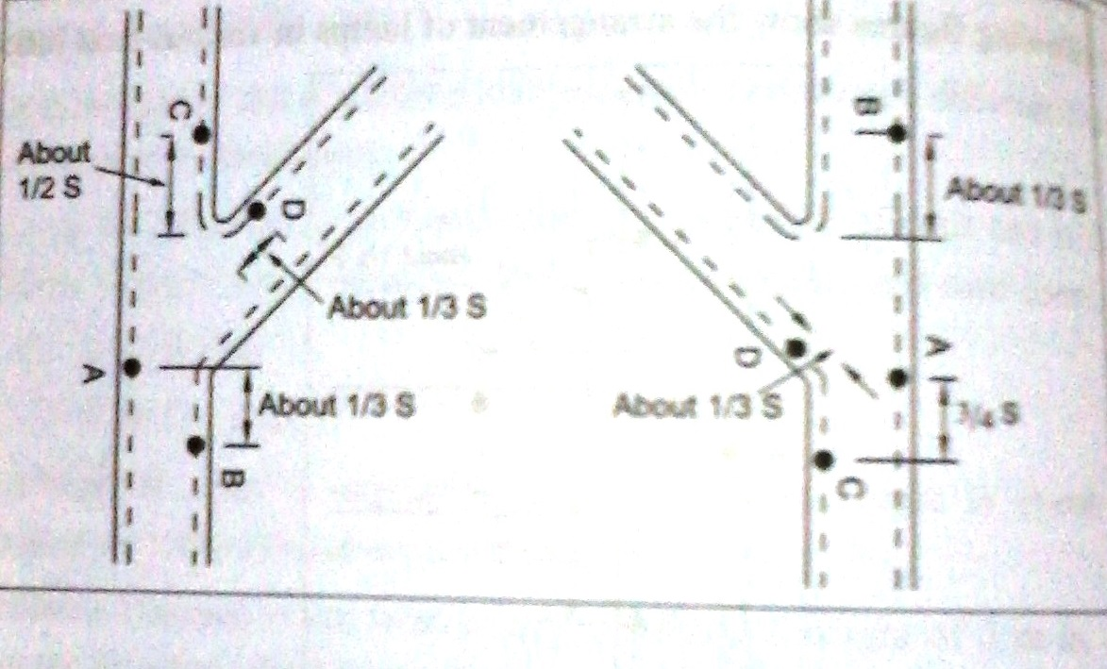
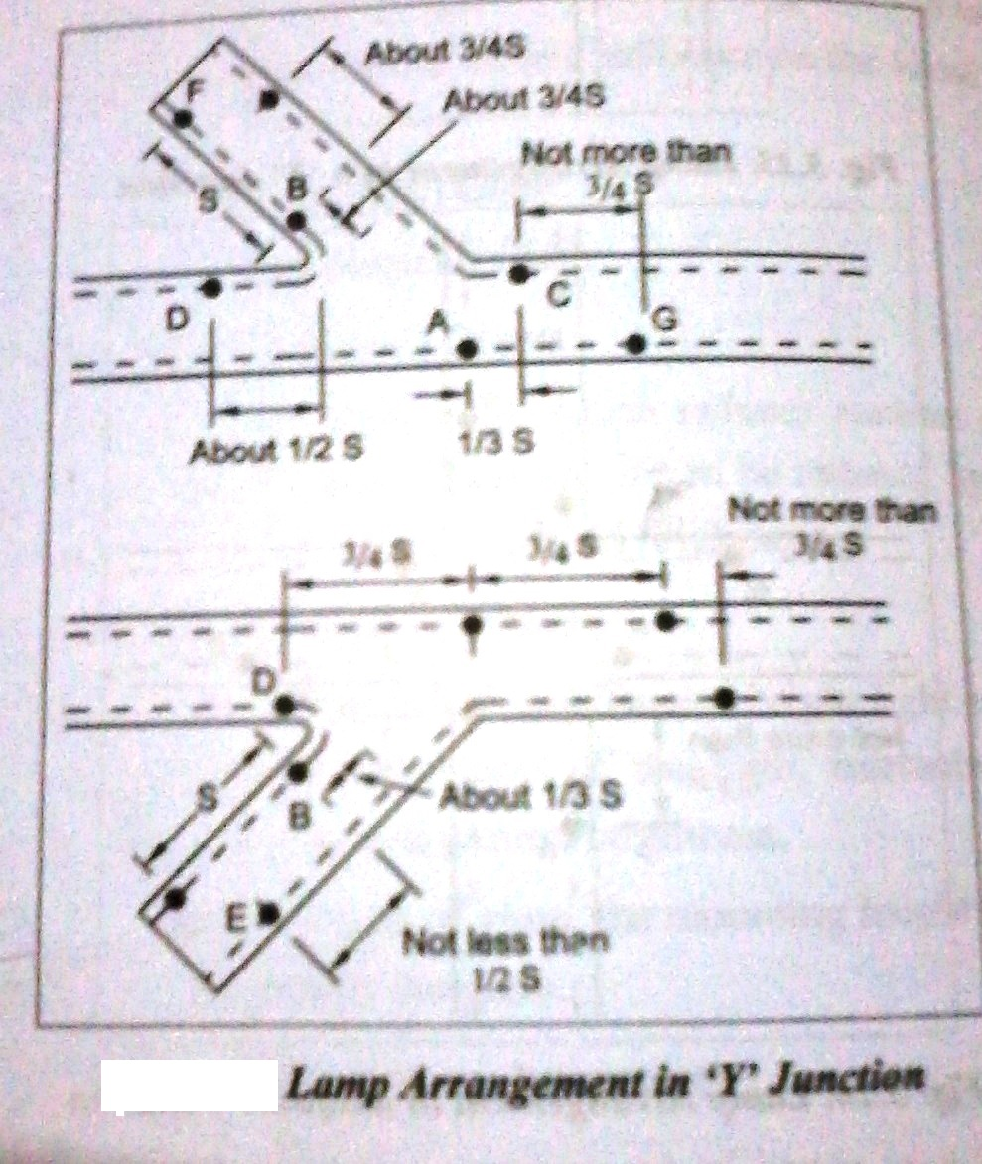

Lamp Arrangement in Square Junction of Pedestrian Crossing
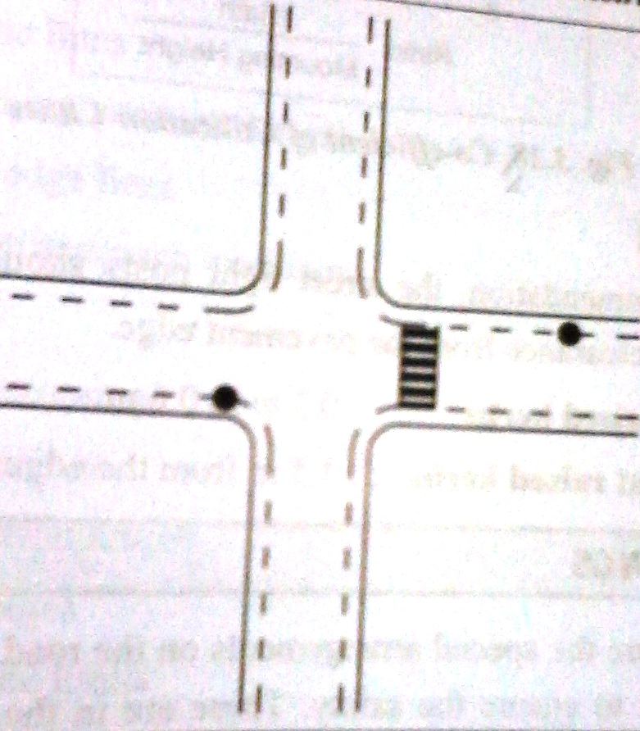
Lamp Arrangement in T-Junction of Pedestrian Crossing
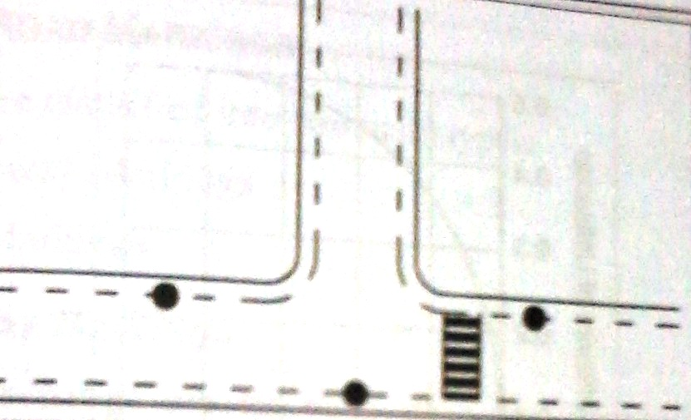

5. explain in detail about traffic and environment hazards.

TRAFFIC AND ENVIRONMENT HAZARDS
The main sources of traffic-related air pollution are:
- cars
- buses
- transport trucks
When engines burn fuel (gasoline or diesel), air pollutants that can affect our health are emitted, such as:
- nitrogen oxides
- carbon monoxide
- fine particulate matter
- volatile organic compounds
Additional air pollution is created when some of the gasoline used by engines evaporates without being burned. Traffic-related emissions also contribute to smog.
Health effects of traffic-related air pollution
Air pollution from traffic has been linked to many negative health effects, including:
- worsening asthma symptoms
- asthma development in children
- lung cancer
- reduced lung function
- heart disease
- increased risk of death from heart conditions
Air pollution may worsen symptoms for people with existing heart and lung conditions.
Risks to young children
Children can be more sensitive to air pollution than people in other age groups. This is because children breathe in more air in relation to their body weight. This means that they breathe in more contaminants, so air pollution can affect them more.
The body's defense and lung systems are also not fully developed yet. Therefore, the health of young children may be more affected by air pollution.
Children living in areas with heavy traffic have a higher risk of having breathing problems than other children. Exposure to traffic pollution can worsen asthma in children and may increase the risk of asthma development.
How can you minimize your risk?
You can minimize your risk of health effects from traffic-related air pollution by:
- choosing low-traffic routes for:
  - cycling
  - walking
  - running
- exercising in parks and green spaces, away from major roadways
- reducing outdoor air pollution in your home by closing windows and using:
  - a ventilation system with filtration
  - air conditioning on very hot days
- considering local traffic patterns and avoiding high-traffic areas when choosing a:
  - school
  - daycare
  - place to live
- limiting time spent outdoors when pollution levels are high, especially for vulnerable groups, such as:
  - infants
  - children
  - diabetics
  - the elderly
  - those with heart or lung problems
- avoiding idling your vehicle in an attached garage, and keeping any doors between your house and the garage closed
You can help reduce pollution from traffic by:
- choosing alternate ways to travel, such as:
  - walking or cycling
  - public transit
  - carpooling
- driving at a steady speed and avoiding rapidly accelerating when possible
- warming your engine with a block heater on cold days before starting it (emissions are higher when the engine is cold)
- consulting the Fuel Consumption Ratings Search Tool before buying a vehicle
- turning off your engine when stopped for more than 10 seconds, unless you are in traffic or at an intersection
- reducing fuel consumption and emissions by:
  - maintaining your vehicle's engine
  - keeping your tires properly inflated as indicated by the manufacturer

6. Describe in detail about noise pollution.

NOISE POLLUTION
Noise is defined as, "the unwanted, unpleasant or disagreeable sound that causes discomfort to all living beings". Sound intensity is measured in decibels (dB) that is the tenth part of the longest unit Bel. One dB is the faintest sound that a human ear can hear.
TYPES OF NOISE: Environmental noise has been doubling every ten years. Noise is classified as:
- Industrial Noise
- Transport Noise and
- Neighborhood noise
Industrial Noise: It is sound with a high intensity sound caused by industry machines. Sources of such noise pollution are caused by machines from machines in various factories, industries and mills. Noise from mechanical saws and pneumatic drills is unbearable and a nuisance to the public.
The Indian Institute of Oto-Rino Laryngology, Chennai reported that increasing industrial pollution damages the hearing ability by at least 20%. Workers in steel industry, who work close to heavy industrial blowers, are exposed to 112dB for eight hours suffer from occupational pollution.
Transport Noise: Transport noise mainly consists of traffic noise from road, rail and aircraft. The number of automobiles on roads like motors, scooters, cars, motor cycles, buses, trucks and diesel engine vehicles has increased enormously in the recent past further aggravating the problem of transport noise.
Noise levels in most residential areas in metropolitan cities are hovering around the border line due to increased vehicular noise pollution. This high level of noise pollution leads to deafening in the elderly.
Neighborhood noise: This type of noise includes disturbance from household gadgets and community. Common sources being musical instruments, TV, VCR, Radios, Transistors, Telephones, and loudspeakers etc. Statistically, ever since the industrial revolution, noise in the environment has been doubling every ten years.
Effects of Noise pollution
- Noise pollution affects both human and animal health. It leads to:
  - Contraction of blood vessels
  - Making skin pale
  - Excessive adrenalin in the blood stream which is responsible for high blood pressure.
  - Blaring sounds are known to cause mental distress
  - Heart attacks, neurological problems, birth defects and abortion
- Muscle contraction leading to nervous breakdown, tension, etc
- The adverse reactions are coupled with a change in hormone content of blood, which in-turn increases heart beat, constriction of blood vessels, digestive spams and dilation of the pupil of the eye.
- Adverse affects health, work efficiency and behavior. Noise pollution may cause damage to the heart, brain, kidneys, liver and may produce emotional disturbance.
- The most immediate and acute effect of noise is impairment of hearing that diminishes some part of the auditory system. Prolonged exposure to noise of certain frequency pattern leads to chronic damage to the inner ear.
- Impulsive noise may cause psychological and pathological disorders
- Ultrasonic sound can affect the digestive, respiratory, cardiovascular system and semicircular canals of the internal ear.
- The brain is adversely affected by loud and sudden noise by jets and airplanes. People are subjected to psychiatric illness.
- Recent reports suggest that blood is thickened by excessive noise.
- The optical system of human beings is also affected by noise pollution. Severe noise pollution causes:
  - Pupullary dilation
  - Impairment of night vision and
  - Decrease in rate of color perception

Abatement Measures:
- SOURCE CONTROL: This includes source modification such as acoustic treatment to machine surface, design changes, limiting operational timings, etc
- TRANSMISSION PATH INTERVENTION: This includes containing the source inside a sound insulating enclosure, constructing a noise barrier or provision of sound absorbing materials along the path.
- RECEPTOR CONTROL: This includes protection of the receiver by altering the work schedule or provision of personal protection devices such as ear plugs for operating noisy machinery. The measure may include dissipation and deflection methods.
- OILING: Proper oiling will reduce noise from the machine.
Preventive measures:
- Prescribing noise limits for vehicular traffic
- Ban on honking (usage of horns) in certain areas
- Creation of silence zones near schools and hospitals
- Redesigning buildings to make them noise proof
- Reduction of traffic density in residential areas
- Giving preference to mass public transport system.

7. explain in detail about air pollution.

AIR POLLUTION
Air pollution may be defined as the presence of one or more contaminants like dust, mist, smoke and color in the atmosphere that are injurious human beings, plants and animals.
Causes of Air Pollution:
- Rapid industrialization
- Fast urbanization
- Rapid growth in population
- Growth of vehicles on the roads and
- Activities of human beings have disturbed the natural balance of the atmosphere.
The composition of Air is given below:
Nitrogen 78%
Oxygen 21%
Argon less than 1%
Carbon dioxide 0.037%
Water vapour Remaining
Ozone, Helium and ammonia Trace amount
Sources of Air pollution
Sources of air pollution are of two types. Natural sources and artificial sources
Natural sources of pollution are those that are caused due to natural phenomena. Ex: Volcanic eruptions, Forest fires, Biological decay, Pollen grains, Marshes, Radioactive materials.
Artificial sources are those which are created by man. Ex: Thermal power plants, Vehicular emissions, Fossil fuel burning, agricultural activities etc.

Classification of Air Pollutants
Depending on the form of pollutants present in the environment, they are classified as:
- Primary pollutants and
- Secondary pollutants
Primary pollutants are those that are directly emitted in the atmosphere in the harmful form
Ex: CO, NO, CO2, SO2 etc.
Secondary pollutants are those that are formed by reacting with other components or some basic component of the atmosphere to form new pollutants. Ex: Oxides of Nitrogen (NO2 or NO3) react with moisture in the atmosphere to give Nitric acid
Indoor air pollutants are primary air pollutants. The most important indoor air pollutant is Radon gas.
Sources of indoor air pollutants are:
- Radon gas is emitted from building materials like bricks, concrete, tiles, etc that are derived from soil containing radium
- Radon is also found in natural gas and ground water and is emitted while being used.
- Burning fuel in the kitchen and cigarette smoke release pollutants like CO, SO2, HCHO (Formaldehyde) and BAP (Benzo-(A) pyrene).
Abatement Measures
The atmosphere has several built-in self cleaning processes such as dispersion, gravitational settling, flocculation, absorption, rain-washout, etc to cleanse the atmosphere. However, control of contaminants at their source level is a desirable and effective method through preventive or control technologies.
Source control: Some measures that can be adopted in this direction are:
- Using unleaded petrol
- Using fuels with low sulphur and ash content
- Encouraging people to use public transport, walk or use a cycle as opposed to private vehicles
- Ensure that houses, schools, restaurants and playgrounds are not located on busy streets
- Plant trees along busy streets as they remove particulates, carbon dioxide and absorb noise
- Industries and waste disposal sites should be situated outsdide the city preferably on the downwind of the city.
- Catalytic converters should be used to help control emissions of carbon monoxide and hydrocarbons
Control measures in industrial centers
- Emission rates should be restricted to permissible levels by each and every industry
- Incorporation of air pollution control equipment in design of plant layout must be made mandatory
- Continuous monitoring of the atmosphere for pollutants should be carried out to know the emission levels.
EQUIPMENT USED TO CONTROL AIR POLLUTION
Air pollution can be reduced by adopting the following approaches.
- Ensuring sufficient supply of oxygen to the combustion chamber and adequate temperature so that the combustion is complete thereby eliminating much of the smoke consisting of partly burnt ashes and dust.
- To use mechanical devices such as scrubbers, cyclones, bag houses and electro-static precipitators in manufacturing processes. The equipment used to remove particulates from the exhaust gases of electric power and industrial plants are shown below. All methods retain hazardous materials that must be disposed safely. Wet scrubber can additionally reduce sulphur dioxide emissions.
- The air pollutants collected must be carefully disposed. The factory fumes are dealt with chemical treatment.

PROMOTION AND INTEGRATION OF PUBLIC TRANSPORTATION
8. write short note on public transport integration.

A good public transport system must be easy and convenient to use, fast, safe, clean and affordable.
A key feature is that they integrate multiple technologies, such as metro rail, light rail, Bus Rapid Transit and basic bus services. A common ticket or fare card serves all the systems, making it easy for passengers to transfer from one mode to the other. Passenger information systems enable users to know when the next service is due and to understand the routes easily, and high frequency of service reduces the hassle of a long wait for the next bus or train.
In general, integration implies the opportunity to use the entire public transport system across a local or regional area (e.g. city, conurbation) independently of transport modes, tariffs, fares, schedules, ticket systems, etc.
Non-integrated public transport systems tend to neglect the needs of customers, which ultimately results in a decrease of ridership. In particular, the absence of an integrated public transport system causes the following problems and inconveniences for customers and authorities:
Comfort: More than one ticket is needed for a single-trip ride.
Information: The customer faces a non-transparent jungle of tariff systems.
Travel time: Timetables and connections between operators are not harmonized.
Costs: In some relations, parallel, competitive services exist.
At the beginning of any public transport integration an analysis of these issues is needed.
PROMOTION OF NON-MOTORIZED TRANSPORT
Coordinating bicycling with public transport is mutually beneficial, enhancing the benefits of both modes and encouraging more bicycling as well as more public transport use. Bicycling supports public transport by extending the catchment area of transit stops far beyond walking range and at much lower cost than neighborhood feeder buses and park-and-ride facilities for cars. Access to public transport helps cyclists make longer trips than possible by bike. Transit services also can provide convenient alternatives when cyclists encounter bad weather, difficult topography, gaps in the bikeway network, and mechanical failures.
CE 6006 TRAFFIC ENGINEERING AND MANAGEMENT
UNIT IV - TRAFFIC SAFETY AND ENVIRONMENT
PART A (2 MARKS QUESTIONS WITH ANSWERS)
- What do you mean by Accident?
Accident is an unfortunate incident that happens unexpectedly and unintentionally, typically resulting in damage or injury.
- What are the major Objectives of accident studies?
- To study the causes of accidents and suggest corrective measures at potential location
- To evaluate existing design
- To compute the financial losses incurred
- To support the proposed design and provide economic justification to the improvement suggested by the traffic engineer
- To carry out before and after studies and to demonstrate the improvement in the problem.

- What are the major Objectives of accident studies?
Road Users, Vehicle, Road Condition, Road design, Environmental factors & Other factors.
- Enlist the effects of road accidents.

1. Shattering of dreams
2. Handicap
3. Death
4. Loss in the family
5. Near and dear ones grievance
6. Hospitalization
7. Errors in Hospital treatments
8. Side effects and much more

- Write the Necessity of Street Lighting:
Street lighting is primarily intended to enable the road users (motorists, cyclists and pedestrians) to see accurately and easily the carriageway and the immediate surroundings in darkness. A large proportion of the road accidents are caused in the night and one of the chief reasons is the unsatisfactory lighting.
- Enlist the main types of lamps.
- Tungsten filament
- Tabular fluorescent
- Sodium vapour discharge
- High pressure mercury discharge

- What are all the factors affecting the Street Lighting.
- Distribution of Light
- Position of Posts
- Types of Power of Sources
- Spacing of Lamps
- Overhang
- Avoidance of glare
- Mounting Height etc.,

- Write the Arrangement of Lamps at Junctions.
- Lamp Arrangement in Square Junction
- Lamp Arrangement in T- Junction
- Lamp Arrangement in Y- Junction
- Lamp Arrangement in Square Junction of Pedestrian Crossing
- Lamp Arrangement in T-Junction of Pedestrian Crossing

- What are all the main sources of traffic-related air pollution?
- Cars
- Buses
- Transport trucks - When engines burn fuel (gasoline or diesel), air pollutants that can affect our health.
- What are all the major air pollutants?
- Nitrogen oxides
- Carbon monoxide
- Fine particulate matter
- Volatile organic compounds
- Enlist the health effects of traffic-related air pollution.
Air pollution from traffic has been linked to many negative health effects, including:
- worsening asthma symptoms
- asthma development in children
- lung cancer
- reduced lung function
- heart disease
- increased risk of death from heart conditions
- How can you minimize your risk?
- Choosing low-traffic routes for:
  - cycling
  - walking
  - running
- Exercising in parks and green spaces, away from major roadways
- Reducing outdoor air pollution in your home by closing windows and using:
  - a ventilation system with filtration
  - air conditioning on very hot days
- Considering local traffic patterns and avoiding high-traffic areas when choosing a:
  - school
  - daycare
  - place to live

- Define Noise.
Noise is defined as, "the unwanted, unpleasant or disagreeable sound that causes discomfort to all living beings".

- Enlist the types of Noise.
- Industrial Noise
- Transport Noise and
- Neighborhood noise
- Write the Effects of Noise pollution.
      - Contraction of blood vessels
      - Making skin pale
      - Excessive adrenalin in the blood stream which is responsible for high blood pressure.
      - Blaring sounds are known to cause mental distress
      - Heart attacks, neurological problems, birth defects and abortion
- What are all the Preventive measures for Noise Pollution?
- Prescribing noise limits for vehicular traffic
- Ban on honking (usage of horns) in certain areas
- Creation of silence zones near schools and hospitals
- Redesigning buildings to make them noise proof
- Reduction of traffic density in residential areas
- Giving preference to mass public transport system.
- What is Air Pollution?
Air pollution may be defined as the presence of one or more contaminants like dust, mist, smoke and color in the atmosphere that are injurious human beings, plants and animals.
- Enlist the Causes of Air Pollution.
- Rapid industrialization
- Fast urbanization
- Rapid growth in population
- Growth of vehicles on the roads and
- Activities of human beings have disturbed the natural balance of the atmosphere.

- Write the Sources of Air pollution.
Sources of air pollution are of two types. Natural sources and artificial sources
Natural sources of pollution are those that are caused due to natural phenomena. Ex: Volcanic eruptions, Forest fires, Biological decay, Pollen grains, Marshes, Radioactive materials.
Artificial sources are those which are created by man. Ex: Thermal power plants, Vehicular emissions, Fossil fuel burning, agricultural activities etc.
- Note down the Classification of Air Pollutants.
Depending on the form of pollutants present in the environment, they are classified as:
- Primary pollutants and
- Secondary pollutants

- What is Primary Air Pollutants?
Primary pollutants are those that are directly emitted in the atmosphere in the harmful form. Ex: CO, NO, CO2, SO2 etc.
- What is Secondary Air Pollutants?
Secondary pollutants are those that are formed by reacting with other components or some basic component of the atmosphere to form new pollutants. Ex: Oxides of Nitrogen (NO2 or NO3) react with moisture in the atmosphere to give Nitric acid

