CE 6006 TRAFFIC ENGINEERING AND MANAGEMENT
UNIT V
TRAFFIC MANAGEMENT
Area Traffic Management System - Traffic System Management (TSM) with IRC standards –-Traffic Regulatory Measures -Travel Demand Management (TDM) – Direct and indirect methods – Congestion and parking pricing – All segregation methods- Coordination among different agencies – Intelligent Transport System for traffic management, enforcement and education.

1. what is traffic management? WRITE IN DETAIL ABOUT MANAGEMENT MEASURES.

(NOV/DEC 2011), (NOV/DEC 2012)
TRAFFIC MANAGEMENT
Traffic Management is defined as the method (or) technique of controlling the road network, in which the techniques are employed to increase the traffic capacity, easy transport of vehicle, safety during transport at the minimized cost.
SCOPE OF THE TRAFFIC MANAGEMENT STUDIES
The traffic volumes, especially in cities, are very high and cause delay, congestion and accidents. In order to reduce the traffic problems, a schematic well-planned regulatory measures and enforcing management technique is necessary.
Traffic control measures include the traffic signs and signals. Traffic regulatory measures include the restrictions on speed, vehicle and parking etc. The important objective of the traffic management study is the re-orientation of the traffic pattern on the existing streets, so that the conflicts points between the pedestrians and vehicles are highly reduced.
Management Techniques and tools are introduces in traffic system, in order to reduce the traffic problems such as accidents, delay in travelling time, congestion etc., especially in important cities like Chennai, Delhi, etc., It is quite hard to control the traffic flow and traffic volume due to the development of industries, business growth in population etc. For these purposes, management tools are imposed to minimize the traffic problems and to regulate the traffic with highest safety. These management techniques involve various activities such as speed revelation, dimension of the vehicles and parking etc.
The following are some of the traffic management measures.
- Restriction on turning movements
- One-way Streets
- Tidal Flow Operations
- Exclusive Bus lanes
- Closing Side Streets
- Traffic Segregations etc.,
TYPES OF TRAFFIC MANAGEMENT
- Transportation System Management (TSM)
- Travel Demand Management (TDM)
TRANSPORTATION SYSTEM MANAGEMENT (TSM)
Transportation System Management (TSM) is defined as a system (or package) of short-term measures to make the most productive and cost-effective use of existing transportation facilities and transportation services. Transportation System Management (TSM) also referred as Travel Demand Management (TDM).
TRAFFIC REGULATORY MEASURES
Management Techniques and tools are introduces in traffic system, in order to reduce the traffic problems such as accidents, delay in travelling time, congestion etc., especially in important cities like Chennai, Delhi, etc.,
It is quite hard to control the traffic flow and traffic volume due to the development of industries, business growth in population etc. For these purposes, management tools are imposed to minimize the traffic problems and to regulate the traffic with highest safety. These management techniques involve various activities such as speed revelation, dimension of the vehicles and parking etc. the following are some of the traffic management measures.
- Restriction on turning movements
- One-way Streets
- Tidal Flow Operations
- Exclusive Bus lanes
- Closing Side Streets
- Traffic Segregations etc.,
RESTRICTION ON TURNING MOVEMENTS
Restrictions o turning movements at a junction includes the following two operations,
- Restriction on Left Turners
- Restriction on Right Turners
Generally, in a junction, the left turning of the vehicle does not affect the traffic stream, (Except in the case of left turning immediately after the overtaking).
On the other hand, right turning traffic can create a serious problem in the traffic flow. The Right turning traffic affects the traffic flow and stops the entire traffic flow.
Generally, the right turning is permitted under the following ways,
- Separation of Right –Turning Phase
- Introduction of Early – cutoff
- Arrangement of Late Start
PROHIBITED RIGHT –TURNING MOVEMENT
Right Turning Movement can be prohibited where there is availability of alternative tracks ( or routes). Based on the existing layout of the street system, the following methods are available.
- T-Turn
- G-Turn
- Q-Turn
T-Turn
This type of arrangement is used for the right-turning movement from a minor road into a major road. Right turn is transferred into the Minor –Major junctions as shown in figure.
In this turn, the diversion of the right-turning traffic is restricted at the junction point and it is permitted to an alternative intersection along the road, where the possibility of turning is available.

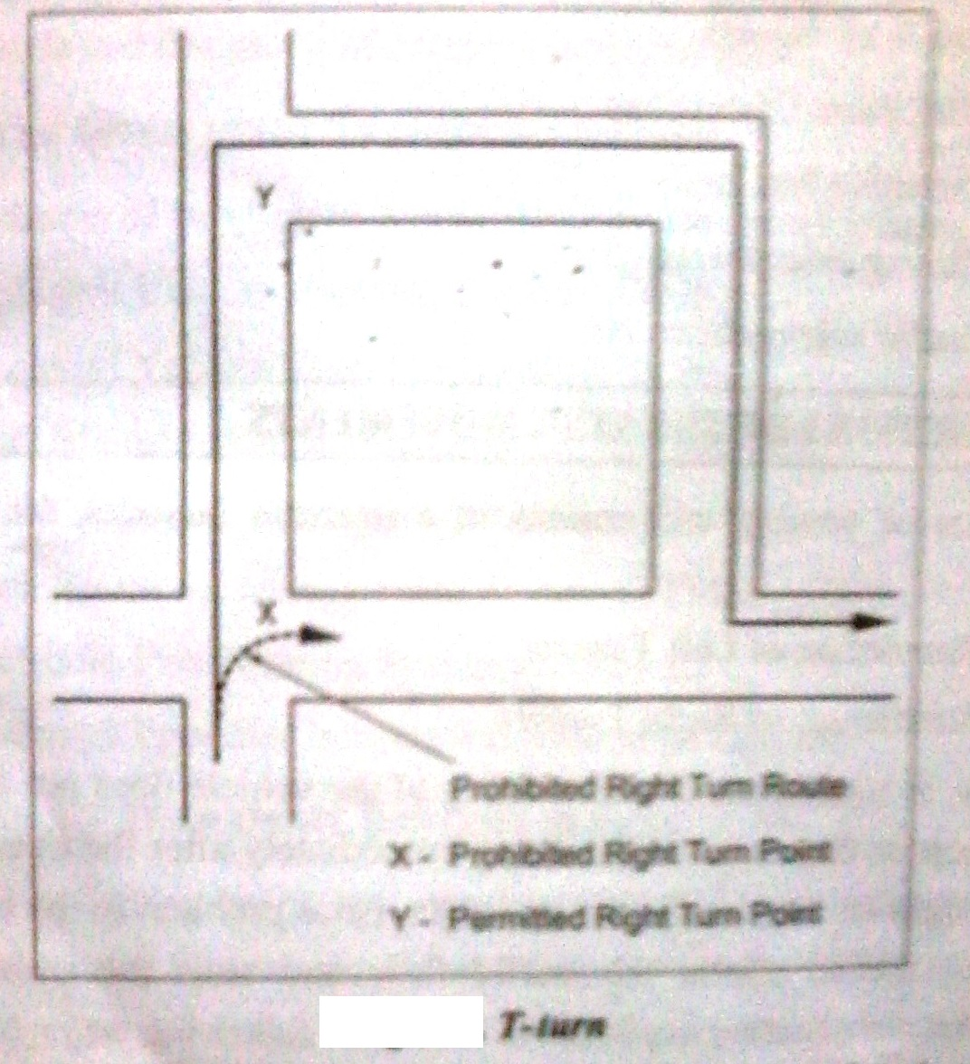
G-Turn
Diversion of the Right-Turning traffic is done by diverting the traffic to the left, before the junction point is called “G-Turn”. It is used for a right turn from a major road, because it is converted to a left turn from the major road and a straight –over movement and the original junction. The right turning is permitted at the less congested point in the traffic. The G-Turning traffic shown in figure.
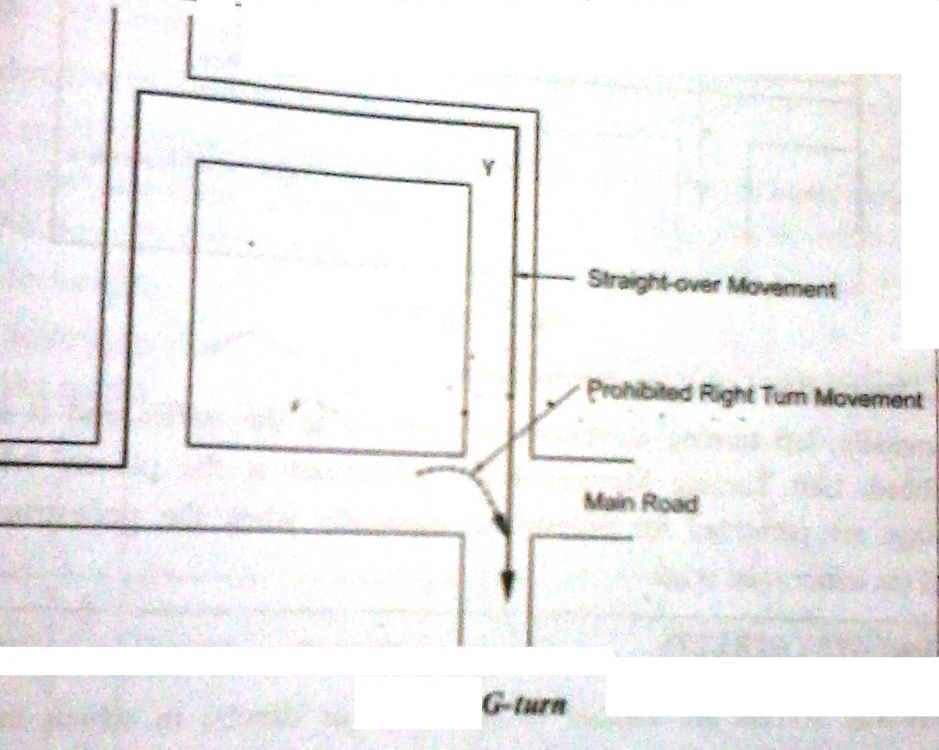
Q-Turn
In this arrangement, diversion of the right turning traffic is achieved by doing the three left turns and it requires the driver to cross twice the junction. In this turning, only left turn is involved and hence it is the least obstructive arrangement.
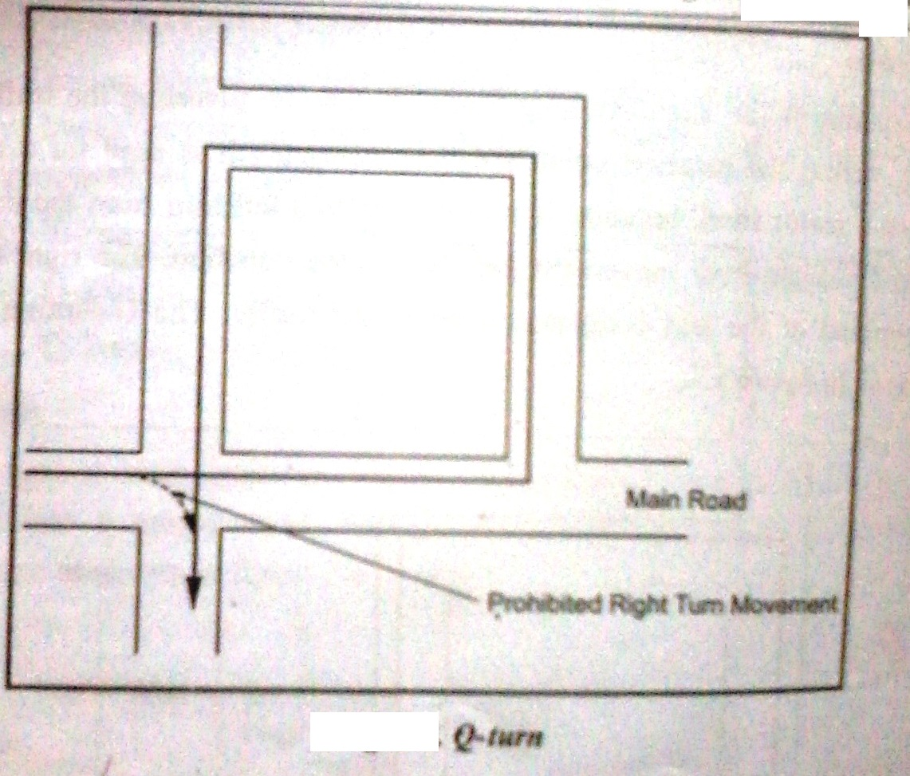
Prohibited Left –Turning Movements
Generally, left turning movement is permitted to the traffic and it is rarely prohibited. Left Turning Movements are prohibited at the places, where the crossings are permitted for pedestrians, especially when the pedestrian traffic across the minor road is heavy.

(NOV/DEC 2013)
2. WRITE IN DETAIL ABOUT ONE –WAY STREETS WITH ITS MERITS AND DEMERITS.

ONE-WAY STREETS
One-Way Streets are defined as the roads (or streets) in which the traffic movement is permitted in one direction only. In order to increase the traffic capacity and to reduce the unnecessary delays in traffic movements, one-way streets are provided. It is the suitable method of diverting the traffic and reducing the congestion in the busy area.
It is proved that, the one-way street system is effective and less expensive method of traffic management measure in congested areas, when it is combined with other traffic control devices such as traffic signals, restricted turning movements, restrictions on loading and waiting etc.,
Advantages of One-Way Streets
- Reduction in the conflict points
- Increased Traffic Capacity
- Increased speed of the vehicles
- Improved Parking Facilities
- Elimination of Dazzles and head-on-collision
- Facilitating the operation of a progressive signal system
- Reduction in Conflict Points
The conflict points at junctions in the traffic movement generate congestion, delay and accidents. The safety and the reduced delay can be achieved in a traffic flow, by reducing the number of conflicts points with a system or technique.
The following figure explains the use of one-way street reduction of conflict points.
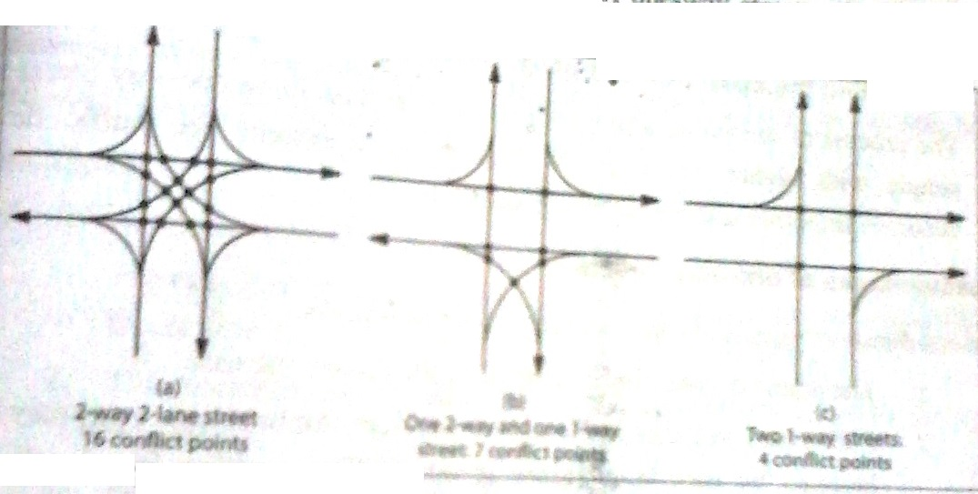
- Increased Traffic Capacity
The traffic capacity increases in one way streets, due to the reduction of conflicts points and the complete removal of the traffic in the opposite direction. The utilization of odd-traffic lane under one-way traffic operation increases the traffic capacity.
- Increased speed of the vehicles
The speed of the vehicles in the one-way streets is also get increased due to the elimination of opposing traffic. With increased speeds, the journey time and delays get decreased. A survey report indicates that the overall reduction of 20% in journey time is achieved by converting the roads into one-way streets.
- Improved Parking Facilities
One-way streets permit the parking provision and if the same street can be used a two-way street, the parking consumers more space in either side of the street. In this situation, one-way operation with permitted parking offers an alternative to the above.

- Elimination of Dazzles and head-on-collision
Elimination of Dazzles and the removal of head-on-collision in one-way streets result in reduction of accidents.
- Facilitating the operation of a progressive signal system
The process of designing a progressive signal system in a one-way street is simple with higher efficiency. With progressive system, the traffic flow becomes smoother and the safety is increased.
Disadvantages of One-Way Streets
- The actual distance to be covered by the drivers will be increase.
- Emergency vehicles (such as Fire Services, Ambulances etc., ) may be blocked by cars in all lanes at intersections waiting for signals to change.
- In One-Way Streets, when buses operate, the relocation of bus stops is essential. In this case, the passenger may have to walk additional distance to important places like railway stations etc.,
- The excessive speed results in the increase of accident rates.
- One –Way streets in residential areas, affect the peacefulness of the locality, especially affects the hospitals and schools zones.
- In the initial stage of the introduction of one-way streets, confusion may be created among motorists and pedestrians.
Points to be remembered in One-Way Streets
Whenever, a one-way street system is introduced, proper signs and sign boards are necessary for the safe and smooth flow of traffic.
- No – Entry signs are needed at all terminal points of the one-way streets.
- One-Way and/or Two-way traffic signs should be placed at the entrance and exit points of all intersections.
- ‘No-Left Turn’ and ‘No-Right Turn’ signs should be displayed at important junctions.

(NOV/DEC 2011)
3. EXPLAIN IN DETAIL ABOUT CLOSING SIDE STREETS AND TIDAL FLOW OPERATIONS.

CLOSING-SIDE STREETS
A main street consists of number of light – traffic side streets and some of the side – streets can be closed without affecting the traffic, in order to increase the speed and to reduce the traffic congestion in the main streets.
Advantages
- Increasing of speed of vehicles in the main street and decreasing the travel time due to the elimination of traffic in the side-streets.
- The accidents get reduced due to the elimination of traffic in the side-streets.
- The closed side streets may be utilized as the parking area of vehicles, travelling in the main street.
- The close to side-streets can be used as pedestrian paths and hence the safety, comfort and convenience of pedestrians are improved.
Disadvantages
- Closing of number cross-streets increases the traffic flow to and from the other cross-roads. This will lead the necessary of providing the signal control and other important traffic control devices at these junctions.
- When a number of side streets are closed, the immediate effect is an increase in the parking of vehicles on the main street. This may create the congested traffic conditions on the main road and lead to delays and lower speeds.
TIDAL FLOW OPERATIONS
During peak hours in the morning, the traffic flow is heavy for the roads towards the city center and in the evening the traffic is heavy for the roads, leaving from the city centre. In both the cases, the street space provided for the opposing traffic will be in excess. This concept is generally noted as “Tidal Flow”. The method of dealing the tidal flow problem by providing more than half the lane for one direction during the peak hours is called tidal flow or reversible flow.
Methods of Providing Tidal Flow Operation
The principle of tidal flow operation can be explained by the following two methods.
- The first is to allocate a greater number of lanes in a multi-lane street to the in-bound traffic during the morning peak and similarly a great number of lanes to the out-bound traffic during the evening peak.
- The second method is based on the requirement of the existence of two separate streets parallel to each other and close to each other, so that the wider of the two can be set apart for the heavier traffic both during the morning and the evening peak. In this case, the two streets will function as one-way streets.
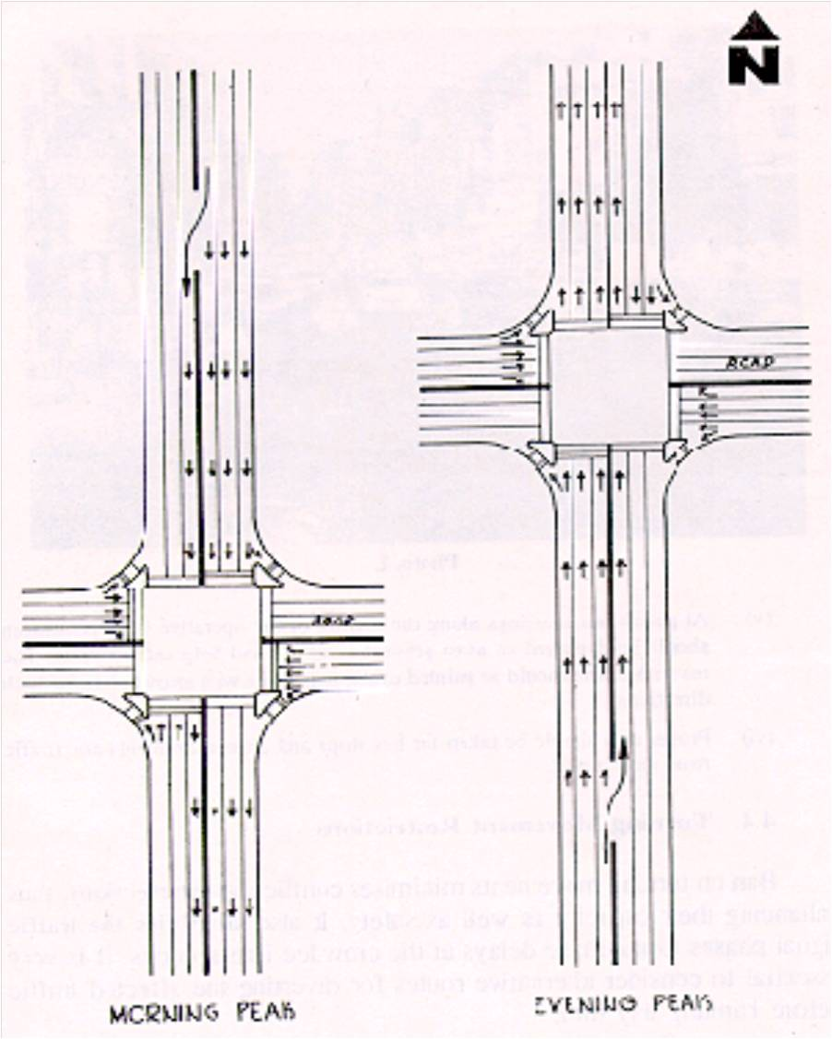
Suitable Conditions of Operation
The tidal flow operation is the best method for undivided streets with number of traffic lanes allocated to the two directions. In a three lane street, two lanes can be allocated for high flow of traffic and one can be used for smaller flow. In a 4 lane street, the entire street may be provided for one-direction traffic and the nearest parallel street may be allocated for opposing traffic. In a 5 lane street, 3 lanes to 2 lane distribution and in a 6 lane street, 4 lanes to 2 lane distribution are convenient.
Conditions for Tidal Flow Operation
Special signs and control devices are essential for the tidal flow operation. The traffic will be smooth, when the tidal flow operation is done with proper signals to regulate the flow in each lane.
It is desirable to restrict the parking operation on the side of the major flow during the peak hours. “No-Right Turn” and “Keep Left” signboards are necessary on pedestals and stanchions.
4. ENUMERATE ABOUT EXCLUSIVE BUS LANES AND TRAFFIC SEGREGATIONS.

(NOV/DEC 2011)
EXCLUSIVE BUS LANES
Exclusive Bus Lanes (or) Bus Only Lanes are defined as the lanes in the road width allocated for buses on certain specified timings, to simplify the traffic in congested areas.
Exclusive bus lanes are provided where the carriageway width is high and that there should be at least 3 lanes in each direction. The capacity of the exclusive bus lanes may be computed by assigning a PCU of 1.6 to each bus. The width of the bus lane should be a minimum of 2.8 m and the desirable value of lane width 3.5m.
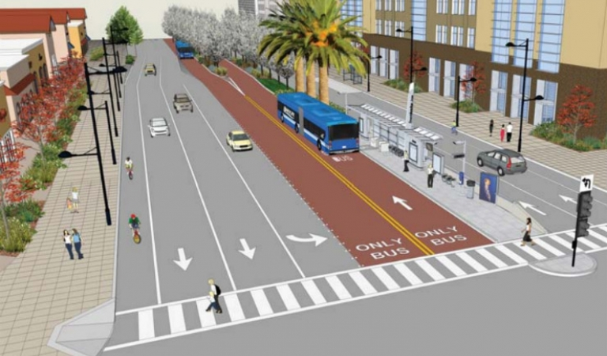
Advantages of Exclusive Bus Lane
- Exclusive bus lanes are generally provided in shopping areas to facilitate the pedestrians, to reach the buses with shortest walking distances.
- Exclusive bus lanes with special bus detectors and traffic signals at street intersections are used to reduce the delays.
- Journey time is considerably reduced, due to the increased speed in the exclusive bus lanes.
Disadvantages of Exclusive Bus Lane
- For the effective implementation of the system, it requires the proper enforcement policy. Satisfactory signing and marking of the lanes and adequate publicity are also needed.
- Exclusive bus lanes should be provided with the roads having minimum of 3 lanes in each direction. Hence for this purpose, exclusive bus lanes need a road with a minimum of 6 lanes.
- To be successful, the bus lanes should be created for a good length of the road instead of small bit of roads.

Design Factors
- Length
- Traffic Signals
- Number of Lanes
- Capacity of Traffic
- Type of Enforcement Needed
TRAFFIC SEGREGATION
Traffic Segregation is defined as the process of segregation or separation of traffic based on the traffic factors such as speed, direction of traffic, grade, time etc.,
The following are the various methods of traffic segregation,
- Place Segregation
- Destination-Segregation
- Speed-Segregation
- Direction-Segregation
- Grade-Segregation
- Time Segregation
- Place Segregation
- Destination –Segregation
Segregation in relation to destination is done by means of a ring road (or) by means of a bypass. In this type, the local and the through traffic are not allowed to mix as shown in figure.
The purpose of the inner ring road is to see whether the traffic in the inner ring road is kept moving, though at a slower speed. The bus centers are provided at the heart of the town, within the inner ring road. The bus centers should not be more than 100 m, from the shopping centers, theaters etc.,
It is better, if the outer ring road is provided at the edge of the town (outer from the city), generally at the future periphery of the city. The ring road is provided to separate the traffic and to facilitate for traffic to go from one part of the city to another, without going into congested and commercial areas.

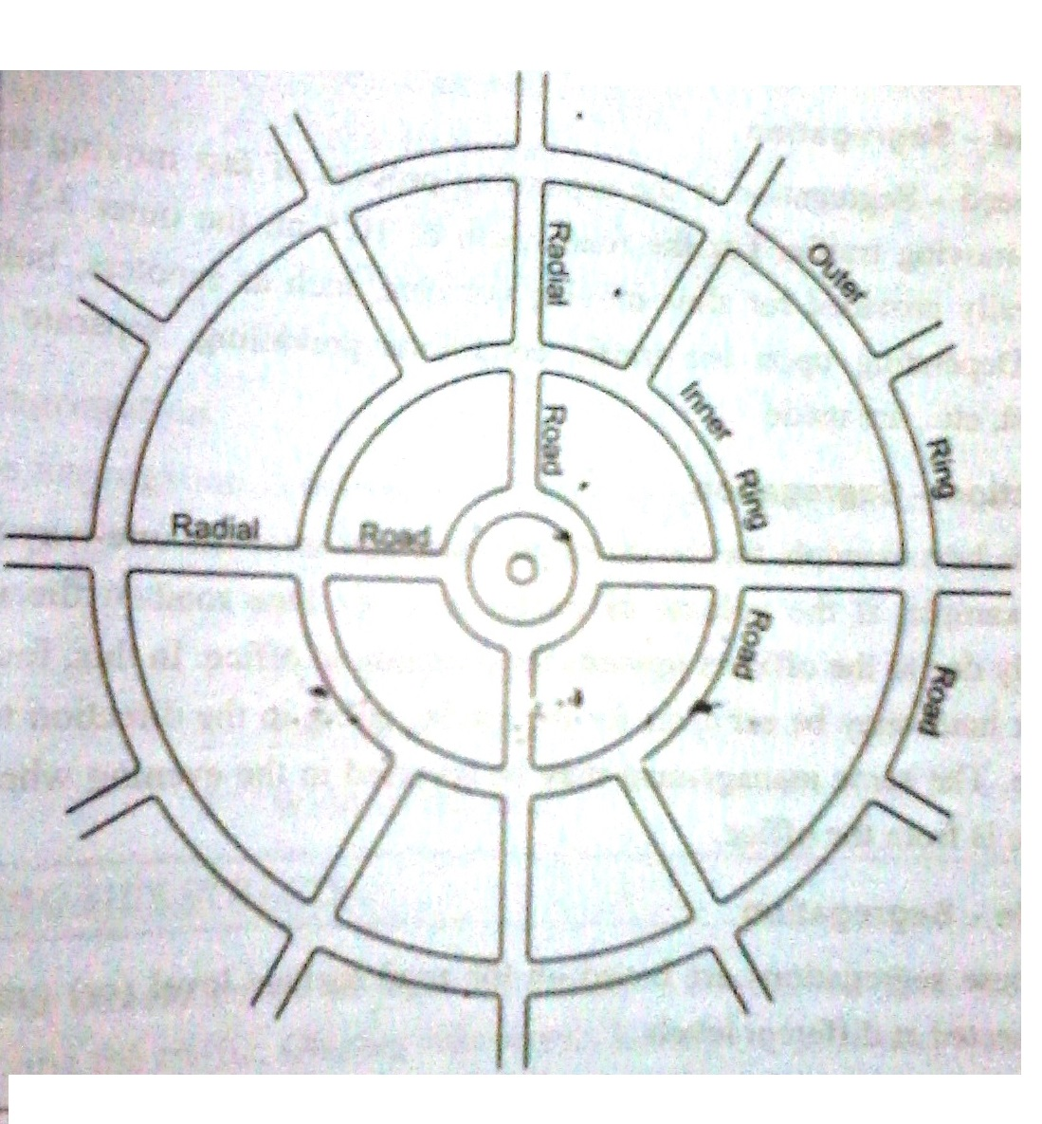
The outer ring road also provides the facility of higher speeds. The junction of radial road to the ring road is traffic rotary. In some countries, flyovers are provided depending upon the traffic and importance of the road. The access to the ring road should be controlled.
- Speed –Segregation
Speed-Segregation is the separating process of fast moving traffic from slow-moving traffic. For the road width of 10.5m, the outer 3.5 m lane is generally provided for slow-moving vehicles, such as scooter, bullock carts etc., Depending upon the traffic conditions prevailing separate tracks for cyclist etc., are made.

- Direction –Segregation
The best example for the direction-segregation is the One-Way Traffic and for example, if the volume of traffic on a six lane road in the morning is mainly due to the officers toward the direction of office. In this, four lanes out of six lanes may be set apart for the traffic, going in the direction towards the office. The same management may be reversed in the evening when the main traffic is from is from the office.

- Grade –Segregation
These segregations are based on the road surface level (or) grade and are intersected at different levels.
Example: Underpass and Over-Bridges
These grade separated intersections are without an interchange because of the traffic, moving separately at different levels and there is no provision for an interchange. When two or more roads have a provision for interchange, the junction is known as the grade separated intersections without interchange.
The number of legs served by an intersection defines the form of grade separated junction.
Examples: 1. Three – Legged Junction
- T-Junction
- Y-Junction
- Rotary Junction
- Four –Legged Junction
- Diamond Junction
- Half –Clover Leaf Junction
- Full – Clover Leaf Junction
- Rotary Junction
- Multiple –Legged Junction
- Time Segregation
Time Segregation is defined as the process of segregation of traffic based on the time considerations. In this method, the traffic may be divided, based on the following factors,
- Peak Flow Time on Traffic
- Locality of the Road
- Width of the Road

(NOV/DEC 2011)
5. EXPLAIN THE TRAFFIC CALMING MEASURES.

TRAFFIC CALMING
Traffic Calming is defined as the usage of series of devices such as bends, humps, etc. in the road, to slow down the traffic.
Traffic calming is a set of street design and traffic rules which slowdown and reduce the traffic and thereby increase the safety.
USES OF TRAFFIC CALMING
- Traffic calming reduces the number of accidents.
- It increases the safety and convenience for pedestrians and other non-motorists.
- It gives more spaces in the road.
- It eliminates the noise and other pollution
- It provides neighborhood revitalization and stability.
- It improves the appearance of the road.
METHODS OF TRAFFIC CALMING
Some of the traffic calming methods are as follows.
- Speed Breakers or Humps
- Rumble Strips
- Crash Barriers
- Road Narrowing
- Provision of separate Cycle Tracks

- Speed Breakers
Speed Breakers (or) Speed controlling Humps are the structures used in private access roads and roads near schools and educational institutions, in order to reduce the speed of the traffic.
In India, the Ministry of Surface Transport (Roads Wing) and the IRC have been opposing the use of speed breakers on the road .However in special situations, as mentioned above, the speed breakers are used in the highways and rural roads.
The design of the speed breaker is shown in figure.
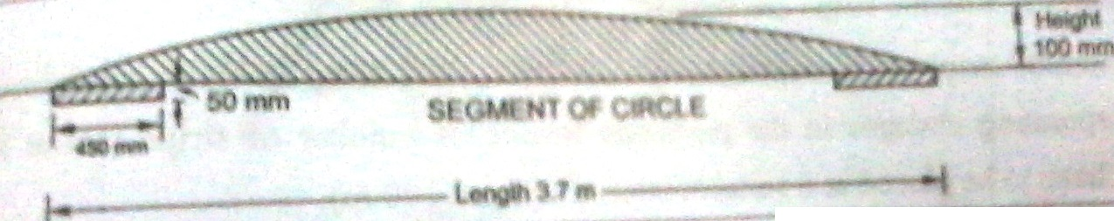
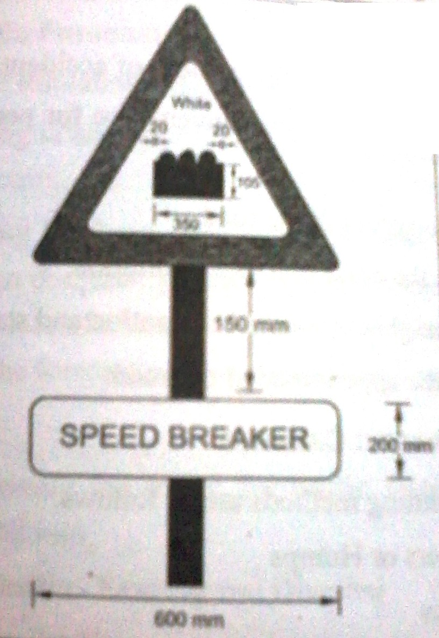
These humps are to be pointed with White Road Points to make them visible during night. Necessary road signs should also be placed to alert the drivers about the presence of speed breakers.

- Rumble Strips
Provision of speed breakers on the main roads is sometimes hazardous and problematic and hence it is not preferred by some of the authorities in the Road Wing. For replacing the speed Breakers, Rumble Strips are introduced.
Rumble Strips are defined as the corrugated surfaces on the roads, producing noise and physical sensation to the driver and the driver gets converted due to these sensations. Rumble strips are shown in figure
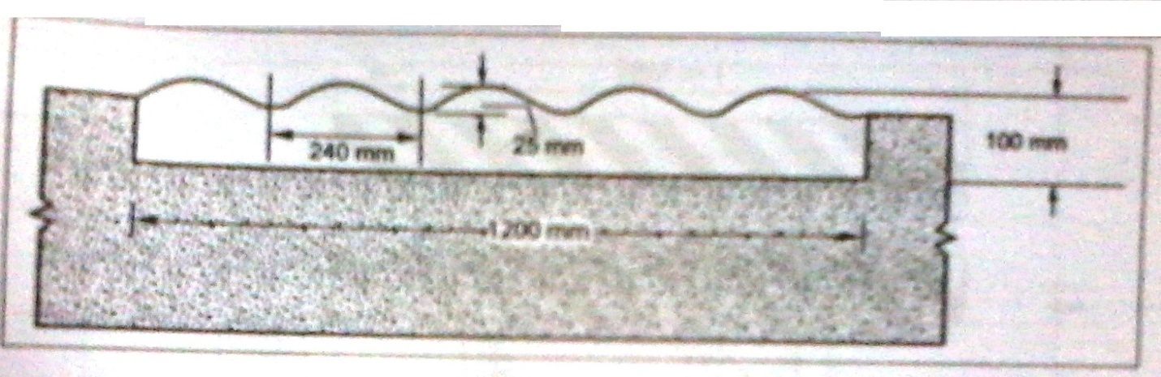
Rumble strips are formed either by a rough surface or by artificial conditions, by incorporating changes in the pavement texture. A number of strips (about 5-10) will have to be placed at a suitable intervals (about 100m)
- Crash Barriers (or Barricades)
Crash Barriers (or Barricades) and Channelisers are the devices required for controlling and diverting the traffic on construction zones, inspecting check posts and temporary diversions.
Following figure provides details about the wooden barricades, generally used in highways. Traffic cones and tubular markers are generally used for the purpose of controlling and guiding the traffic flow. These cones and markers are made of plastic or wood.
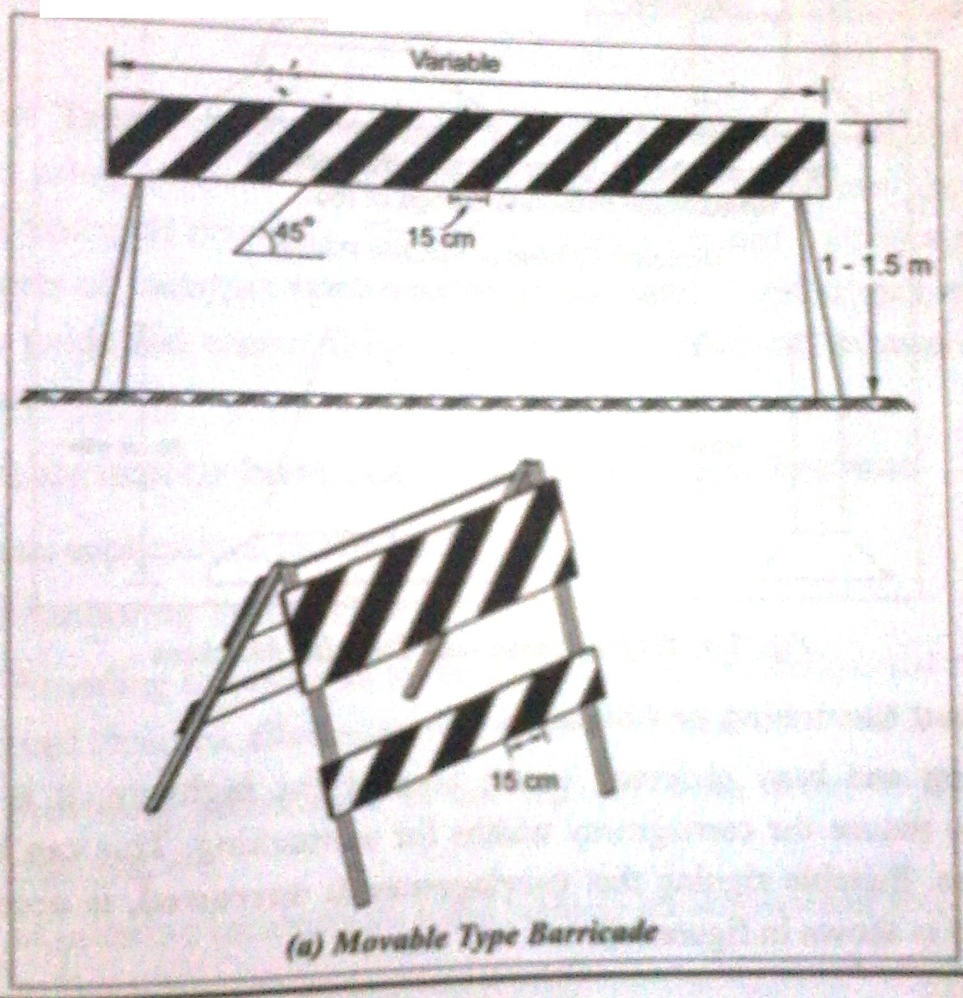
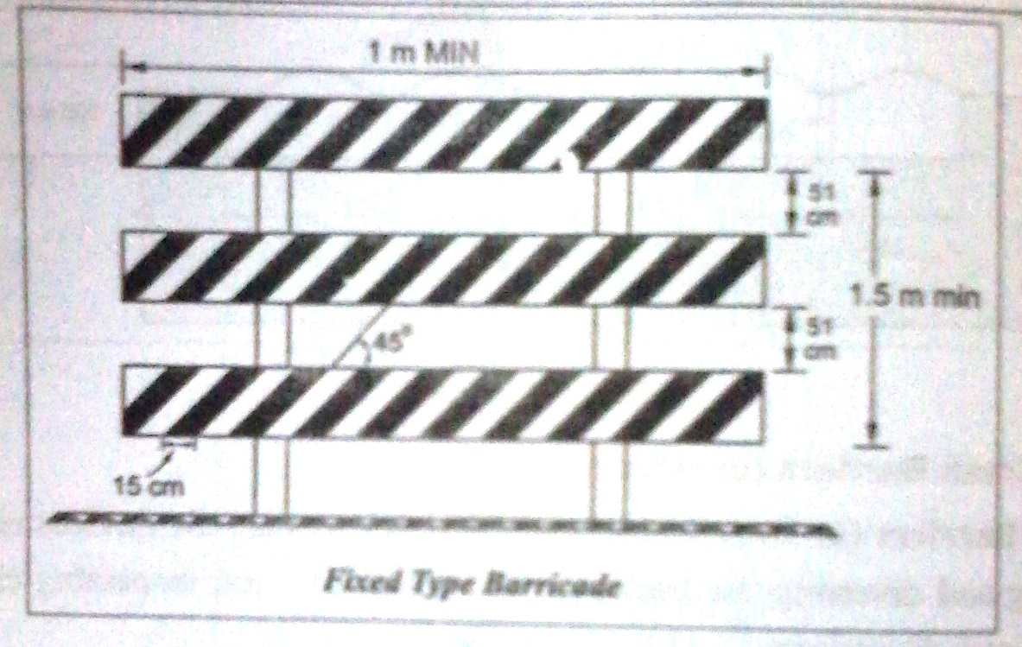
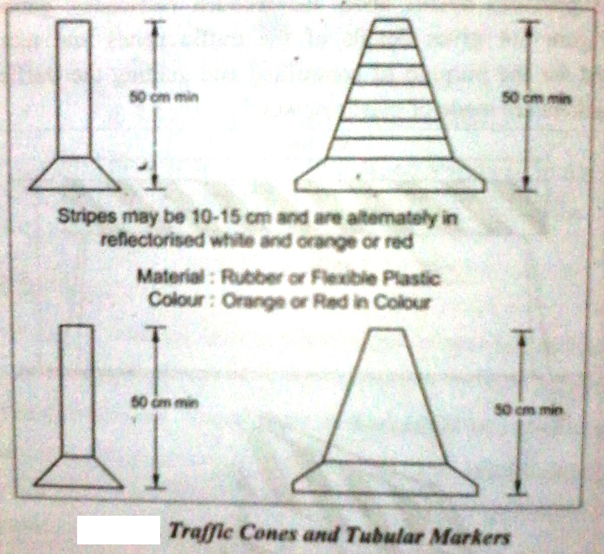
- Road Narrowing or Chicanes
In parking and busy shopping centre area of the highway, it is sometimes necessary to reduce the carriageway widths for earmarking. This can be achieved by Chicanes. Suitable signing that carriageway is narrowed, is necessary. This arrangement is shown in figure.
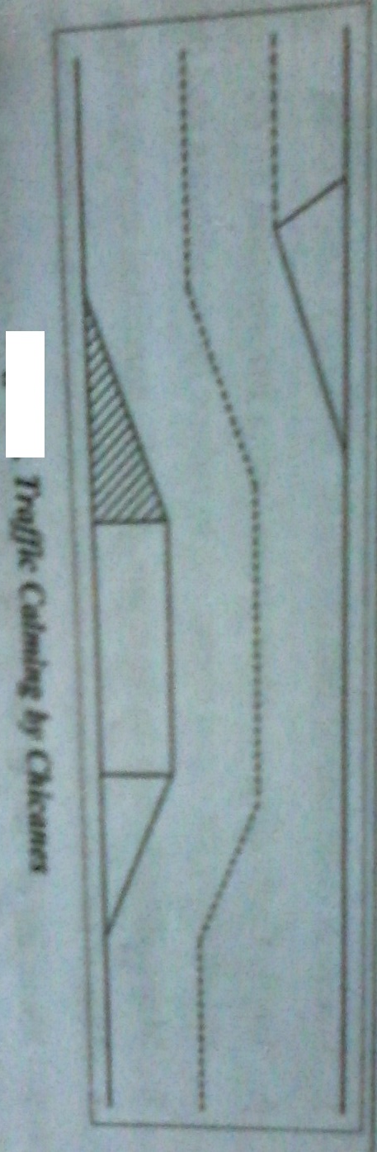
5. Provision of Cycle Tracks
Segregation of cycle tracks promotes the safety. In the view of the large number of cyclists on the streets of Indian towns and cities, it is desirable that the separate cycle tracks to be provided wherever feasible. Generally it is better to provide the cycle tracks on either sides of the road and the width of the track is about 0.5 m to 1 m wide. A design speed for cycles is about 32 km/hour.
TRAVEL DEMAND MANAGEMENT (TDM)
Travel Demand Management techniques are aimed to reduce the traffic flows especially during peak hours. Following are some of the methods employed in the TDM.
- Car pooling and other ride-sharing programmes
- Peripheral Parking Schemes
- Charted Buses
- Staggering of office hours and flexible time off work
- Entry Fee
- Road Pricing
- Priority for buses in traffic
- Restrictions of entry of trucks during day-time
- Internal Shuttle Service in the CBD
- Parking Restraint
PERIPHERAL PARKING SCHEMES
Town centre is the worst place to park the vehicles and it is quite natural to decide that the parking at the periphery of the town is comfortable. The following are the important kinds of peripheral parking schemes.
- Park and Walk
- Park and Ride
- Park and Walk
In this method, the motorists are induced to park their vehicle at the outer zones of the towns and walk to the town centre. The inducement may be in the form of lower parking charges or no parking charges at the periphery than the town centre. The success of this method is based on the attraction of the inducement to the motorists.
- Park and Ride
In this method, the motorists are forced to park their vehicle at the periphery of the town. The total travel time including parking, waiting time for bus and the travel time should be not more than the travel time taken by the motorist to travel to the town centre and parking time. Also the cost of peripheral parking plus the cost for to and fro journey by bus should not be more than the cost of travel by car with the cost of parking at the town centre.

LOCATIONS WHERE PARKING IS PROHIBITED
In order to ensure the safety and convenience, the parking of vehicle is prohibited at certain locations and as follows.
- Near Intersections
Parking at Intersections reduces the traffic capacity of the intersection, visibility and safety. It is the regular practice of avoiding the parking for a distance of about 50 m on the approaches to an intersection.
- Pedestrian Crossings
Parked vehicles obstruct the visibility at the pedestrian crossings and it is better to avoid the parking within about 8 m from the pedestrian crossing.
- Narrow Streets
Heavy traffic in narrow streets requires obstacle free flow traffic. Parking causing troubles to such traffic and hence it is desirable to avoid the parking on two-way streets less than 5.75 m wide and one-way streets less than 4m wide.
- Structures
Important structures such as bridges, tunnels and underpasses are having less width than the width of the highway. It is desirable to avoid the parking near those structures.
- Entrance Driveways
Vehicles should be prohibited from parking in front of the entrance driveways leading to residential buildings and other buildings.

PARKING RESTRAINT
The control of parking especially in town areas provides the following advantages.
- Reduction in accident rates
- Increase in road capacity
- Traffic restraint
- Presentation of the environment
ROAD PRICING
Road pricing is the method of road user taxation, charging the users of congested roads based on the usage time (or) travelling distance.
The principle of road pricing is that the person who causes the traffic congestion should only be charged (or) the person who uses the congested road should be charged. This system provides the choice to the road user whether to travel in the congested road or not.
Requirements of a Good Pricing System
- Charges should be highly related to the usage of congested roads.
- Road Pricing should vary for different roads with different time for different types of vehicles.
- Prices should be intimated to the road users before the travel.
- Method should be simple for road users to understand.
- Method should be simple for police to enforce.
- Pricing should be within the acceptable limits.
- Equipment used should be highly reliable.
- It should be completely truthful to the road users and free from any fraud measures.
- Payment in advance should be possible.
- It should be applied the whole country.

ENTRY FEE
Entry charges include supplement licensing, tolls and admission charges. Supplementary licensing charges enable a vehicle to travel in a particular area. Tolls are collected from the vehicles to travel in a bridge, tunnel and particular expressways in the areas. Admission charges are collected from vehicles through a number of controlled entry points during the peak hours of the day.
The important advantage of this system is that it is applied to all parking and non-parking areas. The main disadvantages of this system are that it fails to differentiate between various road usages within the licensing area and to make any distinction of charge on the basis of amount of congestion.
In Singapore, this system is successfully introduced in 1975.

(NOV/DEC 2012), (NOV/DEC 2013)
6. WHAT DO YOU KNOW ABOUT ITS? MAKE BRIEF NOTE ON IT.

INTELLIGENT TRANSPORT SYSTEM
Intelligent Transport System (or) Transport Telematics is the transport systems by using modern information technologies to improve the effective operation of transport networks. ITS requires a detailed collection of data on various aspects of transport operation. These data are processed then and applied the result to guide and control the traffic improves operation, enhance safety and transport costs.
Application of Intelligent Transport Systems
- Monitoring traffic flow.
- Providing information to the drivers (about congestion on the road, road closures, alternative routes, weather conditions and speeds).
- Providing information to the highway users about traffic jam, road closures etc.,
- Monitoring incidents on Road (vehicle breakdown and accidents)
- Electronic toll collection
- Traffic controlling on urban streets (using information on traffic flows and adjusting the signal operations to reduce the conditions and delay)
- Maintaining the data on the assets, periodic condition survey data.
- Uses of software package to optimize the maintenance interventions.
- Managing of Fleet by analyzing the data on vehicle location, adherence to schedules and passenger loadings.
- Analyzing the data on vehicle location, detentions etc., and action initiated to improve the operation, by using GIS Systems.
- Electronic Road Pricing System to decongest the city centers
- Acquiring the data on travel patterns in a city and develop forecasting models and designing of efficient transport plans.
Forms of Intelligent Transport System
- Intelligent Vehicle Highway System (IVHS)
- Advanced Vehicle Control System (AVCS)
- Asset Maintenance Management System (AMMS)
- Public Transport Management System (PTMS)
- Track Transport Management System (TTMS)
- Electronic Road Pricing System (ERPS)
- Advanced Traveler Information System (ATIS) etc.,
Intelligent Transport System in India
In India, toll collecting roads are very common and these tolls are effectively collected by using the Electronic Road Pricing System (ERPS) of ITS. The suitable example for the Centralized to Traffic Control System with CCTV Monitoring is the Mumbai-Pune Expressway. The application of ITS gives enhanced safety, higher productivity and reduced user costs, especially in the developing countries like India.

